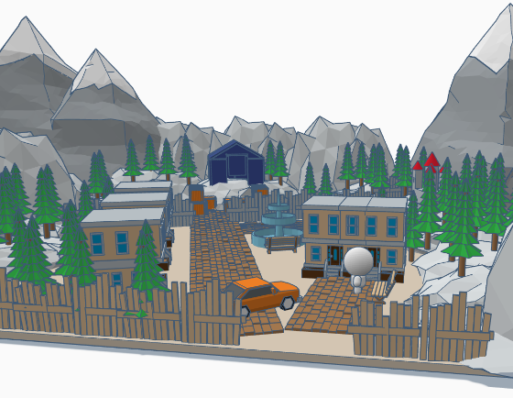

Fallout 4: “Chromosome”
  - Version 1.5
Designer: | Anona Yang
Document Date: | 2/16/2024
Intended Level Delivery Date: | 4/29/2024

Document Revisions Table
Version | Description | Requestor | Date
1.0 | Initial Document | Professor Myque Ouellette | 2/19/2024
1.5 | Updated Narrative in Level Narrative Details | N/A | 3/3/2024

Table of Contents
Table of Contents 2
Table of Figures 4
Level Summary 5
Quick Summary 5
Level Feature Overview 5
Development Schedule 6
Level Overview 7
Overview Map 7
Level Details 10
Detail Maps 10
Exterior Section 1 10
Interior Section 1 12
Interior Section 2 14
Interior Section 3 16
Exterior Section 2 19
Side Quest Overview 21
Skill Progression Chart 22
Aesthetic References 23
Old Town 23
The Clinic 26
References 28
Appendices 30
Appendix A: New Skills / Gameplay Mechanics 30
Light Puzzles 30
Terminal with Passwords 30
Appendix B: Context Detail 31
General Context 31
Backstory 31
Aftermath 31
Appendix C: Character Descriptions 32
NPC 1: Rocco 32
NPC 2: Eda 32
NPC 3: Iris 32
NPC 4: Gellert 32
NPC 5: Jessica 32
NPC 6: Della 32
Appendix D: Dialog Flow 34
Step 0-2: Rocco 34
Step 3-4: Gellert 35
Step 9: Jessica 36
Step 16: Jessica 36
Step 19-20: Iris, Eda 37
Step 25-26: Gellert, Iris, Eda 38
NPC 1: Rocco 39
NPC 2: Eda 39
NPC 3: Iris 40
NPC 4: Gellert 40
NPC 5: Jessica 41
Side Quest: Della 42
Appendix E: Development Risks 43
Appendix F: Key Asset Needs 44

Table of Figures

Figure 1: Narrative Flow [1] 7
Figure 2: Exterior Map Overview [2] 9
Figure 3: Interior Map Overview [3] 9
Figure 4: Exterior Section 1 [2] 10
Figure 5: Interior Section 1 [3] 12
Figure 6: Interior Section 2 [3] 14
Figure 7: Interior Section 3 [3] 16
Figure 8: Exterior Section 2 [2] 19
Figure 9: Side Quest Map Overview [2] 21
Figure 10: Skill Progression Chart [4] 22
Figure 11: Contact Sheet for Old Town from Fallout 4 [6] 23
Figure 12: Contact Sheet of Old Town in Reality [7,8,9,10,11,12] 24
Figure 13: Contact Sheet of Old Town Church Area [6,13,14] 25
Figure 14: Contact Sheet for the Clinic in Fallout 4 [6] 26
Figure 15: Contact Sheet for the Clinic in Reality [15,16,17,18,19,20,21,22,23] 27
Figure 16: Light Puzzle [5] 30
Figure 17: Dialog: Rocco, Step 0-2 [1] 34
Figure 18: Dialog: Gellert, Step 3-4 [1] 35
Figure 19: Dialog: Jessica, Step 9 [1] 36
Figure 20: Dialog: Jessica, Step 16 [1] 36
Figure 21: Dialog: Iris and Eda, Step 10-20 [1] 37
Figure 22: Dialog: Gellert, Iris, and Eda, Step 25-26 [1] 38
Figure 23: Dialog: Rocco [1] 39
Figure 24: Dialog: Eda [1] 39
Figure 25: Dialog: Iris [1] 40
Figure 26: Dialog: Gellert [1] 40
Figure 27: Dialog: Jessica [1] 41
Figure 28: Dialog: Della [1] 42

Level Summary

Quick Summary
“Chromosome” is an independent level in Fallout 4. It tells a story about a scientist struggling between developing genetic technology with human experiments and her ethics. The player will follow a ten-year-old boy Rocco to look for his mother that’s trapped in the clinic under synth attack. “Chromosome” is a level that features exploration and optional narrative with combats and light puzzles.

Level Feature Overview
Category | Sub-Category | Feature List
Gameplay Themes | Exploration | - Lockpicking  - Hacking  - Puzzle to open doors
 | Narrative | - Looking for optional narrative in terminals/notes  - Environmental narrative  - Charisma check  - Cinematics moment
Player | Player Weapons | - 10mm Pistol  - Institute Laser Gun  - Blade (melee weapon)
 | Player Skills/Abilities | - Combat: Sniper / Stealth  - Lockpicking & Hacking  - Exploration & progress through dialogues  - Light Puzzle
AI | Enemies | - Leveled 3rd Generation Synths (human-like) with Laser Gun/Blade (note: all synths in this level refer to 3rd Generation Synths)  - Town settlers with pistols and piped guns
 | Friendlies | - Leveled 3rd Generation Synths (human) with Laser Gun/Blade  - Town settlers with pistols and piped guns
Challenges | Obstacles/Hazards | - Locked doors
 | New/Unique Gameplay | - Light Puzzles
Context | Location in Game | - A town located on an island, far from commonwealth
 | Challenge Fit in Game | - Requires some level of lockpicking/hacking and charisma perk, but generally medium in terms of combats.
 | Narrative Fit | - This quest should happen after the player learns about the existence of the Institute and what they are working on the synths.
 | Basic Backstory / Results Info | - A scientist is doing secret human experiments to advance her research in genetic technology, but this is found out by a patient. The player needs to help this scientist choose how she wants to continue with the research, to continue with human experiments as consuming volunteers or slowly making progress without human experiments and watch people gradually die from genetic diseases.
Aesthetics | Major Visual Themes | - Town: Renaissance style decorated, old fashioned and vintage-like, near harbor  - Lab: Institute lab style
 | Setting/Mood | - Gloomy and Sad

Development Schedule
Milestone | Date
LDD | 2/19/2024
Whitebox | 3/4/2024
Initial Gameplay | 3/25/2024
Gameplay Complete | 4/15/2024
Aesthetics | 4/22/2024
Launch | 4/29/2024

Level Overview

Overview Map
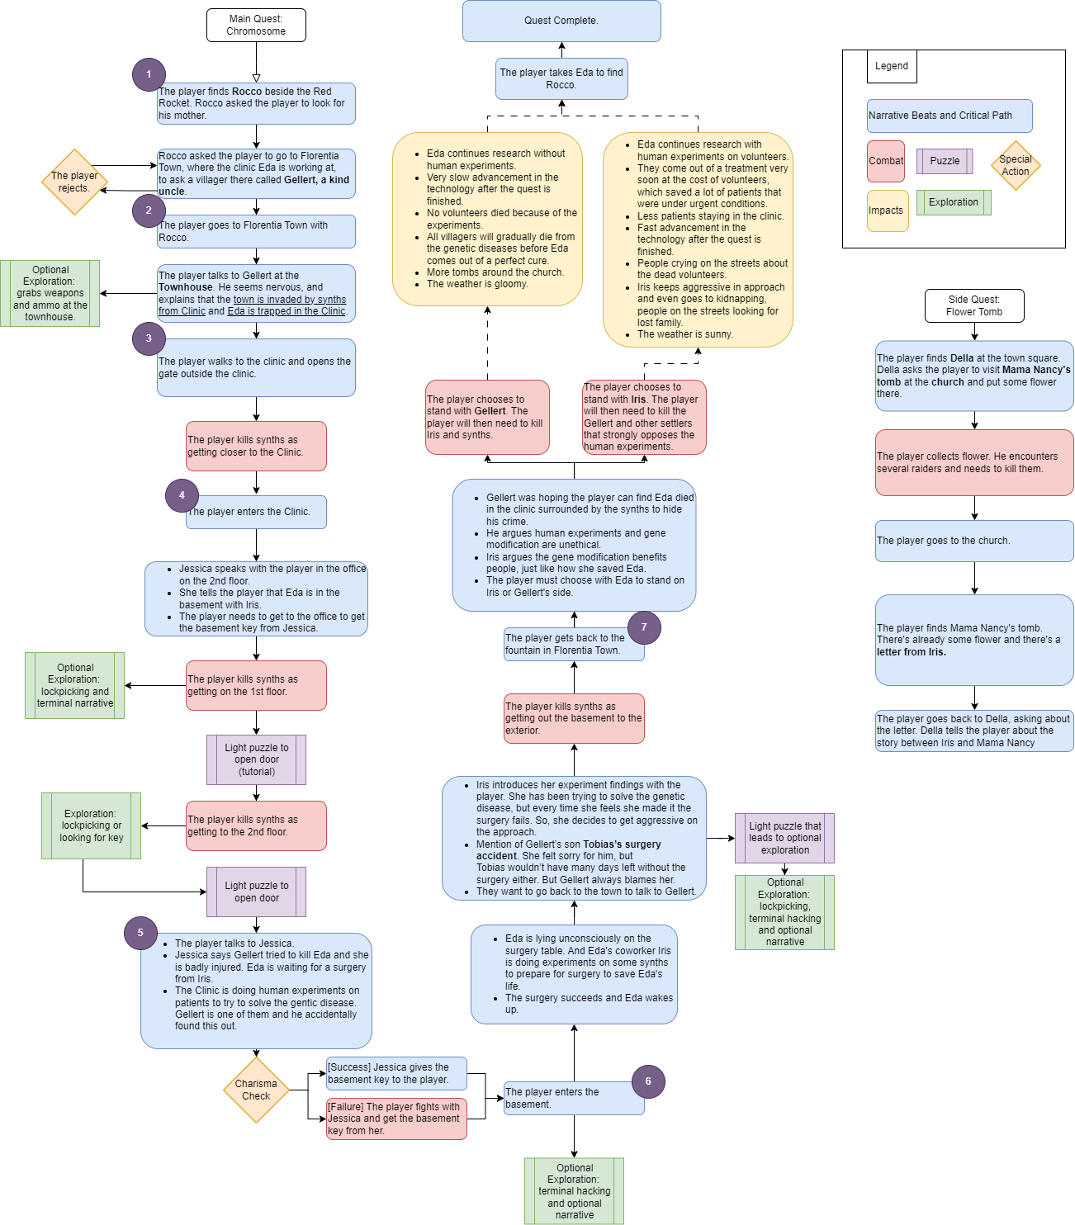
Figure 1: Narrative Flow [1]

Map Label | Gameplay Summary
1 | The player accepts quest from Rocco, a boy at Red Rocket, to look for his mother Eda.
2 | The player travels to the Florentia Town and talks to Gellert, knowing Eda is trapped in the Clinic by synths.
3 | The player enters the 1st combat before entering the Clinic.
4 | The player enters the Clinic, talks to Jessica.  The player kills synths on the 1st floor, explores the rooms, and gets to the 2nd floor.
5 | The player gets the basement key from Jessica and enters the basement.
6 | The player meets Eda and Iris, learning about the truth for the synth attack and human experiments.  The player kills synths to get out of the Clinic.
7 | The player goes back to the town, confronts Gellert with Eda and Iris.  The player makes a choice on standing with Gellert or Iris and kills the other side.

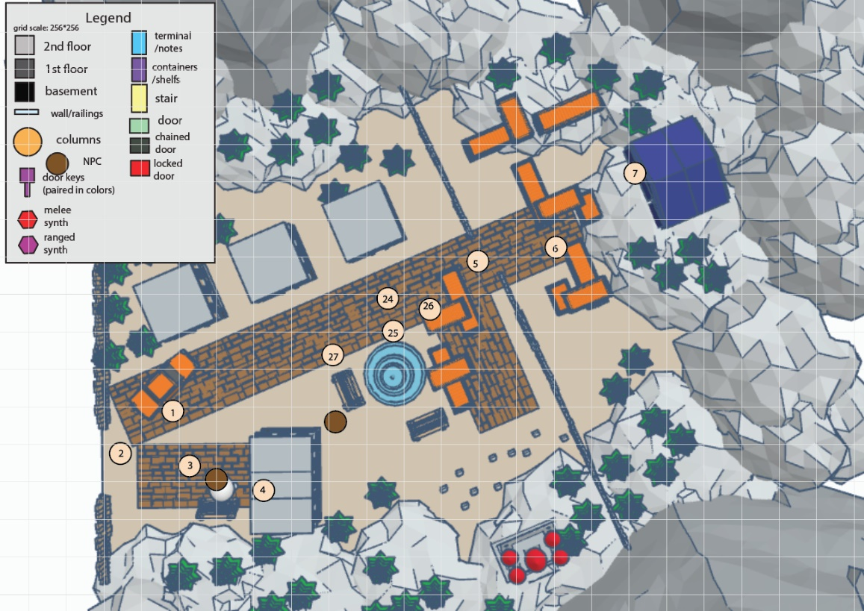
Figure 2: Exterior Map Overview [2]
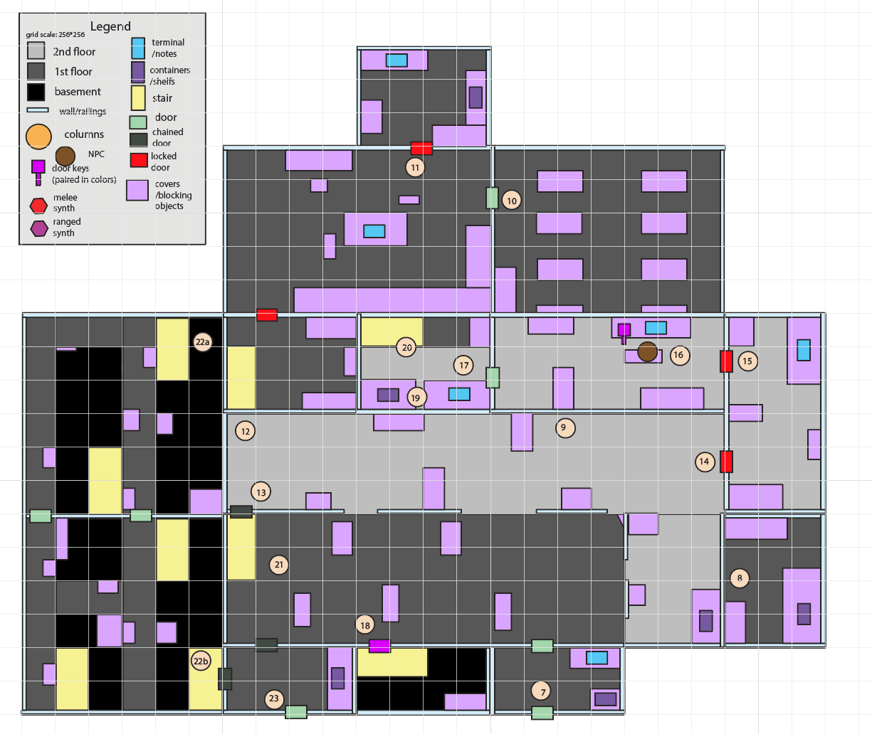
Figure 3: Interior Map Overview [3]

Level Details

Detail Maps

Exterior Section 1
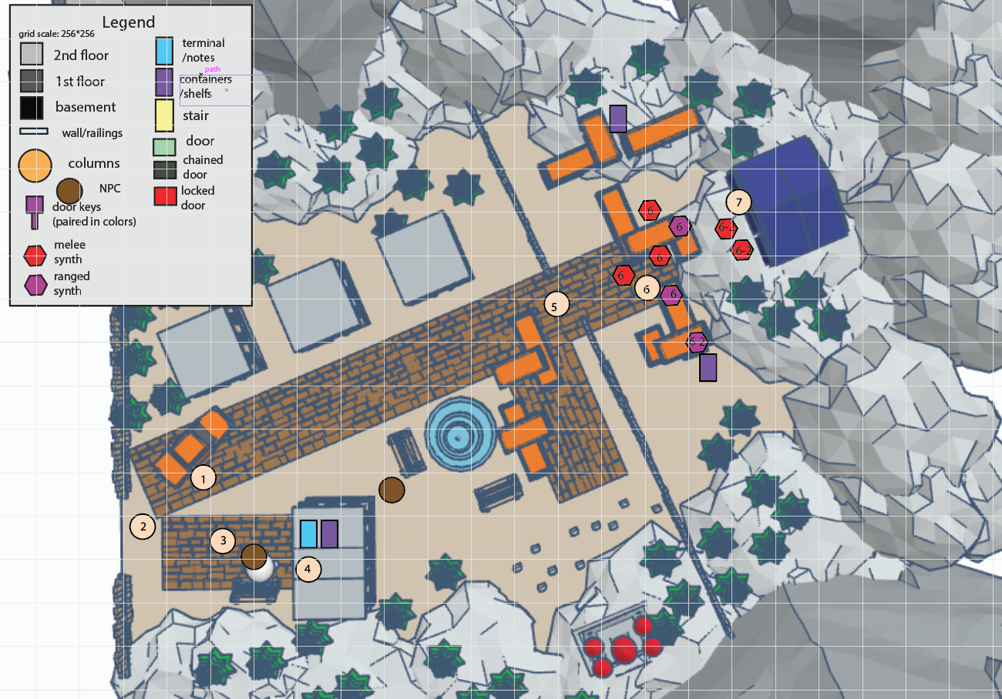
Figure 4: Exterior Section 1 [2]
Map Label / Stage |  | Event Summary | Event Details
0 | 0 | Quest Setup | - The player hears a radiocasting from Gellert that is asking for help to save his friend Eda.  - Gellert lives in Florentia Town where the player needs to get to the Pier first.  - [Quest Accepted] after hearing the complete radiocasting.
1 | 20 | Travels to Pier to Florentia. | - The player fast travels to Pier to Florentia.
2 | 40 | Travels to Florentia Town. | - The player teleports to Florentia Town through the boat.
3 | 60 | Talk to Gellert. | - The player talks to Gellert sitting at the Town Square. Gellert is anxious and worried.  - He explains to the player that Iris, as the Clinic director, is conducting research on treating the genetic disease that has a long history among the town people.  - Gellert’s missing friend, Eda, is a 3rd generation synth in the Clinic that Iris uses as test subject. He got to know Eda when she was free from the experiments, and they became good friends soon after they met.  - Gellert hadn’t seen Eda for a long while, and he had heard from other town people that Eda was imprisoned by Iris. He requested the player to find it out since his condition is getting worse because of the disease and is not able to move a lot.  - Gellert also mentioned that in his house there are some weapons and ammos that the player can pick up before going to the Clinic.
4 | 80 | [Optional] Grab supplies. | - [Optional] The player grabs weapons and ammo in the house following Gellert’s advice.  - switchblade*1, 10mm Pistol*1, 10mm round ammo*30, Stimpak *2.  - [Optional] From a terminal there, the player can learn about the town's history: Florentia Town has a history of genetic disease after the war. Settlers had been looking for treatments desperately for a long time.  - [Optional] Gellert’s diary: supplemental stories between Gellert and Eda.
5 | 100 | Get to the Clinic Gate. | - The player walks to the clinic and opens the gate outside the clinic.
6 | 120 | Kill the synths. | - The player kills synth as getting closer to the Clinic. (2nd generation synth, listen to Iris command, attacking the player because Iris knows the player is here to save Eda.)  - 1st wave: 3 melee synths with blades, 2 ranged synths with laser gun. Spawn upon interaction with the gate at step 4.  - 2nd wave: 2 melee synths with blades, 1 ranged synth with laser gun. Spawn upon entering the range of the front door.  - Stealth and Sniper options will be provided to get across the first wave. Both lead to the Clinic door, where the 2nd wave will start fighting as the player approaches.  - [Stealth] Stimpak*2, 10mm round ammo*30. On the right, move around the construction and reach the clinic’s front door.  - [Sniper] Institute Laser Gun (has an aiming mod) *1, fusion cell*40. On the left, get inside the construction and reach the clinic’s front door.
7 | 140 | Enter the Clinic. | - N/A

Interior Section 1
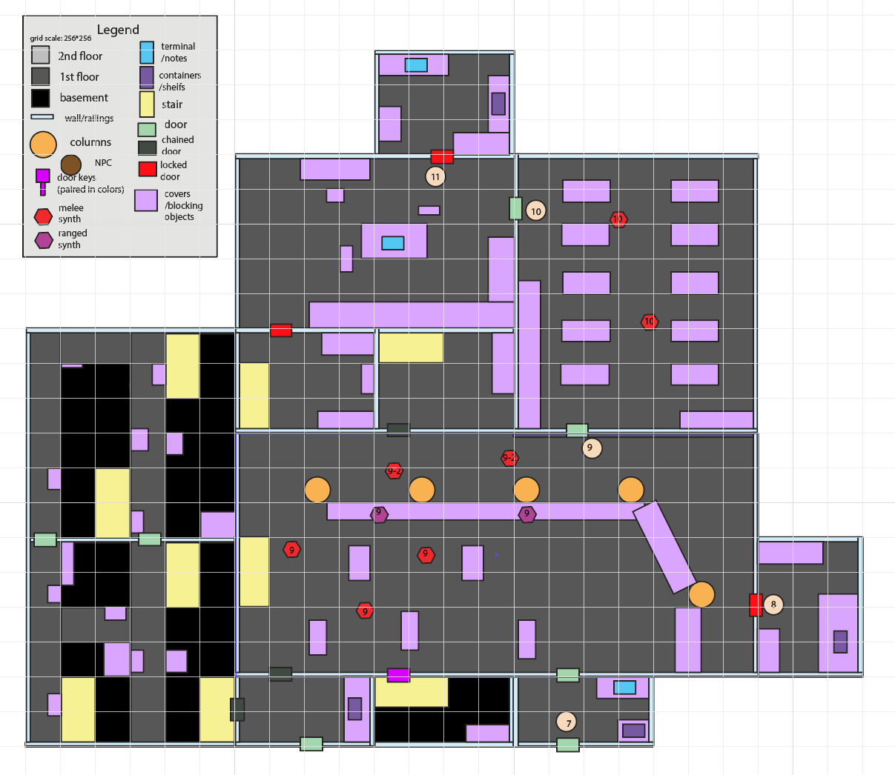
Figure 5: Interior Section 1 [3]
Map Label / Stage |  | Event Summary | Event Details
7 | 140 | Enter the Clinic. | - The player enters the Clinic.  - [Optional] 2 Stimpaks, fusion cell*30, 10mm round ammo*30 provided on the shelf.  - [Optional] There’s a terminal at the interior entrance that includes some notes (opinion book) from patients about their genetic diseases. (villager’s gratitude towards Iris.)  - Iris speaks with the player asking why they are here in the office on the 2nd floor when the player enters the hall.  - As the player explains he is here to find Eda for Gellert, Iris tells the player that Eda is now the key to her research, and they cannot take Eda away.  - Iris walks into the 2nd floor office.
8 | 160 | [Optional] Grab Supplies from the Wareroom. | - [Optional] Exploration room that requires lockpicking. Key is somewhere around the closets in the hall.  - [Optional] 2 Stimpaks, fusion cell*30, 10mm round amm*30 provided on the shelf.
9 | 180 | Get to the Patients’ Room. | - The player needs to kill the synths in the hall and on the 2nd floor, then gets to the Patients’ Room.  - 1st wave: 3 melee synths with blades on the 1st floor, 2 ranged synths with laser gun at catwalk. Spawn upon entering the hall at a short delay.  - 2nd wave: 2 melee synths with blades on the 1st floor. Spawn upon finishing the 1st wave.
10a | 200 | Get to the Operating Room | - The player needs to kill the synths in the Patient’s Room to get to the Operating Room (a place for surgeries).  - There are some dying patients in the Patient’s room, hoping Iris got progress in her research so they can live longer.  - 1st wave: 2 melee synths with blades on the 1st floor. Spawn upon entering the room after a short delay.  - [Optional] Notes about surgery documents, recording strange symptoms after patients accepting surgeries.
10b | 210 | [Optional] Access the Terminal. | - The player can only lockpick this locked door at this moment. (The door key is on Iris, which the player can get after standing with Iris at the quest end).  - The player can talk to Jessica (beside the terminal door), a 3rd generation synth test subject that also is a lab worker in the Clinic. She showed empathy on the other 3rd generation synths because they don’t have freedom and keep losing memories, expressing the idea of if the research stops, they can have freedom, and they don’t want saving the human’s life becomes the purpose of their lives.  - [Optional] More detailed notes about the human experiments conducted through the surgeries in a safe or on the table.  - [Optional] 2 Stimpaks, fusion cell*30, 10mm round ammo*30 provided on the shelf.  - [Optional] A letter from Mama Nancy to Iris, saying that she’s seriously sick because of the genetic disease, and this might be the last correspondence between them, she hoped everything is going on well for Iris. (Side quest info foreshadowing, doesn’t affect anything).
11 | 220 | Open the Door. | - Terminal door.  - [Tutorial for the light puzzle.] The player interacts with the terminal to open the door towards the 2nd floor.  - [hacking & password on the table in the room]

Interior Section 2
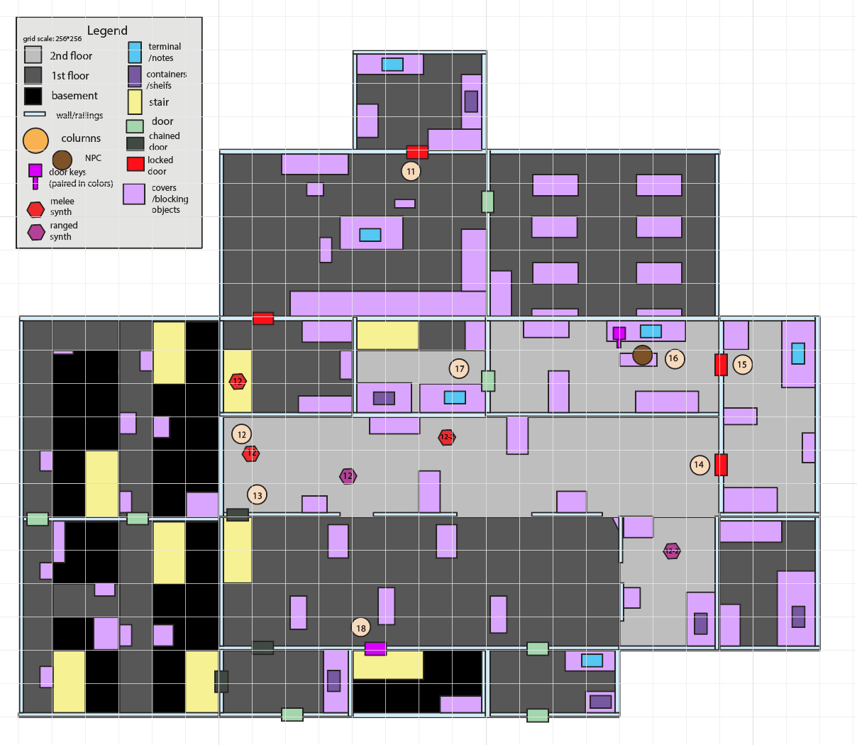
Figure 6: Interior Section 2 [3]
Map Label / Stage |  | Event Summary | Event Details
11 | 220 | Open the Door. | - N/A
12 | 240 | Get to the 2nd Floor. | - Synths will come from the room and 2nd floor.  - 1st wave: 2 melee synths with blades on the 1st floor, 1 ranged synth with laser gun on the 2nd floor. Spawn upon interaction with the door (exiting the operation room).  - 2nd wave: 3 ranged synth with laser gun on the 2nd floor. Spawn upon entering 2nd floor.
13 | 260 | [Optional] Open the Chained Door. | - Create a shortcut from 1st floor to 2nd floor.
14 | 280 | Go to the Clinic Office. | - Continue the combat.  - A main stage objective showed up after the player talking to Jessica at step 7.  - The clinic door is locked, forcing a lockpicking. And there is also a secret key hidden at the end of the hallway.  - On a shelf: fusion cell*40, 10mm round ammo*30, Stimpak *2.
15 | 300 | Open the Door. | - [Light puzzle] The player needs to solve a light puzzle to open the door.  - [Hacking & password]
16 | 320 | Talk to Iris. | - The player talks to Iris asking about why Eda cannot have freedom.  - Recently Iris has succeeded in a simulation experiment on Eda. To replicate the result on humans, Iris needs to permanently shut down Eda and extract the biological unit in her body, which means Eda will “die”. Eda rebelled so Iris imprisoned her.  - [Charisma Check] on player persuading Iris Eda should have her own life.  - [Success] Iris showed some sympathy and recalled her friendship when Eda was created. Eda was the first 3rd generation synth she created.  - [Failure] Synths are created by humans so they should serve humans. What about the town people’s life?  - Iris walked into the stair room [door locked -> unlocked]. Objective on step 18 is shown.
17 | 340 | [Optional] Access the Terminal. | - A terminal that requires hacking.  - On a shelf: fusion cell*40, 10mm round ammo*30, Stimpak *2.  - [Optional] Genetic modifications are becoming mature to treat genetic diseases under Iris’s lead. To further advance the findings, the Institute supports Iris’s decision to open a clinic and find patients to do human experiments. (Background for the relationship between the clinic & the Institute.)
18 | 360 | Get to the Basement. | - A main stage objective showed up after step 16.  - The player gets to the basement by stairs.  - [Optional] The player opens the chained door on the first floor to create a shortcut to the hall.

Interior Section 3
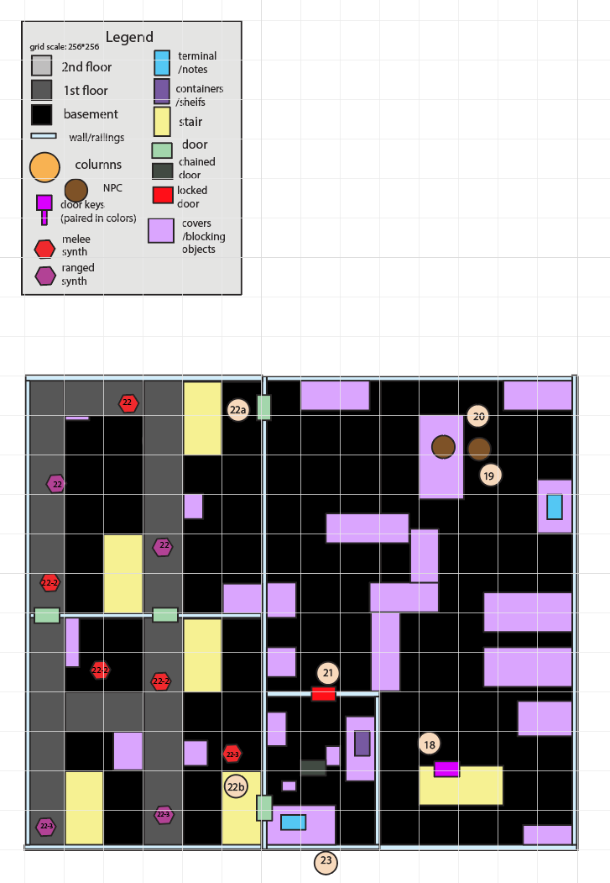
Figure 7: Interior Section 3 [3]
Map Label / Stage |  | Event Summary | Event Details
18 | 360 | Get to the Basement. | - N/A
19 | 380 | Kill the Synths. | - There are more synths out in the basement. Iris doesn’t want the player to reach Eda.  - Combat leads the way to the Iris’ lab.  - 1st wave: 1 melee synth with blades on the 2nd floor, 2 ranged synths with laser gun on the 2nd floor. Spawn upon entering the room.  - 2nd wave: 1 melee synth with blades on the 1st floor, 2 melee synths with laser gun on the 2nd floor. Spawn upon 1st wave cleared.  - 3rd wave: 1 melee synth with blades on the 1st floor, 2 ranged synth with laser gun on the 2nd floor. Spawn upon entering the next room.
20 | 400 | Talk to Iris. | - In the basement the player meets Eda in a jail room, and several 3rd generation synths around her, but afraid of Iris.  - The player mentions Gellert’s worrying about Eda and Eda becomes excited and begs Iris to let her see Gellert once more before dying.  - Iris agreed, they want to go back to the town to talk to Gellert.
21 | 420 | [Optional] Check the terminal. | - [Optional] Eda’s diary. Good memory with Iris, and how their relationship changes, how she met Gellert after that, how their friendship had developed.  - [Optional] Villagers’ letters asking about what they can help with the research.
22 | 440 | [Optional] Go to Iris’s Office. | - Exploration room that requires lockpicking. Can also be accessed through entering a password on the terminal outside the room.  - There’s a light puzzle in the room, leading to some secret entry in the terminal.  - [Optional] 2 Stimpaks, fusion cell*30, 10mm round ammo*30 provided on the shelf.  - [Optional] Iris terminal keeps a work diary and archives her letters. Noted down her 3rd generation synths that died / experienced bad things after the experiments. She was at first hesitant but persuaded herself to keep away from emotions for the sake of technological advancement. The letters are between her and her family during the past 10 years.
23 | 460 | Leave the Clinic. | - The player grabs the supply and exits the Clinic through the doors.  - On a shelf: fusion cell*40, 10mm round ammo*30, Stimpak *2.

Exterior Section 2
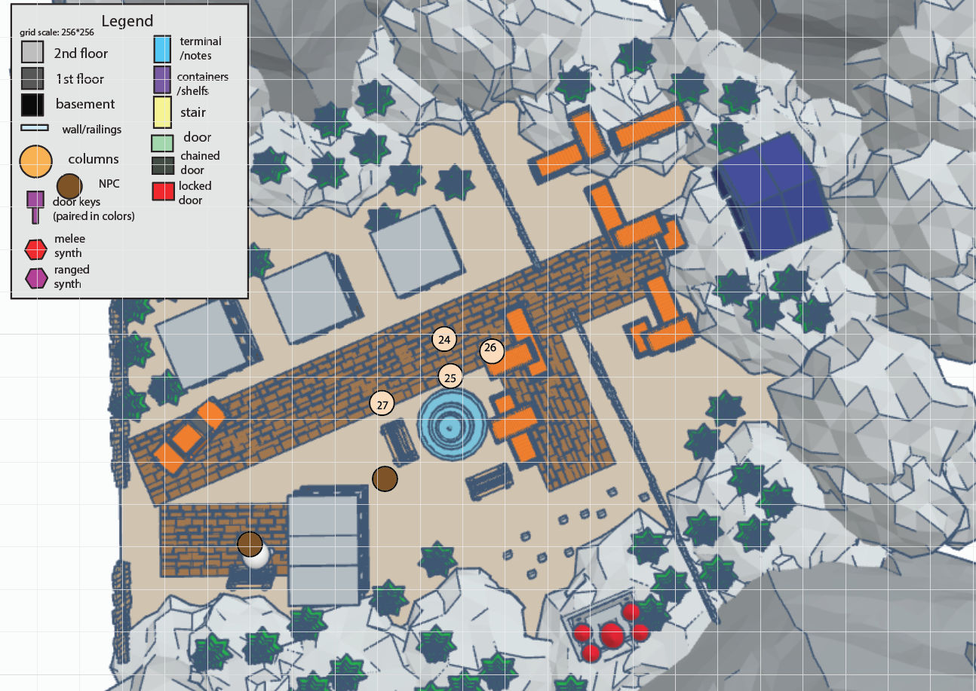
Figure 8: Exterior Section 2 [2]
Map Label / Stage |  | Event Summary | Event Details
24 | 480 | Get Back to the Florentia Town. | - The player gets to the fountain, where Gellert is still sitting at the fountain and surrounded by some town people.
25 | 500 | Talk to Gellert. | - Iris and Eda go back to Florentia Town with the player.  - Eda is surprised by how sick Gellert is and confirms with Iris that the biological unit in her body can save Gellert’s life.  - Gellert asks what the biological unit means and refuses Eda to give up her life only because of him. He wants her to have freedom.  - Town people feel sorry for Eda, but they need her to save their lives.  - Iris mentions applying the biological unit replicant on human isn't guaranteed to cure the genetic disease, it is very possible that the unit only stretches people' lifetime for only a few years, which is still a pretty good reward to risk for, especially for those are severely sick and will die very soon.  - Eda faces a dilemma, she wants to have freedom with her other 3rd generation synth friends, but she doesn’t want Gellert to die or the town people to suffer, and most importantly, to let Iris down.  - Iris faces a dilemma, she doesn’t want to lose her 3rd generation synth friends [she allows them to keep their memories because she wants friends], but she wants Eda to stay for the biological unit so Iris can continue the research. Though Iris could possibly duplicate the experiment on a new synth but that would take longer time and the patients that are currently dying can’t wait.  - The dilemma is passed to the player to decide, the player must choose between let the 3rd generation synth stay or not.
26a | 510 | Shut down the 3rd generation synths. | - Iris and the town people thank the player for their choice.  - Iris recalls her memories with Eda and says sorry to her. Eda says goodbye to Gellert.  - Iris said the shutdown code on Eda and other rebellious 3rd generation synths.  - Iris brings Eda back to the Clinic.  - Quest Complete.
26b | 520 | Let the 3rd generation synths leave the island. | - Gellert and the 3rd generation synths thank the player for their choice.  - Gellert recalls his memories with Eda and says he is very happy to see her finally free. Eda says sorry to Iris, saying she will leave the island to see the world she hasn’t known about.  - Town people are disappointed.  - Quest Complete.
27a | 530 | Eda died. | - All the 3rd generation synths lost memories; Iris lost her friends.  - The biological unit replicant is tested to extend people’s life by 5 years.  - Gellert misses Eda badly.  - The weather is rainy.
27b | 540 | Eda left. | - Gellert dies.  - Eda creates new 3rd generation synths for experiments and cleans their memories every day.  - Some town people want to save their desperate family, so they volunteer to start human experiments.  - The weather is sunny.

Side Quest Overview
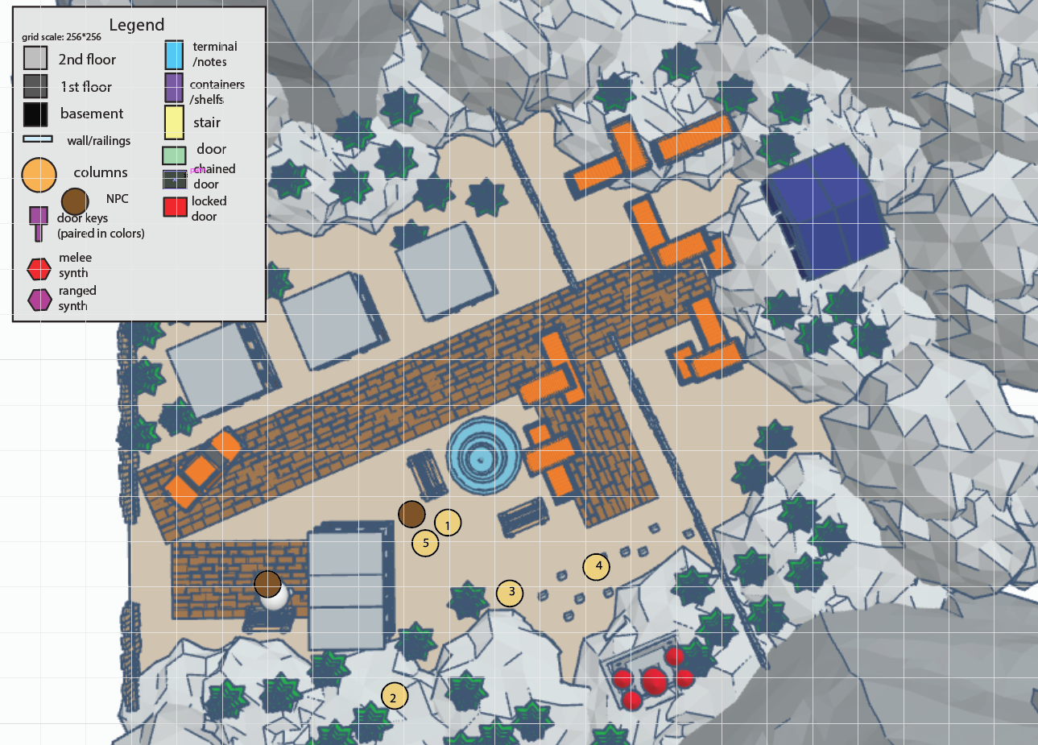
Figure 9: Side Quest Map Overview [2]
Map Label / Stage | Event Summary | Event Details
S1 | Talk to Della. | - The player finds Della at the town square. Della asks the player to visit Mama Nancy's tomb at the church (purely exterior) and put some flower there.
S2 | Get some flowers. | - The player collects flower at a place, where he encounters several raiders and needs to kill them.
S3 | Get to the Church. | - The player goes to the church.
S4 | Read the Letter. | - The player finds Mama Nancy's tomb. There are already some flowers and there's a letter from Iris, saying that she's sorry to be late. It was a pity that her original dream as a child did not come true.
S5 | Talk to Della. | - The player goes back to Della, asking about Iris's letter. Della tells the player that Iris grew up in Florentia Town but was taken away by the Institute at a very young age. Mama Nancy is Iris's mother, a very well-respected woman in the town, but died recently because of a disease that can be cured by genetic surgery.
S6 | Quest Complete. | - Quest Complete.

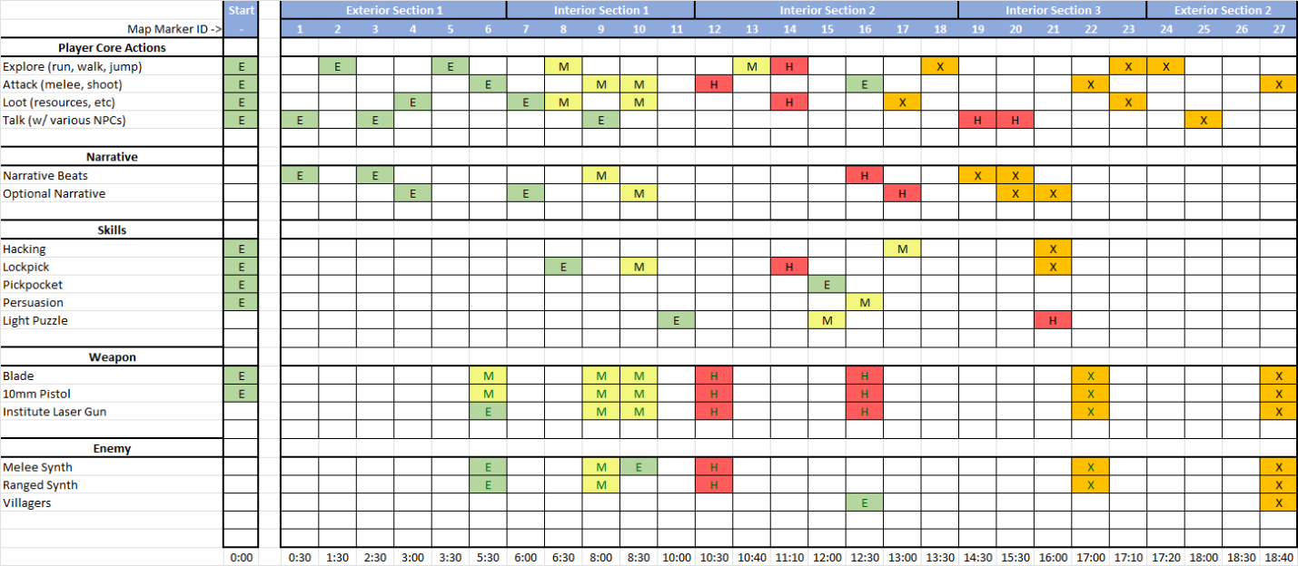
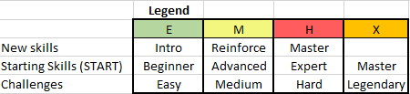
Skill Progression Chart
Figure 10: Skill Progression Chart [4]

Aesthetic References
For the exterior, Florentia Town is an old-fashioned town on an island by the sea. It has some parts that’re renaissance styled. Most of the houses there are small, shattered, and old. The town also has an old church.
Generally, the town buildings are dark-colored, with some decorations that are bright colors. And the houses have triangular roofs, like the ones in Far Harbor.
For the interior, the Clinic is a high-tech building founded by the Institute in recent years. It has many labs, offices, and machines in it.

Old Town
Figure 11: Contact Sheet for Old Town from Fallout 4 [6]
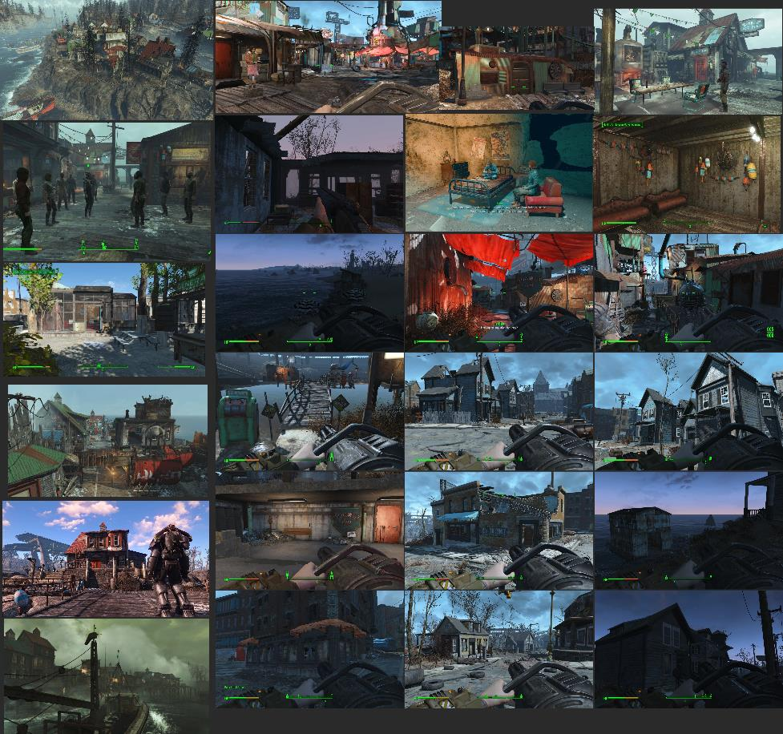
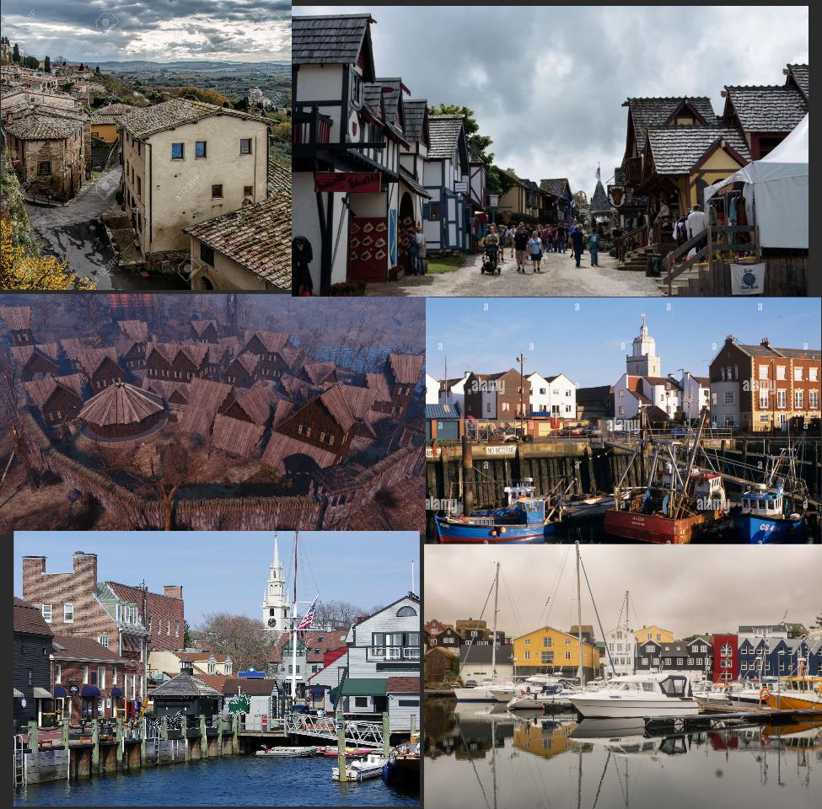
Figure 12: Contact Sheet of Old Town in Reality [7,8,9,10,11,12]
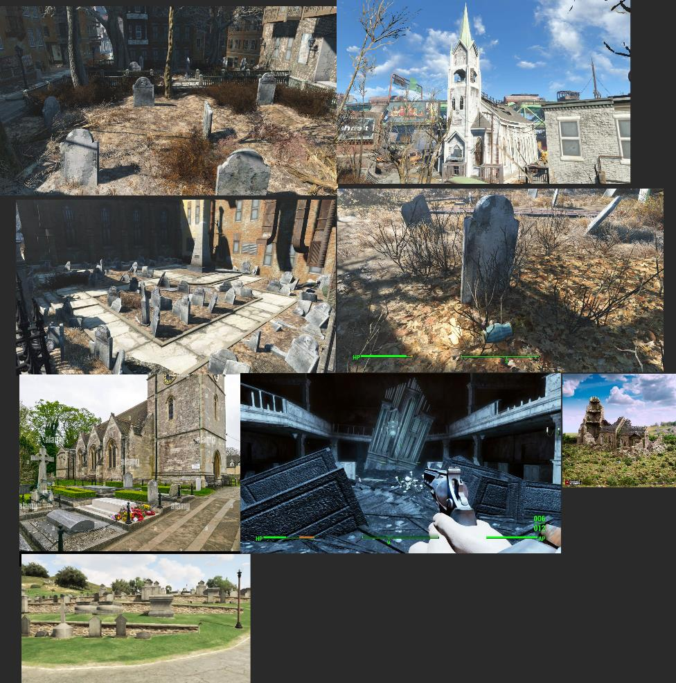
Figure 13: Contact Sheet of Old Town Church Area [6,13,14]

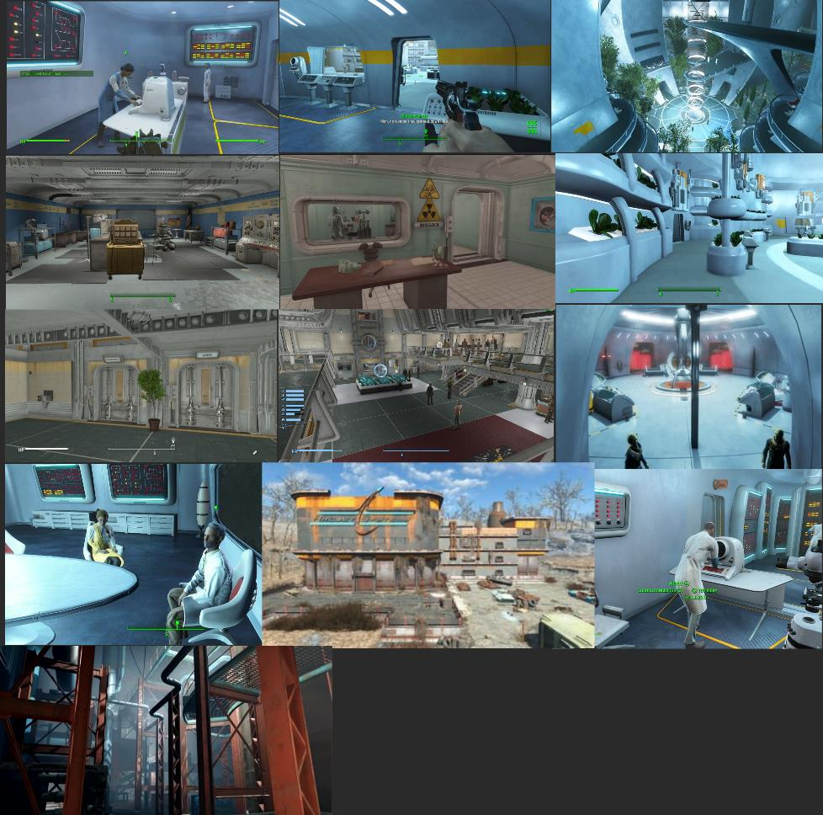
The Clinic
Figure 14: Contact Sheet for the Clinic in Fallout 4 [6]
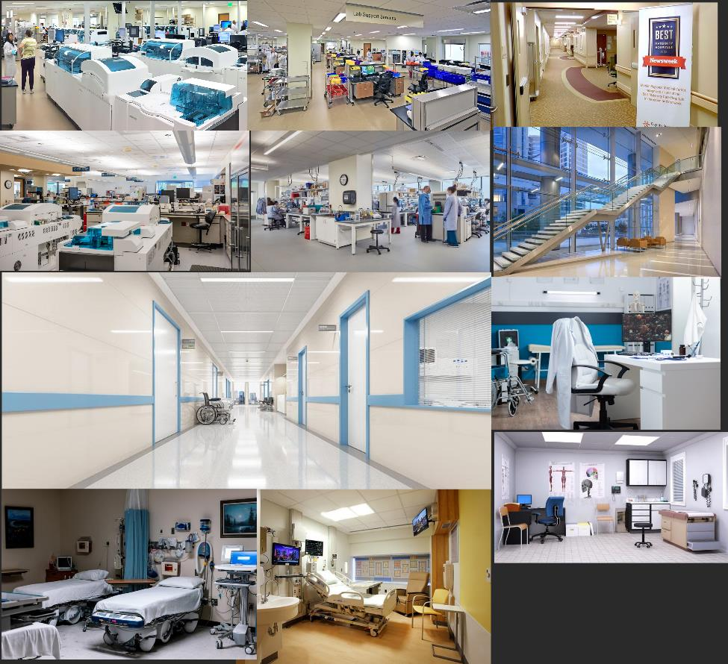
Figure 15: Contact Sheet for the Clinic in Reality [15,16,17,18,19,20,21,22,23]

References
[Cover Image] Anona Yang, Feb 7, 2024. Screenshot from Tinkercad.
[1] “Narrative Flow Charts,” Anona Yang, Feb 18, 2024. Made in draw.io.
[2] “Exterior Maps,” Anona Yang, Feb 18, 2024. Made by Tinkercad and Adobe Illustrator.
[3] “Interior Maps,” Anona Yang, Feb 18, 2024. Made by Adobe Illustrator.
[4] “Skill Progression Chart,” Anona Yang, Feb 18, 2024. Made in Excel.
[5] “Light Puzzle,” Anona Yang, Feb 18, 2024. Screenshot from Miro.
[6] “Visual References,” Anona Yang, Feb 18, 2024. Screenshots from Fallout 4.
[7] “11 most scenic Rhode Island towns,” WorldAtlas,
https://www.worldatlas.com/cities/11-most-scenic-rhode-island-towns.html (accessed Feb. 18, 2024).
[8] Richardcedwards and Richardcedwards, “Old town,” Where in the world is Riccardo?, https://richedwardsimagery.wordpress.com/tag/old-town/ (accessed Feb. 18, 2024).
[9] A. Limited, “Portsmouth Old Harbour Town camber fish docks with colourful fishing boats in water. Portsmouth Hampshire england UK stock photo,” Alamy, https://www.alamy.com/portsmouth-old-harbour-town-camber-fish-docks-with-colourful-fishing-image6820302.html (accessed Feb. 18, 2024).
[10] T. Zbrodko, “Exterior view of buildings in the medieval and Renaissance town Montepulciano
with dramatic sky. it is a hill town and comune in the Italian province of Siena.,” 123RF, https://www.123rf.com/photo_67150157_exterior-view-of-buildings-in-the-medieval-and-renaissance-town-montepulciano-with-dramatic-sky-it.html (accessed Feb. 18, 2024).
[11] “Explore great prompts.,” KREA, https://search.krea.ai/prompt/24812f7c-6f22-4393-8b94-71a1adbb6c2b (accessed Feb. 18, 2024).
[12] “The cabin in the woods at fallout 4 nexus - mods and community: Cabins in the woods,
fallout RPG, fallout settlement,” Pinterest, https://www.pinterest.com/pin/464081936603298928/ (accessed Feb. 18, 2024).
[13] “Ruined Norman church king and country printable scenery terrain wargaming d&d dnd 10mm
15mm 20mm 25mm 28mm 32mm 40mm 54mm,” Etsy, https://www.etsy.com/listing/1322017623/ruined-norman-church-king-and-country (accessed Feb. 18, 2024).
[14] Offline Forever | Cemetery Club says:, A Pause for Breath | Cemetery Club says:, and Post Apocalyptic Mourning: A Virtual Cemetery Tour in Fallout 4 | Cemetery Club says:, “Grand Theft Gravestone:- A Cemetery Club visit with a virtual twist,” Cemetery Club, https://cemeteryclub.wordpress.com/2013/10/10/dead-people-in-gtav/ (accessed Feb. 18, 2024).
[15] “Parkland Health & Hospital System,” HERA Laboratory Planners, https://herainc.com/portfolio/parkland-health-hospital-system/ (accessed Feb. 18, 2024).
[16] “Laboratory services,” Harbor Regional Health - Grays Harbor County Washington,
https://www.ghcares.org/laboratory (accessed Feb. 18, 2024).
[17] “Medical Hospital Doctor Examination Room. illustration of a doctor office or EXA , #AD, #room,
#I...: Healthcare Furniture, Hospital Furniture, medical office design,” Pinterest, https://www.pinterest.com/pin/389139224055229235/ (accessed Feb. 18, 2024).
[18] “Medical offices images - free download on Freepik,” Freepik,
https://www.freepik.com/free-photos-vectors/medical-offices (accessed Feb. 18, 2024).
[19] “Steel handrails for hospitals: Essential projects: Metal fabrication,” Essential Projects, https://www.essentialprojects.co.uk/products/stainless-steel-handrails/steel-handrails-for-hospitals/ (accessed Feb. 18, 2024).
[20] “Your hospital room,” Johns Hopkins Medicine, https://www.hopkinsmedicine.org/patient-care/patients-visitors/admission-discharge/hospital-room (accessed Feb. 18, 2024).
[21] R. Oxner, “Dozens of Texas hospitals are out of ICU Beds as covid-19 cases again overwhelm the state’s capacity,” The Texas Tribune, https://www.texastribune.org/2021/08/10/coronavirus-texas-hospitals-icu-beds/ (accessed Feb. 18, 2024).
[22] kpage_drupal, “Report: Hospitals’ margins dip again in October, signaling continued difficulties : AHA News,” American Hospital Association | AHA News, https://www.aha.org/news/headline/2022-11-30-report-hospitals-margins-dip-again-october-signaling-continued-difficulties (accessed Feb. 18, 2024).
[23] MaryBeth DiDonnaMaryBeth DiDonna MaryBeth DiDonna is managing editor, MaryBeth DiDonnaMaryBeth DiDonna MaryBeth DiDonna is managing editor, and F. Profile., “Project profile: Loyola Medicine Laboratory,” Lab Manager, https://www.labmanager.com/project-profile-loyola-medicine-laboratory-27115 (accessed Feb. 18, 2024).

Appendices

Appendix A: New Skills / Gameplay Mechanics

Light Puzzles
- The player interacts with command options provided in the terminal to change the light colors in the room. When the lights are combined into a specific color that is required, the locked door will be unlocked.
- If time allowed, will add scenes for each light color, so that combing colors also means combining a narrative scene. For example, in the picture below, the red light enables a figure and the table in the room, the blue light enables another figure and a book on the table. If the terminal describes a NPC’s memory of him discussing a book with his friend, opening both lights and turning the room under purple light will solve the puzzle.

Figure 16: Light Puzzle [5]

Terminal with Passwords
- While the terminal can directly open a locked door by a command, the command can also prompt the player to enter a password to unlock the door.
- There will be a terminal-controlled door designated for optional exploration that can be accessed by both lockpicking and entering a password from the terminal, which engages the player to find some information from the NPC through dialogue or other optional narrative.
- Just a bonus one-off to add fun into exploration.

Appendix B: Context Detail

General Context
Florentia Town has a history of genetic disease after the war. Settlers had been looking for treatments. But since the town is on an island far from the commonwealth, the cost of doing this is expensive. After trying too much fake cures and lots of people died for that, they decided to surrender to their fate. The people stayed conservative and even after the Clinic was established, they are still thinking passively about the disease and don’t want to sacrifice their current life for something new.

Backstory
Iris grew up on this island, but unlike the others, she wanted to fight against the fate. She left the island when once the Institute people came for research. In the Institute she was always passionate about healing the genetic disease, and because of her outstanding work, the Institute decided to fund her the Clinic on this island and facilitate her research on modifying human genes.

Aftermath
Eda is sad because of the loss of Iris or Gellert. Rocco will grow up and become a scientist like his mother, helping Eda continuing the research.
If the player chooses to stand with Gellert:
- Eda continues research without human experiments.
- Very slow advancement in the technology after the quest is finished.
- No volunteers died because of the experiments.
- All villagers will gradually die from the genetic diseases before Eda comes out of a perfect cure.
- More tombs around the church.
- The weather is gloomy.
If the player chooses to stand with Iris:
- Eda continues research with human experiments on volunteers.
- They come out of a treatment very soon at the cost of volunteers, which saved a lot of patients that were under urgent conditions.
- Less patients staying in the clinic.
- Fast advancement in the technology after the quest is finished.
- People crying on the streets about the dead volunteers.
- Iris keeps aggressive in approach and even goes to kidnapping, people on the streets looking for lost family.
- The weather is sunny.

Appendix C: Character Descriptions

NPC 1: Rocco
Description | 10-year-old boy, brown hair, black eyes.
Background | N/A
Goals/Motivation | Become a scientist that can help people.
Personality/Archetype | Considerate and clever.
Relationships | Eda’s son.

NPC 2: Eda
Description | Brown hair reaches shoulder, blue eyes, a gentle woman.
Background | Well raised in a scientist family, keeps the reverence for science all the time.
Goals/Motivation | Helping people in a way that’s ethic and supported by them.
Personality/Archetype | Kind-hearted, indecisive.
Relationships | Rocco’s mother. Iris and Jessica’s coworker. Gellert’s friend.

NPC 3: Iris
Description | Black female, sharp face, with glasses, black eyes, and short hair.
Background | Iris grew up on the island, but unlike the others, she wanted to fight against the fate. She left the island when once the Institute people came for research. In the Institute she was always passionate about healing the genetic disease, and because of her outstanding work, the Institute decided to fund her the Clinic on this island and facilitate her research on modifying human genes.
Goals/Motivation | Find a way to cure the genetic disease, especially her parents.
Personality/Archetype | Persistent, but stubborn.
Relationships | Eda and Jessica’s coworker.

NPC 4: Gellert
Description | 50 years old male. Black hair, brown eyes, strong.
Background | Gellert has a son named Tobias that died several years ago in a surgery conducted by Iris, because the technology isn’t mature enough. He always blames Iris for this.
Goals/Motivation | Stop human experiments and any other immature medications.
Personality/Archetype | Rough but not tough.
Relationships | Eda’s friend.

NPC 5: Jessica
Description | Blonde long hair female.
Background | N/A
Goals/Motivation | Help Iris.
Personality/Archetype | Timid.
Relationships | Eda and Iris’s coworker.

NPC 6: Della
Description | Young female with red hair, in dresses.
Background | N/A
Goals/Motivation | She misses Mama Nancy a lot.
Personality/Archetype | Passionate.
Relationships | N/A

Appendix D: Dialog Flow

Step 0-2: Rocco
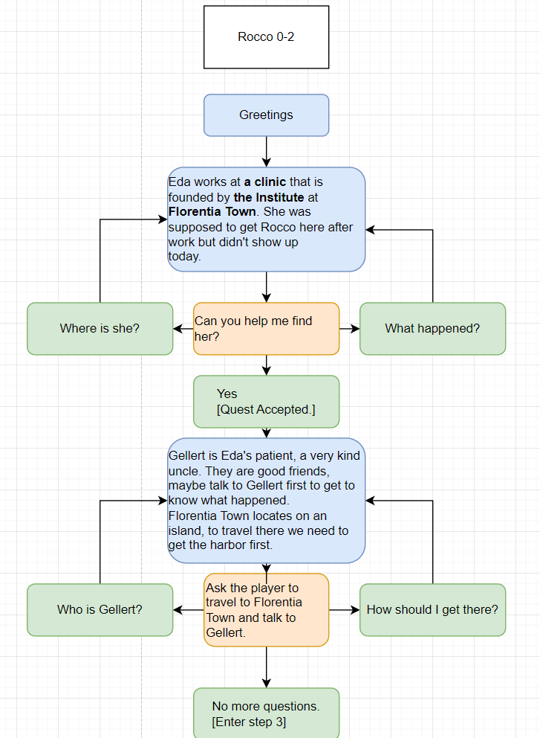
Figure 17: Dialog: Rocco, Step 0-2 [1]

Step 3-4: Gellert
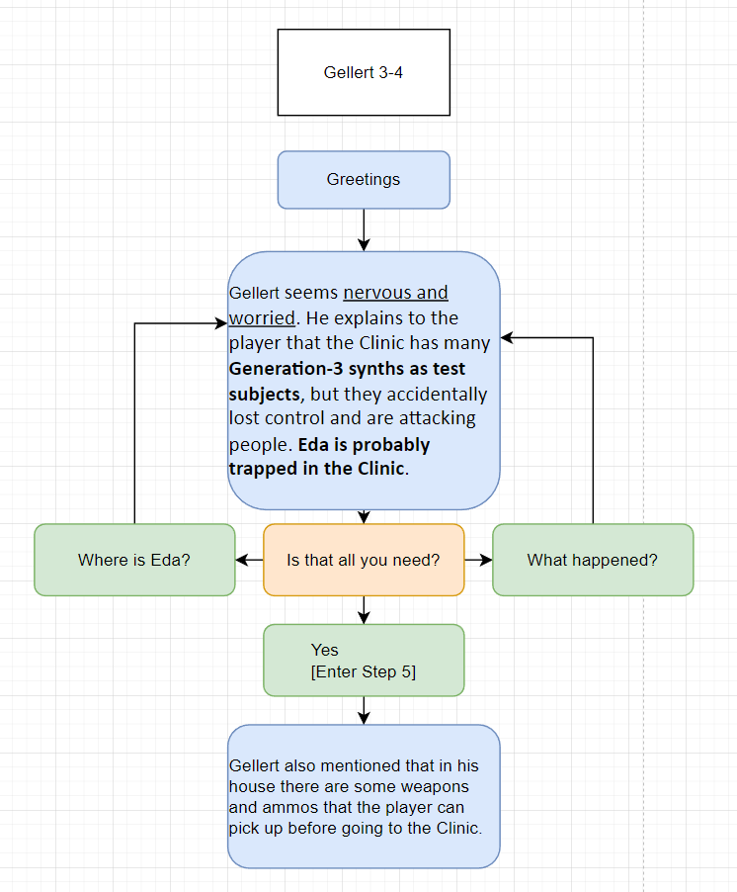
Figure 18: Dialog: Gellert, Step 3-4 [1]

Step 9: Jessica
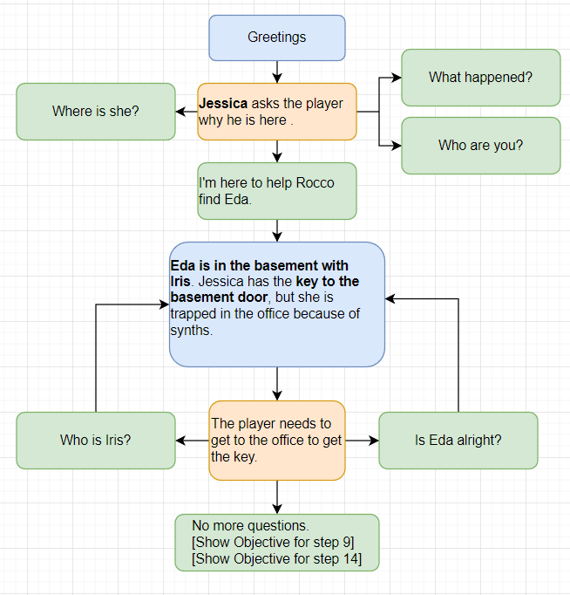
Figure 19: Dialog: Jessica, Step 9 [1]

Step 16: Jessica
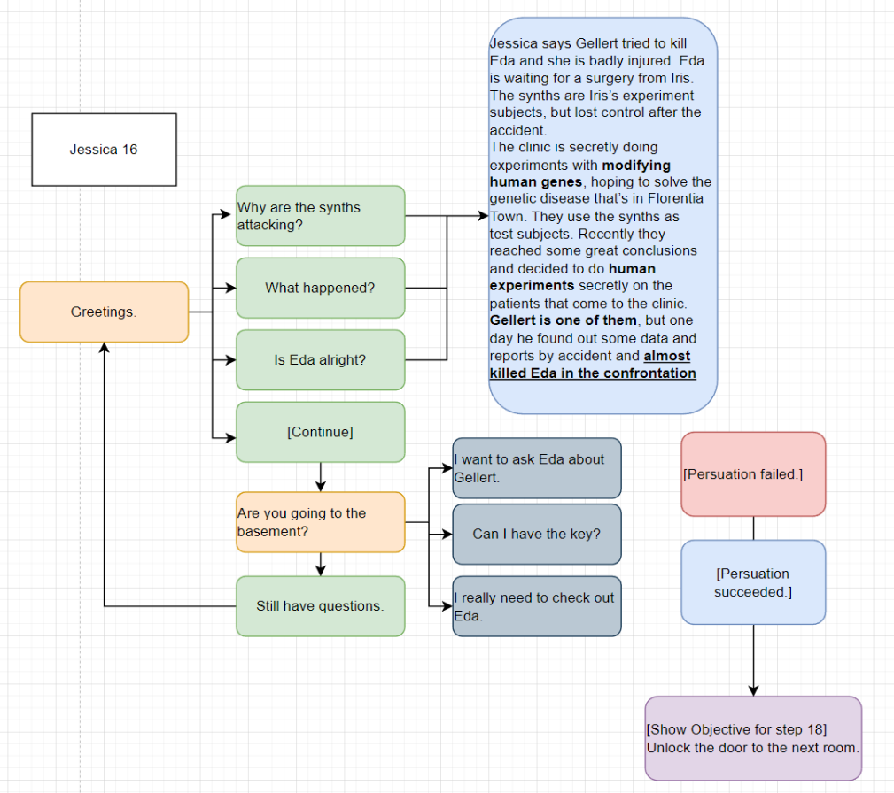
Figure 20: Dialog: Jessica, Step 16 [1]

Step 19-20: Iris, Eda
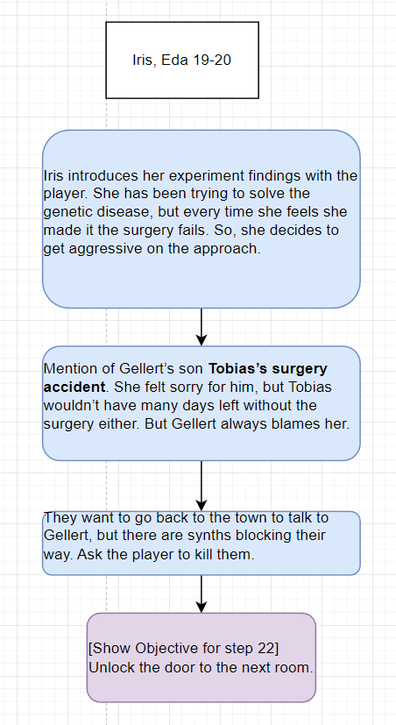
Figure 21: Dialog: Iris and Eda, Step 10-20 [1]

Step 25-26: Gellert, Iris, Eda
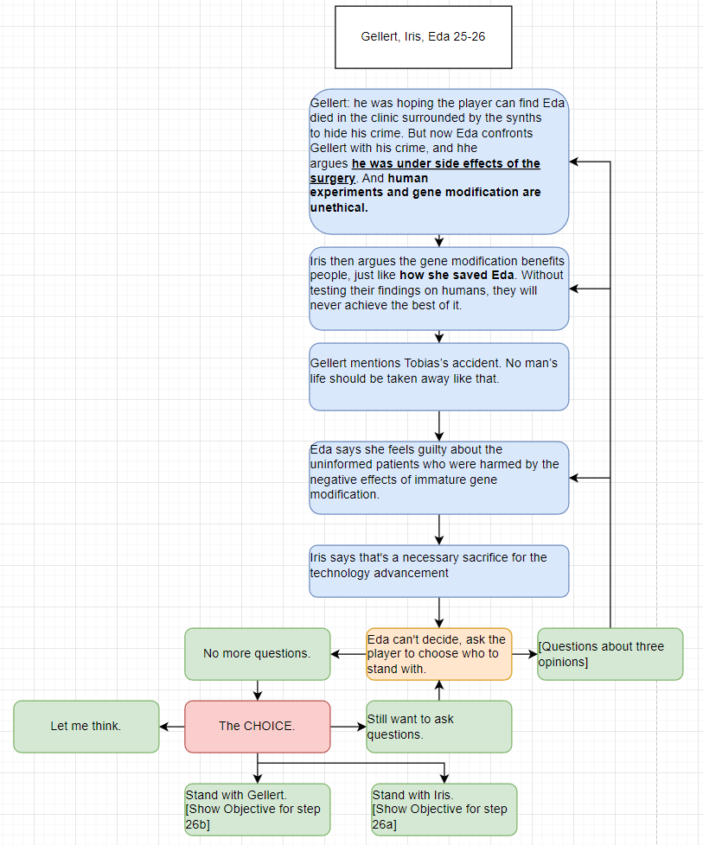
Figure 22: Dialog: Gellert, Iris, and Eda, Step 25-26 [1]

NPC 1: Rocco
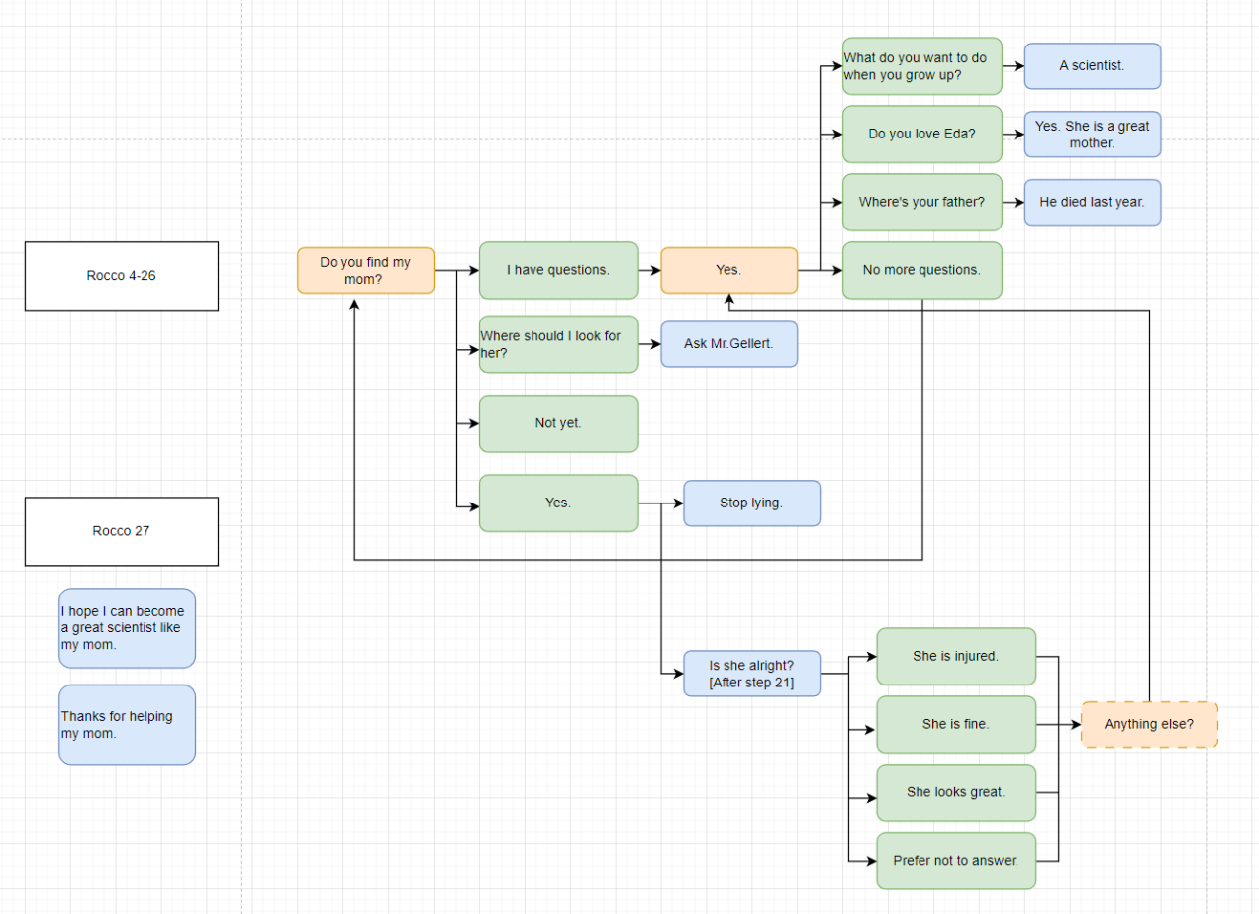
Figure 23: Dialog: Rocco [1]

NPC 2: Eda
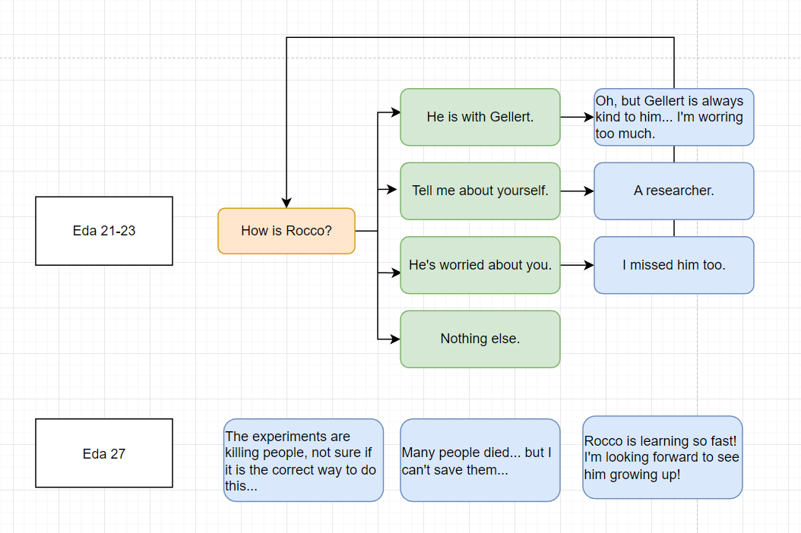
Figure 24: Dialog: Eda [1]

NPC 3: Iris
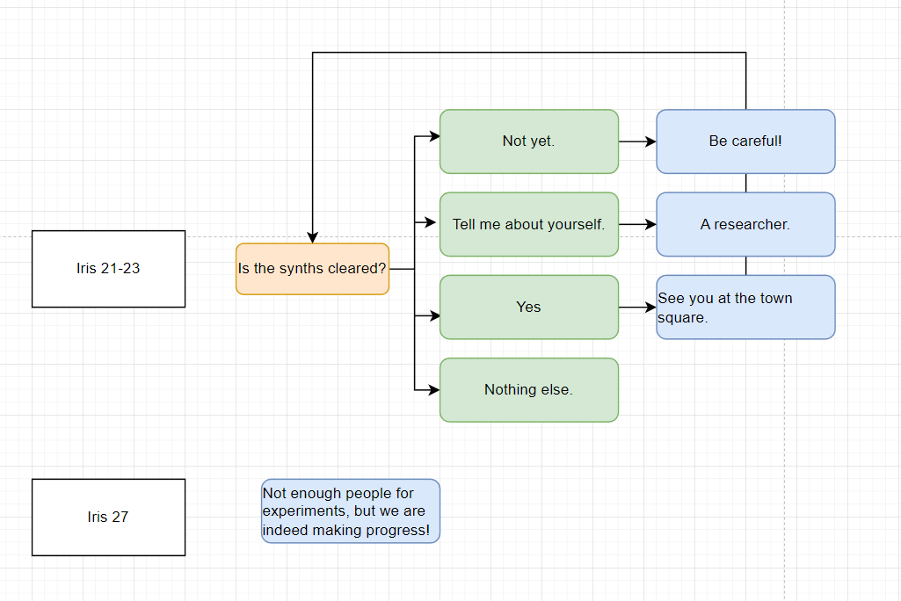
Figure 25: Dialog: Iris [1]

NPC 4: Gellert
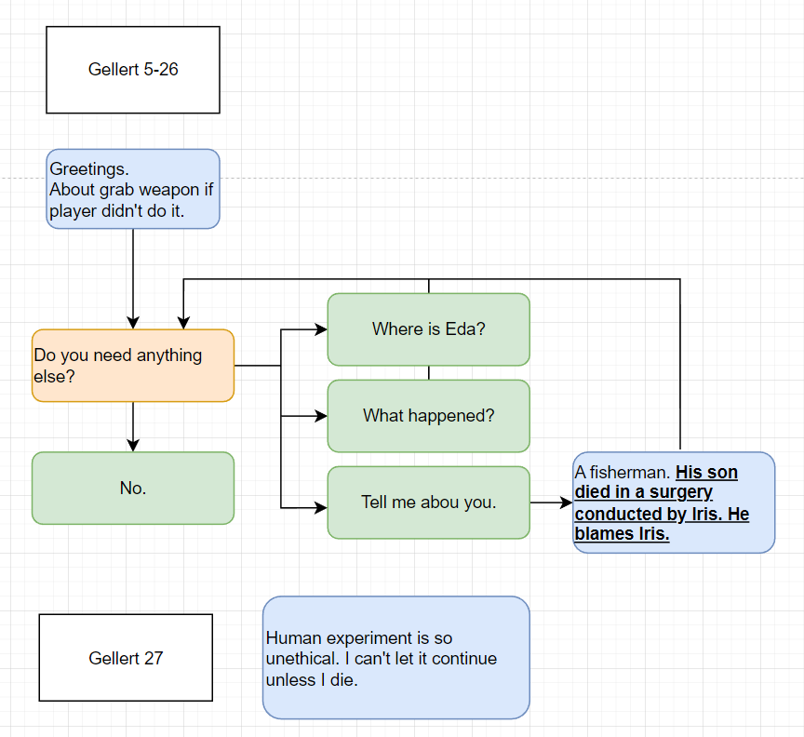
Figure 26: Dialog: Gellert [1]

NPC 5: Jessica
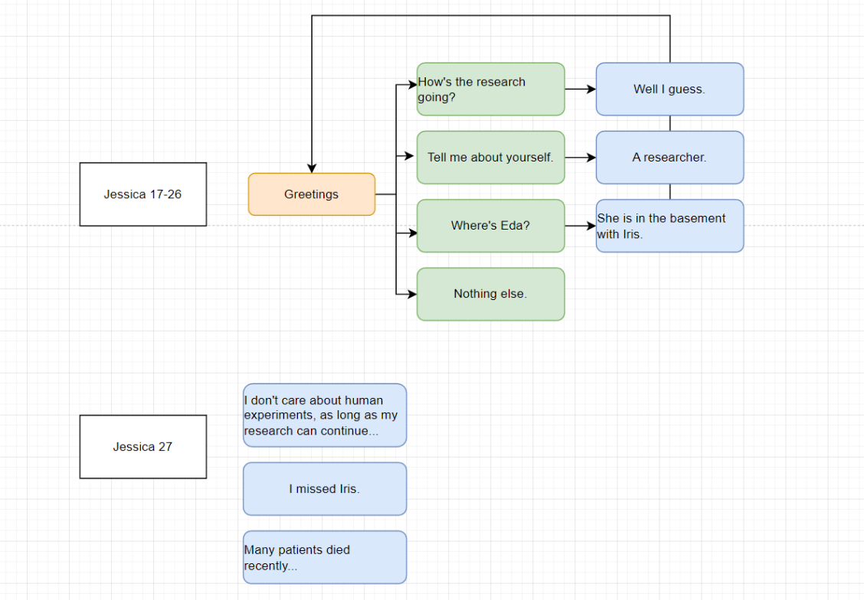
Figure 27: Dialog: Jessica [1]

Side Quest: Della
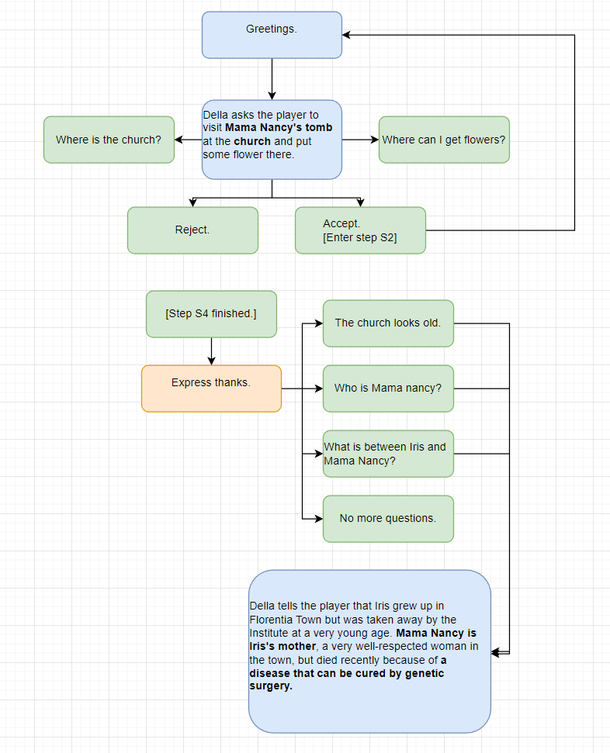
Figure 28: Dialog: Della [1]

Appendix E: Development Risks
Map Label | Description/Mitigation | Type | Priority
20 | Cinematic moment of Eda waking up after the surgery. | Dialogue | Medium
21 | Password implementation in terminal. | Script | Low
11,15,21 | Light puzzle with scenes implemented. | Script | Medium
26 | Exterior combat set up with covers, while not blocking sightline. | Mesh | High

Appendix F: Key Asset Needs
Description | Type | Priority
Harbor with a ship | Mesh Scene | Medium
Island with a Valley | Landscape | High
Townhouse with at least two exits | Mesh Scene | High
Church and tombs | Mesh | Medium
Clinic Gate | Mesh Scene | High
Staircases as combat area | Mesh Scene | High
Clinic Building and a landmark | Mesh Scene | High
Fountain landmark | Mesh | Medium
Combat area around the fountain | Mesh Scene | High
Clinic Hallway (1st+2nd floor) | Mesh Scene | High
Clinic Patient’s Room | Mesh Scene | High
Clinic Operation Room | Mesh Scene | High
Clinic 1st Office | Mesh Scene | Medium
Clinic Wareroom | Mesh Scene | Low
Clinic 2nd Office (3 rooms) | Mesh Scene | High
Basement Lab | Mesh Scene | High
Basement Office | Mesh Scene | Medium
Basement Combat Area (2 rooms) | Mesh Scene | High
Exit Room | Mesh Scene | Medium
Melee Synth | Enemy | High
Ranged Synth | Enemy | High
Raider | Enemy | Medium
Rocco | NPC | High
Gellert | NPC and Enemy | High
Jessica | NPC and Enemy | High
Eda | NPC and Friendly | High
Iris | NPC and Enemy | High
Della | NPC | High
Villager with random dialogues | NPC and Enemy | High
Doors (lockpicking, chained, required keys or terminals) | Interactable | High
Terminals (puzzle, password, optional narrative) | Interactable | High
Letters and Notes | Collectable | High
Shelves and Containers with supplies | Collectable | High
Secret Collectable (TBD) | Collectable | Low
Pickable Flower | Collectable | Medium

