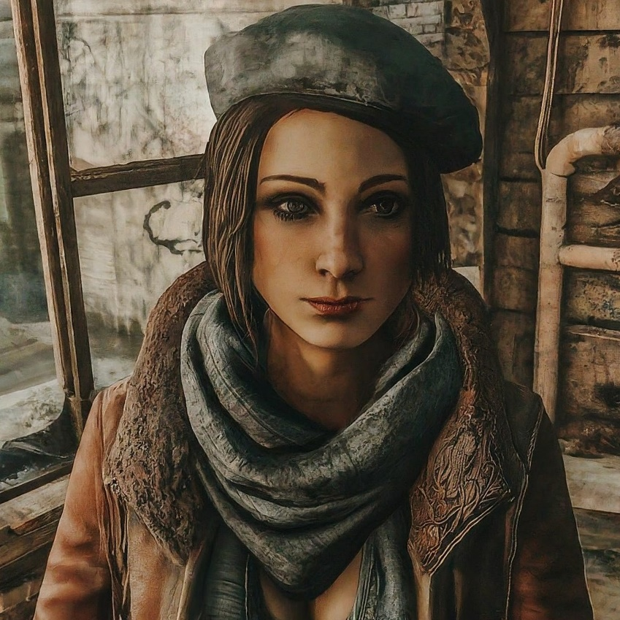

Fallout 4: “Towards the Dark”
  - Version 1.0
Designer: | Anona Yang
Document Date: | 05/21/2024
Intended Level Delivery Date: | 07/14/2024

Document Revisions Table
Version | Description | Requestor | Date
1.0 | Initial Document | Professor Brandon Stephens | 05/21/2024

Table of Contents
Table of Contents 2
Table of Figures 3
Level Summary 4
Quick Summary 4
Level Feature Overview 4
Development Schedule 4
Level Overview 6
Overview Map 6
Level Details 8
Detail Maps 8
Combat Rooms - Small 8
Combat Rooms - Medium 9
Combat Rooms - Large 10
Other Rooms – Start, Exit, Vendor 11
Aesthetic References 12
References 13
Appendices 14
Appendix A: New Skills / Gameplay Mechanics 14
Difficulty Calculation and Game Balance (subject to change in development) 14
Resource Economy (subject to change in development) 14
Buff List 15
Appendix B: Context Detail: N/A 16
General Context 16
Backstory 16
Aftermath 16
Appendix C: Character Descriptions: N/A 17
NPC 1: N/A 17
Appendix D: Dialog Flow: N/A 18
NPC 1: N/A 18
Appendix E: Development Risks: N/A 19
Appendix F: Key Asset Needs: N/A 20

Table of Figures

Figure 1: Overview Map and Legends [1] 6
Figure 2: Combat Rooms – Small [1] 8
Figure 3: Combat Rooms – Medium [1] 9
Figure 4: Combat Rooms – Large [1] 10
Figure 5: Other Rooms – Start, Exit, Vendor [1] 11
Figure 6: Contact Sheet [2] 12

Level Summary

Quick Summary
“Towards the Dark” is an independent level in Fallout 4. It is a rogue-like level that the player dives into Sonia’s dreams, as if she is a synth produced in the institute lab and is trying to escape the place. The player will start the level with an empty inventory, earn caps by killing enemies and completing random room challenges, buy better weapon and buffs at vendors, and fight a boss at the end.

Level Feature Overview
Category | Sub-Category | Feature List
Player | Player Weapons | - Given to the player at 1st round beginning: 10mm pistol, Baton.  - At vendor: Institute Laser Gun, Combat Shotgun, Minigun  - Grenade: baseball grenade, Molotov cocktail, nuka grenade, plasma grenade
 | Player Skills/Abilities | - Combat: melee, short ranged, medium ranged  - Resource Planning: buy weapons, ammos, buffs from the vendor and save money for the next round
AI | Enemies | - Melee Synths  - Ranged Synths  - Turrets  - Boss Synth
 | Friendlies | - Vendor NPCs (lab workers)
Challenges | Gameplay Themes | - Combat  - Manage Resources  - Fragmented Narrative (see if time allows)
 | Obstacles/Hazards | - N/A
 | New/Unique Gameplay | - Random room spawning, random rewards
Context | Where Fits in Game | - Independent, after the player learns about the Institute
 | Challenge Fit | - Anywhere, the player starts with all inventory supplies removed, and those will be returned anytime when the player leaves the level.
 | Additional Info | - N/A
Aesthetics | Major Visual Themes | - Institute Lab  - Town rooms
 | Setting/Mood | - Dreamy, mysterious

Development Schedule
Milestone | Date | Plan
LDD | 5/27/2024 | - LDD & Action Block on room spawning
Whitebox | 6/3/2024 | - Basic geometry structure  - Vendor set up
Initial Gameplay | 6/17/2024 | - Combat sequences  - Quest structure  - Scripting
Gameplay Complete | 7/1/2024 | - Polish resource management  - Polish combat feel
Aesthetics | 7/8/2024 | - Decorations  - Add narratives  - Fix bugs
Launch | 7/14/2024 | - Fix bugs

Level Overview

Overview Map
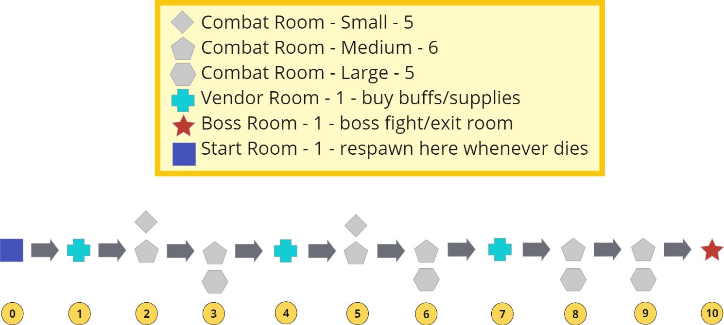
Figure 1: Overview Map and Legends [1]
Note: The rooms are labeled C1-C16 for the combat rooms, and V1-V3 for vendor rooms. Each time the player enters a new combat room, the enemy’s damage will be raise by 1.1x.
Map Label | Gameplay Summary
0a | The player enters the level through talking to an NPC at the Red Rocket.
0b | The player enters the start room, provided by the initial resources.
1 | The player enters the 1st vendor room, buy any buffs and supplies they want for this round.
2 | The player enters the 1st combat room, which will be randomly chosen among 5 small rooms and 2 medium rooms, that is C1-C7.
3 | The player enters the 2nd combat room, which will be randomly chosen among 6 medium rooms and 1 large room, that is C6-C12.
4 | The player enters the 2nd vendor room, buy any buffs and supplies they want for this round using the caps they earned.
5 | The player enters the 3rd combat room, which will be randomly chosen among 2 small rooms and 6 medium rooms, that is C4-C11.
6 | The player enters the 4th combat room, which will be randomly chosen among 2 small rooms and 6 medium rooms, that is C6-C13.
7 | The player enters the 3rd vendor room, buy any buffs and supplies they want for this round using the caps they earned.
8 | The player enters the 5th combat room, which will be randomly chosen among 4 medium rooms and 3 large rooms, that is C8-C14.
9 | The player enters the 6th combat room, which will be randomly chosen among 2 medium rooms and 5 large rooms, that is C10-C16.
10a | The player enters boss fight.
10b | The player exits the level to red rocket.
10c | At anytime the player dies in the level, they get automatically respawned in Start room with the caps they earned from the previous round. They can buy buffs that weapons that stay for every round at the start room and start the next round of escape.

Level Details

Detail Maps
Note: For the rewards details, please refer to Resource Economy section in Appendix A. For the difficulty (my version of Skill Progression Chart) please refer to the Difficulty Calculation and Game Balance section in Appendix A.

Combat Rooms - Small
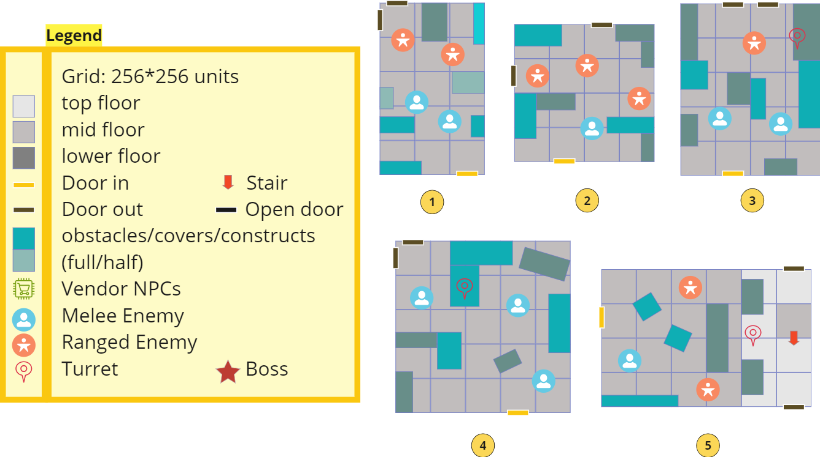
Figure 2: Combat Rooms – Small [1]
Map Label / Stage | Enemy Details | Difficulty | Rewards Details
1: bedroom | 2 melees, 2 ranged | 4.5 | ~960
2: library | 1 melee, 3 ranged | 4.75 | ~990
3: office | 2 melees, 1 ranged, 1 turret | 4.75 | ~990
4: console | 3 melee, 1 turret | 4.5 | ~980
5: reception | 1 melee, 2 ranged, 1 turret | 5.0 | ~1000

Combat Rooms - Medium
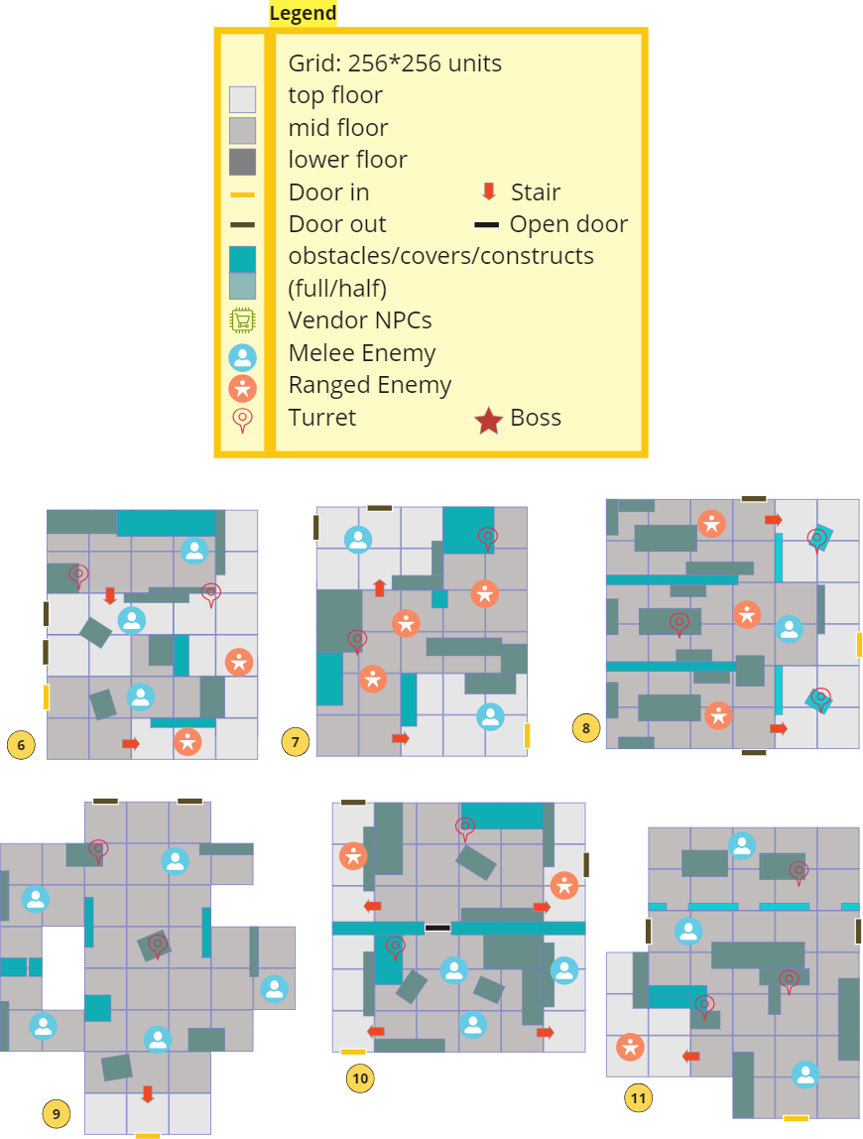
Figure 3: Combat Rooms – Medium [1]
Map Label / Stage | Enemy Details | Difficulty | Rewards Details
6: wareroom | 3 melees, 2 ranged, 2 turrets | 8.5 | ~1540
7: factory | 2 melees, 3 ranged, 2 turrets | 8.75 | ~1550
8: hair salon | 1 melee, 3 ranged, 3 turrets | 9.25 | ~1570
9: hallway | 5 melees, 2 turrets | 8 | ~1520
10: vault room | 3 melees, 2 ranged, 2 turrets | 8.5 | ~1540
11: clinic | 3 melees, 1 ranged, 3 turrets | 8.75 | ~1550

Combat Rooms - Large
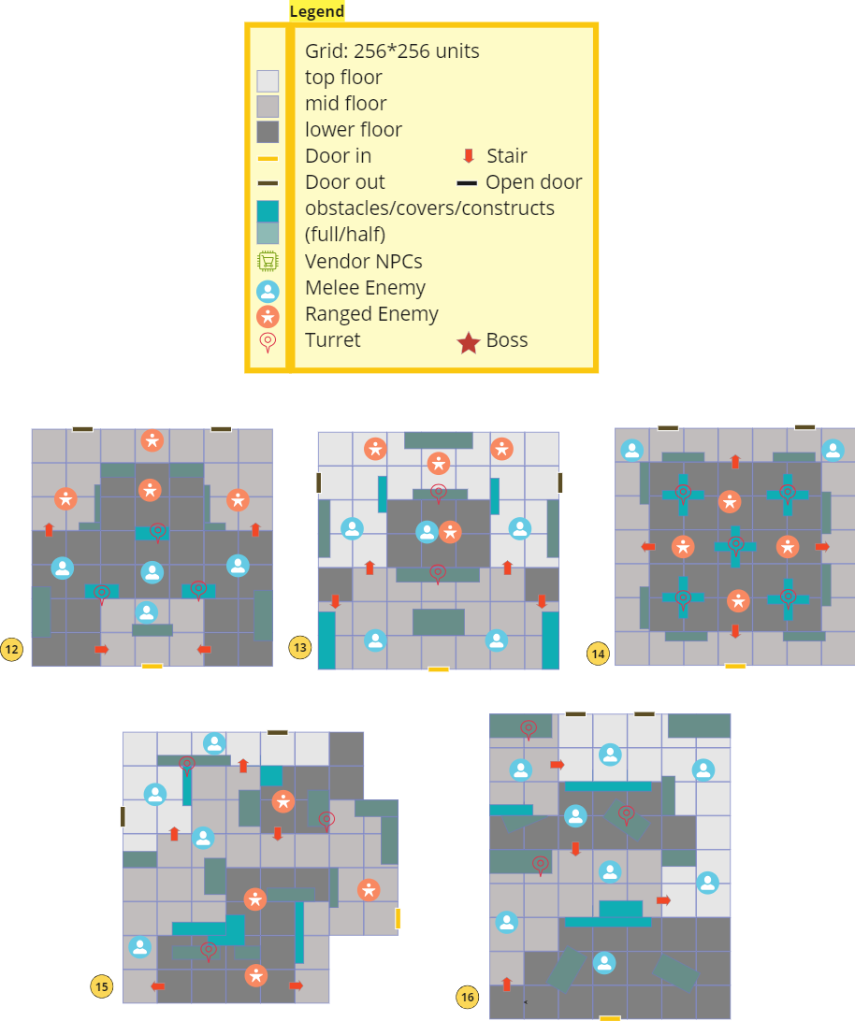
Figure 4: Combat Rooms – Large [1]
Map Label / Stage | Enemy Details | Difficulty | Rewards Details
12: lab | 4 melees, 4 ranged, 3 turrets | 13.5 | ~2540
13: console | 5 melees, 4 ranged, 2 turrets | 13 | ~2520
14: office | 2 melees, 4 ranged, 5 turrets | 14.5 | ~2580
15: factory | 4 melees, 4 ranged, 3 turrets | 13.5 | ~2540
16: hall | 8 melees, 3 turrets | 12.5 | ~2500

Other Rooms – Start, Exit, Vendor
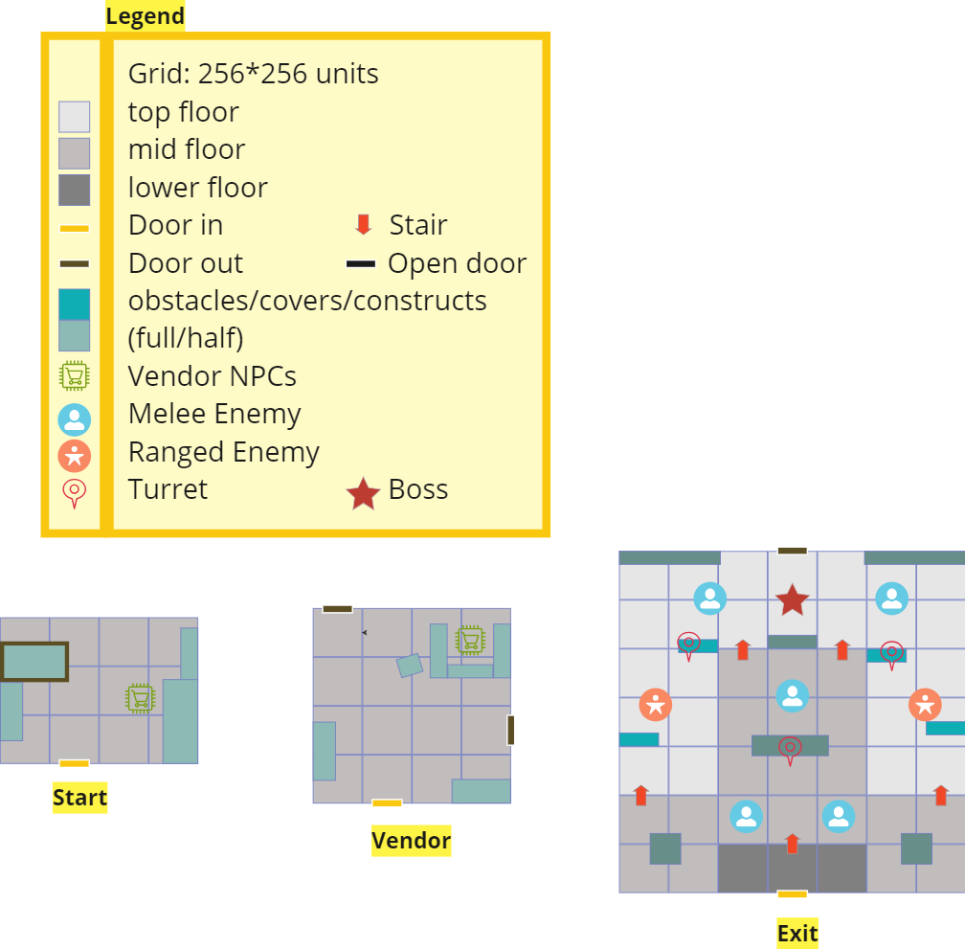
Figure 5: Other Rooms – Start, Exit, Vendor [1]
Note: check Appendix A for detailed buff lists
Map Label / Stage | Content Details | Vendor Details
Start: memory den | Supplies provided:  - 10mm pistol, Baton  - ~80 ammo for 10mm | - Weapons  - Buffs that stay for every round
Exit: lab | Enemy details:  - 1 boss, 5 melees, 2 ranged, 3 turrets  - Difficulty: 15  - Rewards: ~3680 | N/A
Vendor: reception | Supplies provided:  - 2 stimpaks  - ~40 ammos of each kind  - ~400 caps | - Ammos  - Buffs that only stay for the current round  - Stimpaks & Chems  - Grenades

Aesthetic References
This is an interior-only level. Since the story for this level is a dream of the synth girl, the rooms will be different places that she had visited in her past, including factories, institute labs, vault rooms, reception rooms, etc. The rooms will be varied in themes and decorations to convey the girl’s past experiences.
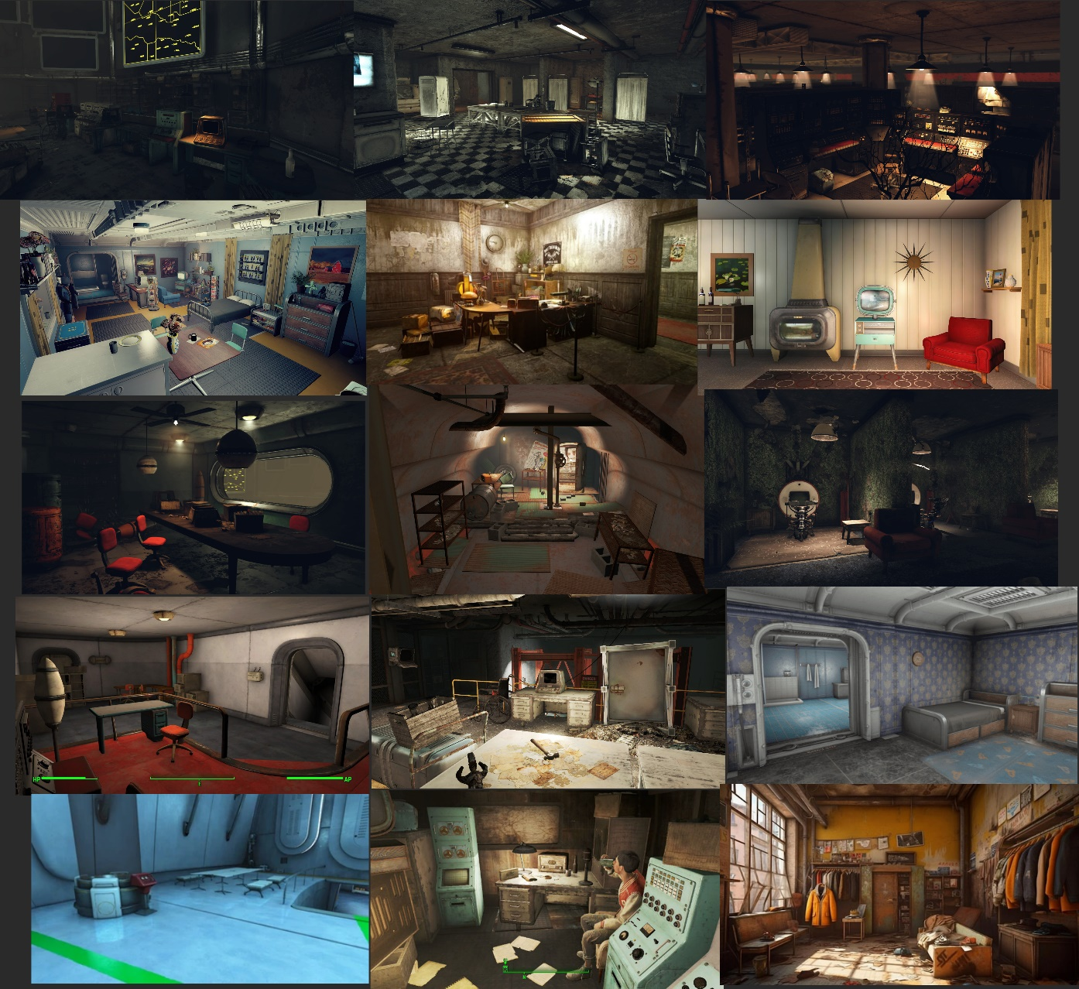
Figure 6: Contact Sheet [2]

References
[Cover Image] “Institute Girl”, May 26, 2024. ImageFX.
[1] “Maps,” Anona Yang, May 27, 2024. Screenshot from Miro.
[2] “Visual References,” Anona Yang, May 27, 2024. Screenshots from Fallout 4.

Appendices

Appendix A: New Skills / Gameplay Mechanics

Difficulty Calculation and Game Balance (subject to change in development)
- Enemy Difficulty Parameter:
  - Melee Synth: 1x
  - Ranged Synth: 1.25x
  - Turret: 1.5x
  - Boss: 3x
- Room Difficulty Parameter: Sum of the enemy parameters in the room

Resource Economy (subject to change in development)
- Killing enemies will be rewarded caps
  - Melee Synth: ~40 (~means a random number that is around the given number here)
  - Ranged Synth: ~50
  - Turret: ~60
  - Boss: ~200
- Complete a combat room will be rewarded caps
  - Small: ~800
  - Medium: ~1200
  - Large: ~2000
  - Exit Room: ~3000
- Vendor rooms will provide some free resources
  - 2 stimpaks
  - ~40 ammos of each kind
  - ~400 caps
- Weapons will be at price
  - Institute Laser Gun: 1200
  - Combat Shotgun: 1800
  - Combat Rifle: 1600
  - Minigun: 3600
- Grenades will be at default prices
  - Molotov cocktail: 20
  - baseball grenade: 40
  - nuka grenade: 100
  - plasma grenade: 135
- Buffs will be at prices:
  - Orange level 1-3: 800, 1200, 1600
  - Normal level 1-3: 300, 600, 900

Buff List
- Orange ones are only available at start room vendor
- Other ones will appear randomly in normal vendor rooms

Damage
- melee weapon damage by percentage 20%, 40%, 60%
- gun damage increase by 20%, 40%, 60%
- explosives do more damage by percentage 25%, 50%, 75%,
- inflict more damage in combat by percentage 5%, 10%, 15%
- ignore the target's armor by percentage 10%, 15%, 20%

Defense
- gain extra damage resistance by 5, 10, 15
- gain extra energy resistance by 20, 30, 40
- gain extra health by 20, 40, 60
- stimpaks restore extra health by percentage 20, 40, 60

Movement
- action points regenerate faster by percentage 20%, 40%, 60%
- gain extra action points by 5, 10, 15

V.A.T.S.
- V.A.T.S. attack accuracy increases by 5%, 10%, 15%
- criticals do extra damage by 1.5x, 2x, 2.5x
- each hit in V.A.T.S. has a better chance of filling critical meter by 20%, 40%, 60%

Appendix B: Context Detail: N/A

General Context

Backstory

Aftermath

Appendix C: Character Descriptions: N/A

NPC 1: N/A
Description
Background
Goals/Motivation
Personality/Archetype
Relationships

Appendix D: Dialog Flow: N/A

NPC 1: N/A

Appendix E: Development Risks: N/A
Map Label | Description/Mitigation | Type | Priority
 | N/A

Appendix F: Key Asset Needs: N/A
Description | Type | Priority
N/A

