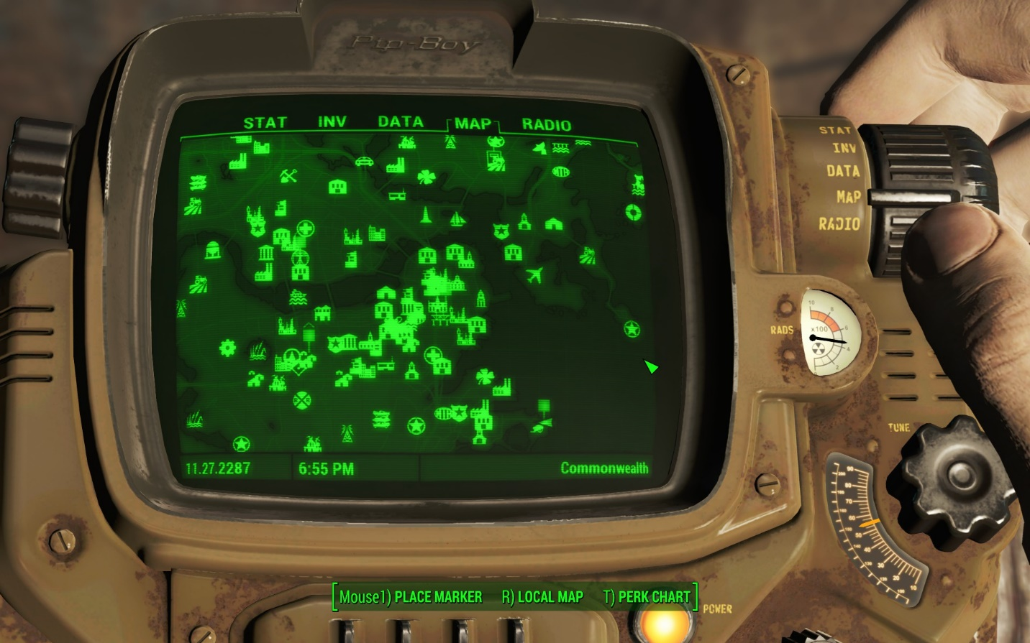

Fallout 4 Deconstruction
Designer: | Anona Yang
Document Date: | 01/31/2024

Table of Contents
Table of Contents 1
Table of Figures 3
Table of Tables 3
High Concept 4
Skill Progression Chart 4
Gameplay Loops 5
Core (Primary) Gameplay Loop 5
Secondary Gameplay Loop 5
Tertiary Gameplay Loop 6
Gameplay Styles / Systems 7
Gameplay Systems 7
Player System 7
Weapons & Modification 11
Enemy & Factions 14
Quest 16
Navigation & Map 18
Settlement 19
Companion 19
Collectables 20
Gameplay Styles 20
Exploration 20
Combat 20
Charisma 21
Conveyances/Affordances 21
Feedback 25
References 27

Table of Figures

Figure 1: Skill Progression Chart 4
Figure 2: Primary Gameplay Loop 5
Figure 3: Secondary Gameplay Loop 5
Figure 4: Tertiary Gameplay Loop 6
Figure 5: Health HUD [2] 9
Figure 6: Consumables [2] 10
Figure 7: Apparel in Pip-Boy [2] 11
Figure 8: Weapons in Pip-Boy [2] 13
Figure 9: Special Weapons [2] 13
Figure 10: Optional Quest Objectives [2] 17
Figure 11: Objective HUD [2] 18
Figure 12: Map Markers [2] 19
Figure 13: Notification [2] 21
Figure 14: Red Exit [2] 22
Figure 15: Light Contrast [2] 22
Figure 16: Diamond City Framing [2] 23
Figure 17: Bunker Hill Landmark [2] 23
Figure 18: Highways [2] 24
Figure 19: Wires [2] 24
Figure 20: Diamond City Decal [2] 24
Figure 21: Stealth HUD [2] 25
Figure 22: Damage Feedback [2] 25
Figure 23: Killing Feedback [2] 26

Table of Tables
Table 1: Perk Chart Attributes [1] 7
Table 2: Chem Examples [3] 10
Table 3: Weapons [4] 12
Table 4: Modifications [5] 14
Table 5: Enemies and Factions [6][7] 15

Game Deconstruction

High Concept
Fallout 4 is a single-player open world action role playing game that is quest driven, combat focused, and exploration encouraged. The player starts as a survivor from nuclear attack, waking up from Vault 200 years later, and steps into the Commonwealth of Boston to look for his son Shaun that is kidnapped during his sleep in the Vault. Fallout 4 is published in 2015 by Bethesda Softworks and developed by Bethesda Game Studios.

Skill Progression Chart
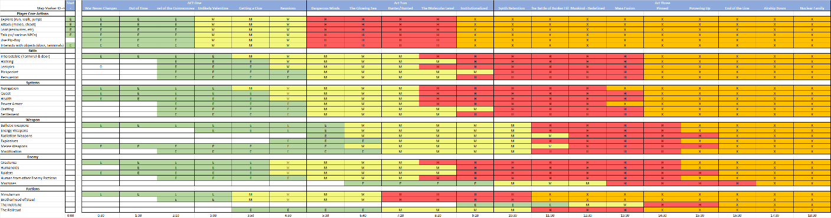
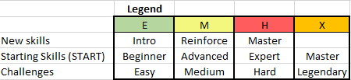

Figure 1: Skill Progression Chart

- The Skill Progression Chart is based on the Institution Ending.
- Check the attached file “YangA_FO4_Deconstruction.xlsx” for the whole chart.

Gameplay Loops

Core (Primary) Gameplay Loop

Figure 2: Primary Gameplay Loop

Secondary Gameplay Loop

Figure 3: Secondary Gameplay Loop

Tertiary Gameplay Loop

Figure 4: Tertiary Gameplay Loop

Gameplay Styles / Systems

Gameplay Systems

Player System
- Appearance. As the player enters the game, the player chooses the character gender and modifies appearance, including hair styles, skin color, eye color and face shapes, etc.
- Pip-Boy. A watch-like machine that the player wears, that is used to check armor data, inventory items, quest details, map markers, and switch radio signals.
- Perk Chart. The player allocates initial points to the main attributes at the game start. And as the player levels up, he gains a point per level and chooses to upgrade whichever attribute in Perk Chart that he wants. And when an attribute reaches a certain level, new special attributes will be unlocked, and players will be able to level up these ones as well. Unlike each of the main attributes having 10 ranks to upgrade, the special ones only have 3~5 ranks.
Table 1: Perk Chart Attributes [1]
Main Attributes | Affected Ability | Affected Special Attributes & Required Rank | Notes
Strength | Melee Weapon Damage  Melee Weapon Mods  Armor Mods  Carry Weight  Shooting Accuracy  Damage Resist | Iron Fist STR 1  Big Leagues STR 2  Armorer STR 3  Blacksmith STR 4  Heavy Gunner STR 5  Strong Back STR 6  Steady Aim STR 7  Basher STR 8  Rooted STR 9  Pain Train STR 10 | Carry weight is an essential factor that affects exploration experience (with looting).
Perception | Pickpocket  Lockpicking Level  Ranged Weapon Damage  Energy Resistance  V.A.T.S. penetration | Pickpocket PER 1  Rifleman PER 2  Awareness PER 3  Locksmith PER 4  Demolition Expert PER 5  Night Person PER 6  Refractor PER 7  Sniper PER 8  Penetrator PER 9  Concentrated Fire PER 10 | Essential with dealing with secret terminals and doors. And essential with critical hits.
Endurance | Damage Resistance  Radiation Resistance  Health | Toughness END 1  Lead Belly END 2  Lifegiver END 3  Chem Resistant END 4  Aquaboy/Aquagirl END 5  Rad Resistant END 6  Adamantium Skeleton END 7  Cannibal END 8  Ghoulish END 9  Solar Powered END 10 | Essential to survival with respect to different kinds of resistance.
Charisma | Trading  Persuasion  Ally Attack Damage  Pacify Enemies | Cap Collector CHR 1  Lady Killer / Black Widow CHR 2  Lone Wanderer CHR 3  Attack Dog CHR 4  Animal Friend CHR 5  Local Leader CHR 6  Party Girl/Party Boy CHR 7  Inspirational CHR 8  Wasteland Whisperer CHR 9  Intimidation CHR 10 | Essential to persuade NPCs for avoiding combats and gaining more rewards.
Intelligence | V.A.N.S  Hacking/Lockpicking  High-Tech Mods  Scrap Resources | V.A.N.S. INT 1  Medic INT 2  Gun Nut INT 3  Hacker INT 4  Scrapper INT 5  Science! INT 6  Chemist INT 7  Robotics Expert INT 8  Nuclear Physicist INT 9  Nerd Rage! INT 10 | Essential if the player has goals with crafting mods and building settlements.
Agility | Ranged Weapon Damage  Sneak Attack Damage  V.A.T.S Validate Range  Reload Speed | Gunslinger AGI 1  Commando AGI 2  Sneak AGI 3  Mister Sandman AGI 4  Action Boy/Action Girl AGI 5  Moving Target AGI 6  Ninja AGI 7  Quick Hands AGI 8  Blitz AGI 9  Gun Fu AGI 10 | Essential if the player prefers stealth style combat.
Luck | Cap Collection  Ammo Collection  Experiences Points  Critical Hits  Attack Damage | Fortune Finder LCK 1  Scrounger LCK 2  Bloody Mess LCK 3  Mysterious Stranger LCK 4  Idiot Savant LCK 5  Better Criticals LCK 6  Critical Banker LCK 7  Grim Reaper's Sprint LCK 8  Four Leaf Clover LCK 9  Ricochet LCK 10 | Higher opportunity of gaining more resources.

- Health (and Consumables). The player’s Hit Points is a certain number that can increase if leveled up in certain attributes in the Perk Chart.
  - Players can pick up Consumables: food (animal meat, plants, cans), drinks (water, radiated water, nuka products, alcohol) and chems in the game to restore HP.
  - Since the story setting is after nuclear attack, the environment contains radiation damage. Most of the food and drinks that the player can pick up have radiation. When the player consumes items that contain radiation. The radiation reduces the player’s max HP.
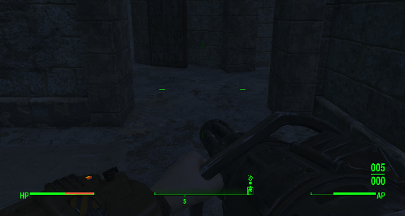
Figure 5: Health HUD [2]
  - For the chems, there are many potions with different effects. Many of those grant special effects that players can utilize to get advantage during combats. Some of the most used ones are listed in the table below. Some of the chems generates addiction and will reduce some attributes points when the addiction is effective, which can be cured by certain chems.

Table 2: Chem Examples [3]
Chem Name | Effect | Addiction
Stimpak | HP +30% | No
Buffout | STR +2, END +2, Max HP +50 for 300s (5m) | Yes
Jet | Slows time for 10s | No
Mentats | PER +2, INT +2 for 300s (5m) | Yes
Med-X | Damage Resistance +25 and Poison Resistance +250 for 300s (5m) | Yes
RadAway | Rads -300 | No
Psycho | Damage +25%, Damage Resistance +25 for 300s (5m) | Yes
Rad-X | Radiation Resistance +100 for 180s (3m) | No
Addictol | Cure all addictions | No

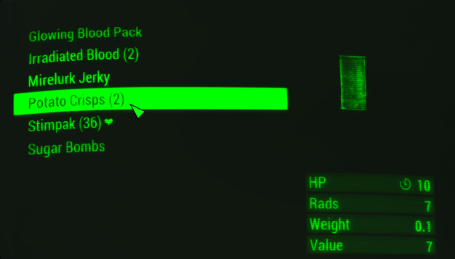
Figure 6: Consumables [2]
- Inventory. A tab inside Pip-Boy, where the player can change apparel, weapon, weapon mods, ammo, consume aid (consumables), and check miscellaneous (collectables), junk (scrap materials).
  - Apparel (Armor). A set of apparel consists of different body parts (head, left arm, right arm, left leg, right leg, chest, mask, goggle). The player can loot apparel from various enemies. Various apparel has different damage resistance, energy resistance, and radiation resistance. Some apparel has low resistance and is just for decoration. Usually, different factions have some certain set of apparel that’s worn by faction NPCs across the game. There are also some special ones that are rewards from quests and companions, and these may include special effects with respect to the perk attributes.
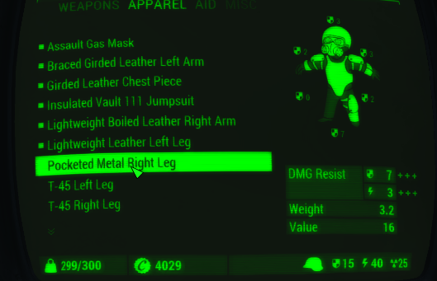
Figure 7: Apparel in Pip-Boy [2]
  - Power Armor. The first power armor is given to the player while engaging in the quest with the minuteman at the museum. With the power armor, the player has higher resistance to damage and can carry more weight. To use the power armor, the player needs to gather fusion core from power stations as energy sources to support the armor’s functionality. The player can pick up power armor parts from enemies to modify and replace the damaged ones. The player can obtain different mods of power armor from different factions.
  - Junks. Miscellaneous items that players can pick up from cabinets, on tables etc. They can be scrapped into materials such as aluminum, adhesive, etc, that can be used for crafting weapon & armor modifications, settlement constructions.

Weapons & Modification
- Normal weapons (lootable from containers and enemies).

Table 3: Weapons [4]
Weapon Type | Damage | Accuracy | Range | Weight | Fire Rate | Notes
Ranged Weapons
Ballistic weapons
Pistols | Low | Medium | Medium | Light | Single shot, Medium | High modifiable
Rifles | Medium | Medium | High | Medium | Single shot, Medium | High modifiable
Shotgun | Medium | Low | Medium | Light | Multiple Shot, Medium
Pipe Weapons | Low | Medium | Low | Very Light | Fast | High modifiable
Heavy Weapons | High | Medium | High | High | Various
Energy Weapons
Laser | Medium | High | Very High | Medium | Fast
Plasma | Low | High | Very High | Medium | Various, Double shot
Radiation Weapons
Gamma | Low | Medium | High | Light | Medium | Has ongoing damage to target
Explosives
Thrown | High | Depends | Depends | Very Light | Slow | Consumable
Placed | Very High | AOE | Depends | Very light | Very Slow | Consumable
Melee Weapons
Bladed | Low | Depends | Low | Light | Medium
Blunt | Medium | Depends | Low | Medium | Slow
Unarmed Weapons | Medium | Depends | Very Low | Light | Medium

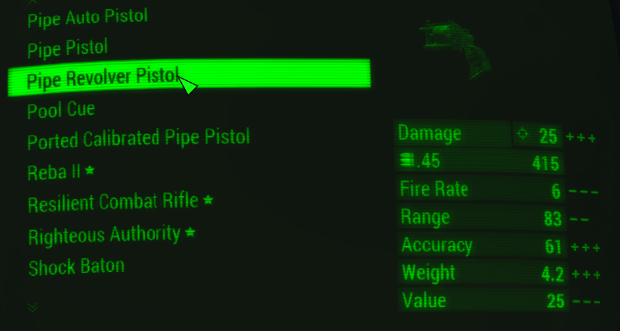
Figure 8: Weapons in Pip-Boy [2]
- Special weapons. The ones that are marked with a star are usually quest rewards from factions or only a few side quests. These are usually comparable powerful to the normal ones. And their specialties are usually related to the quest they are from (for example a quest with a reward of Reba II asked the player to kill some mirelurks, while the Reba II has a specialty of dealing 50% more damage with mirelurks).
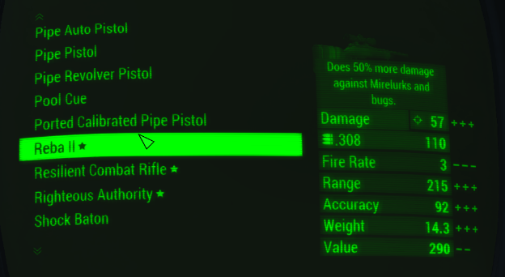
Figure 9: Special Weapons [2]
- V.A.T.S. (Vault-Tec Assisted Targeting System). A visually dynamic, statistical based combat system that helps players in combat that is applicable with all kinds of weapons. It slows down time for the player to aim at enemies with a preview of potential damage numbers. The attack with VATS charges a critical hit bar with certain number of shots and is also determined by luck, action points, enemy health, and player health.
- Modifications. Weapons and armor can be modified on workbenches that’s scattered across the game world by using scrap materials that the player gathers from junk.
Table 4: Modifications [5]
Mod Type | Effects
Ranged Weapons
Receiver | Increase critical hit damage, improve fire rate, armor penetration, etc.
Barrel | Related to hip-fire and recoil
Magazine | Contains more ammo but increases weight, decreases reload time
Grip | Better recoil, more accuracy, AP cost and weight increases
Sights | Helps with aiming
Muzzle | Increases damage, reduces recoil
Capacitor | Specific for energy weapons, adds better burning damage, range and ammo capacity
Melee Weapons
Bladed | Increase damage.
Armor
General | Improve damage resistance, reduced weight, reduces damage taken, increase mobility, decrease AP costs, increase chem duration

Enemy & Factions
- The NPCs in Fallout 4 are organized by factions. When a player chooses to join a faction, they become neutral or allied with the NPCs belonged to the faction. And when the player chooses to leave / fight against a faction, all the NPCs belonged to the fraction become hostile to the player. Only major fractions are listed in the table below.
- The four main factions are Minutemen, Brotherhood of Steel, the Railroad, and the Institute.
- The enemies in Fallout 4 are mainly humans from other factions and creatures scattered all over the world. The player can pick up meat from creatures to restore HP, but most of those contain radiation.
- Some of the enemies are marked with a skull marker besides its HP HUD that indicates they are legendary enemies. They are harder to defeat and mostly equipped with better armor and weapons.

Table 5: Enemies and Factions [6][7]
Type | Difficulty | Attack Style/Weapon/Tech | Mobility | Faction Affinity
Human (faction) /Humanoid
Minutemen | N/A | Melee / Ranged | Medium | Always friendly
Brotherhood of Steel | Hard | Power Armors, Vertibirds, mostly ranged | Medium /Slow | Depends
The Railroad | Normal | Basic Guns/ Melee | Medium | Depends
The Institute | Normal | Energy Weapons | Medium | Depends
Synth | Low | Melee / Ranged | Medium | Depends (some are controlled by the Institute, but some are not)
Children of Atom | Low | Melee | Medium | Depends
Raider | Low | Melee / Ranged | Medium | Always hostile
Triggermen | Median | Melee / Ranged | Medium | Always hostile
Gunner | Median | Melee / Ranged | Medium | Always hostile
Ghouls | Low to Median | Melee | Fast | Always hostile
Super Mutants | Median to High | Melee / Ranged | Medium | Always hostile
Creatures
Brahmin and gazelles | Hard | Melee | Medium | Always hostile
Dogs and Hounds | Low | Melee / Radiation | Fast | Always hostile
Mongrels and wolves | Low | Melee & As group | Fast | Always hostile
House Cats and gorillas | Medium | Melee | Medium | Always hostile
Mole and rad rats | Low | Melee | Medium | Always hostile
Radstag and yao guai | High | Melee | Medium | Always hostile
Deathclaws and gatorclaws | High | Melee | Medium | Always hostile
Arthropods | Low | Melee / Poison | Medium | Always hostile
Bloodworms | Low | Melee | Fast | Always hostile
Aliens | Medium | Melee/Ranged | Medium | Always hostile
Birds | Low | Melee | Fast | Always hostile
Fish and anglers | Medium | Melee / Ranged | Medium | Always hostile
Machines
Sentry | Medium | Ranged | Low | Always hostile
Robots | Medium | Melee/Ranged | Medium | Always hostile

Quest
- The game flow of Fallout 4 is mainly driven by quests. With the quest objectives, the player is guided to finish the entire story and explore other gameplay systems.
- Quests can be categorized into types.
  - Main Quest.
    - The ones that are linearly structured to lead the player into the main story.
    - Main quests are added to Pip-Boy and set active automatically once started.
    - Act 1 and Act 2 quests are same for all faction choices, and in Act 3, player can choose factions at their wishes and complete the Faction Quests to advance in narrative that will eventually lead to different endings.
    - These quests provide large amounts of experience points that help the player level up. And powerful weapons or armor.
  - Faction Quest
    - Quests that are completed specifically for each faction’s interests. They generally impact the player’s faction choice.
    - There will be many important choices during these quests for the player to choose faction, each could result in faction change and potential combats. Different ways and sequence of dealing with the faction quests can lead to various endings.
    - Time-sensitive. Certain quests will be marked failed when they become unavailable to complete (generally have something to do with NPCs from other factions).
  - Side Quest
    - These quests won’t have impact on state/faction of the main quest. It’s the player’s freedom to choose when to complete.
    - Many of these quests provide good rewards such as secret weapons and armor.
    - They generally provide a good number of experience points for the player to level up if the player gets stuck on the main quests.
    - Each faction has its own side quests that don’t interfere with the main story.
  - Miscellaneous Quest
    - These quests are all stored in the Miscellaneous tab under quest data.
    - Most of these are unrelated to the main quests content-wise and timewise.
    - Many of these can be discovered by picking up specific objects, entering a place, or listening to the radio. Some are activated along with other quests.
    - Misc quests usually are very short and provide few rewards.
- There could be optional steps in quests that provide freedom for the player to explore the space more or gather information as they need.
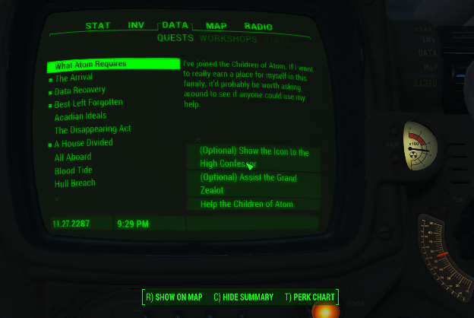
Figure 10: Optional Quest Objectives [2]
- The quest is shown in Pip-Boy with a short description of the current stage and a list of objctives. The quest objectives usually include exploring places, fetching specific items, killing enemies, and talking with NPCs.
  - Dialogue. When talking to the NPCs, the player usually has 4 choices that consist of yes, no, sarcasm, questions, or persuasion options. Each option is displayed with a prompt preview instead of the full sentence. Looking away from the NPC usually stops the conversation.
- Many exploration quests provide multiple ways of handling that encourage different playstyles. For example, to open a door, the player can persuade the owner by charisma check, pickpocket the key, hack the terminal, or lockpick the door.
  - Charisma check. The player can choose a persuasion option in the dialogue and pass through a charisma check, which is determined by possibility with respect to the player’s charisma attribute. The charisma check is marked with colors: red for hard, orange for medium, yellow for easy, and there could always be pass checks when the player meets certain conditions. If the player fails the charisma check, the NPC could become hostile to the player. The persuasion option is usually for the player to gain more rewards, flirting with companions, and pacifying NPCs from faction conflicts.
  - Lockpicking. For the locked doors (and safes) in Fallout 4, the player can use bobby pins to lock pick them. The player can try as many times as they want before they run out of bobby pins. The locked doors have a difficulty level, and the player won’t be able to lockpick them unless their Locksmith level reaches requirements. When the Locksmith attribute is leveled up to the maximum, the player always succeeds.
  - Hacking. Similar as lockpicking the doors but for the terminals only. The player needs to choose the correct password from the options provided on the terminal screen. Every time the player chooses a word the terminal will hint with a likeliness. The terminal will be locked in a while if the player got wrong 4 times. The password and option lists will be refreshed each time the player leaves the terminal screen before hacking succeeds. The terminals with higher difficulties will be open for hacking when the player’s Hacking attributes level up.
  - Pickpocket. The player can pickpocket from NPCs to get resources. The possibility of success is related to the Pickpocket attribute under perception perk. As the attribute levels up the player can pickpocket more valued items or even place a live grenade in the NPC’s inventory.

Navigation & Map
- The player can set active the quest they want to complete at the current moment on Pip-Boy, which enables the player to see the quest objectives on the navigation HUD.
- The active quest objectives will be marked with a green square on its head, on the map, and on the HUD at the bottom edge of the screen. If the distance is within a certain range, the meters will also be shown on top of the green square.
- From the HUD, the player can see the places around within a certain range with relative directions.
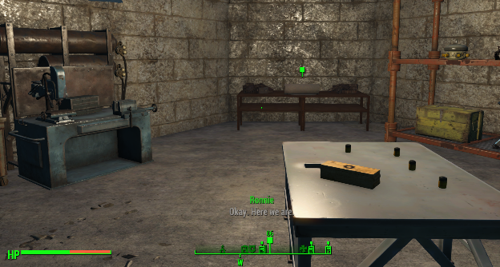
Figure 11: Objective HUD [2]
- Map Marker. As the player discovers a new place, a map marker will be placed on the map at the corresponding position, and the player will then be able to fast travel between these places through the map in Pip-Boy.
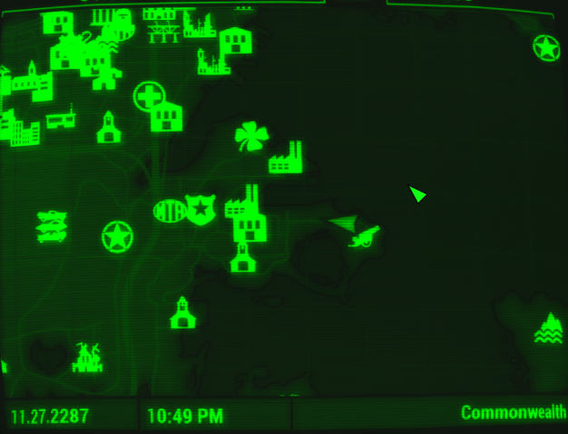
Figure 12: Map Markers [2]
- Interior and Exterior. The gameplay areas in Fallout 4 include interior (inside houses) and exterior. The player can switch view from world map to local map in the Pip-Boy. From the interior, the player is not allowed to fast travel to another places. Also, when there’re enemies around or the carry weight exceeds limits, the player can’t fast travel.

Settlement
- The player can manage a settlement after killing the offending raiders for the settlement and obtain the people’s affinity.
- The settlement usually contains craft benches for weapon & armor modifications, food and potions, power armor station and cooking station.
- The player needs to set up defense constructions and power systems and provide food and water to the settlers. The materials are from collecting junk and scrapping. The player needs to maintain certain level of happiness to keep the settlement, or they will lost it.
- Give the player freedom to customize and decorate their places, which usually provides a sense of belonging.

Companion
- As the player reaches certain story points in factions, certain NPCs become a companion option for the player to explore together. The companions help the player to kill enemies. But the player’s behaviors can affect their relationships with the player. If they dislike the player reaches a certain level, they will leave the player or even become enemies with the player.
- Since some of the companions are from factions, their affinity with the player changes as the player chooses to leave or fight against the faction, for example Paladin Danse and Deacon. For the other companions that are independent with the factions, they have their own interests with different factions.
- For all the companions, when the relationship between them and the player reaches a certain level, the player can flirt with them during dialogues through charisma checks.

Collectables
- Bubblehead figures. Small figures with yellow hair and blue clothes, each with a specific theme (perk chart attributes, weapons, etc.) that are hidden worldwide for the player to discover. No extra functionalities.
- Magazines. These provide extra perk levels and abilities to the player.
- Holotape games. There are 6 in total. They are collectable items that can be plugged into terminals to play.

Gameplay Styles

Exploration
- Resource. Fallout 4 provides vast kinds of junk and resources for the player to explore.
- Secret rooms. Skills including hacking, pickpocketing, lockpicking allow the player to gain access to the secret places to pick up more junk and resources.
- Crafting. If the player wants to experiment with better mods, repair power armor, and build up settlements, the player needs to loot enough number of junk and scrap into materials.
- Secret collectables scattered around the whole world.
- Side quests for the player to dig narratives and NPC relationships. Also with the rare weapons and armor as rewards.
- Map exploration. Besides the places that the main quests take the player to, the world map is big enough and contains many other places for the player to explore, as well as finding hidden side quests. With the experience points provided, the player can level up quickly to unlock the perk attributes they need.
- Terminals that contain extra narratives for the player to investigate.

Combat
- Ranged
  - Most of the weapons in Fallout 4 are guns.
  - Some of the strong enemies have high melee attack damage but move slow, which could be taken down rather easily by ranged attack.
  - With the various modifications the player is encouraged with combat.
  - Perception perk helps with dealing higher damage.
- Melee
  - Most melee weapons have extra effects on enemies.
  - Some enemies with quick moving speed are hard to shoot from a distance but easy to defeat at a closer range.
  - The combat places usually provide enough number of covers in various sizes for the player to maneuver in.
  - Strength perk helps with the player with melee attack damage.
- Stealth
  - Most combat places have high covers for the player to take an alternate path and move around to traverse through. This allows the player to avoid combat and encourages pickpocketing.
  - Agility and sneak perk help the player to avoid being found.
- Sniper
  - Most combat places have great verticality or hills around the site so that the player can take advantage of the distance and height to shoot the enemies in advance and avoid melee combat.
  - Sniper perk encourages this option with higher damage.
- V.A.T.S.
  - With the VATS, the players that are not confident with combat can take time and take advantage of the critical hits to get through the combat.

Charisma
- Reward. The player can persuade NPCs to get more information and rewards.
- Pacify NPCs and avoid combat.
- Companion flirting. Flirt with Companions to increase the relationship level.

Conveyances/Affordances
Type | Descriptions/Screenshots
Conveyance
Notification | Small rectangle message sent out at the upper left corner to indicate quest stage completion and inventory changes (and others) to the player.  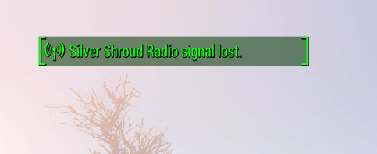  Figure 13: Notification [2]
Light Colors/ Contrast | 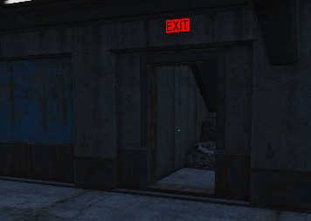  Figure 14: Red Exit [2]  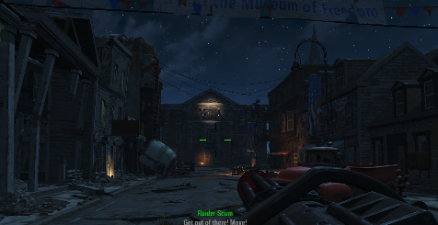  Figure 15: Light Contrast [2]
NPC leading | The enemies are placed in a sequence that led the player to the quest objective place.
Foreshadow | Preview windows at the interior to acknowledge the player of enemies and other information.
Framing | 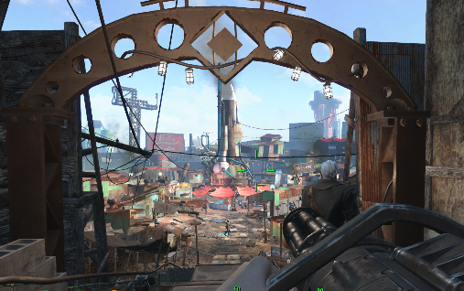  Figure 16: Diamond City Framing [2]
Landmark | 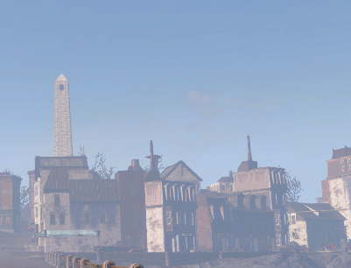  Figure 17: Bunker Hill Landmark [2]
Sightline lining | Roads/wires/pipes lead to the flow direction.  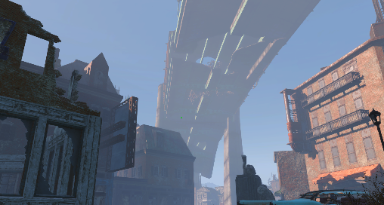  Figure 18: Highways [2]    Figure 19: Wires [2]
Decal | 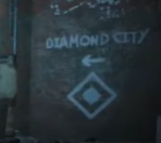  Figure 20: Diamond City Decal [2]
Motions | Light blinking/animals moving to draw the player’s attention.
Stealth | Marker with green/yellow/red colors to indicate the enemies around to the player.    Figure 21: Stealth HUD [2]
HUD navigation | See the navigation sections above. Enemies in the range will also shown as red squares.
Affordance
Interactable | Interaction HUD. (doors, terminals, furniture, pick up junk etc.)
Dialogues | The dialogue options related with charisma checks are colors with respect to difficulties.
Perk Skill Needed | When the player tries to access a lock/door with higher difficulty where their perk doesn’t meet requirements the interaction HUD will be in colors. Like the charisma check.

Feedback
Type | Descriptions/Screenshots
Conveyance
Receive harm | Screen blurs and shakes, with a red arc mark in the middle of the screen.  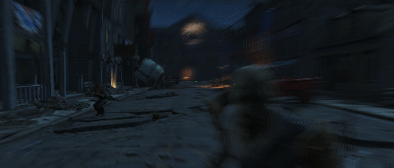  Figure 22: Damage Feedback [2]
Deal damage | Enemies will splash blood, start staggering.
Killing enemy | Experience points added will show in HUD.  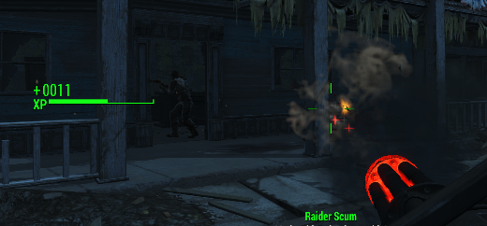  Figure 23: Killing Feedback [2]
Message box | Important choices, low health, leaving certain areas.
Power armor | Preview windows at the interior to acknowledge the player of enemies and other information.
Sound | Most interactions include sound effects for success/failure.
Light | Removing the fusion core will turn the power station down with lights shut down.

References
[Cover Image] Anona Yang, 2024. Screenshots from Fallout 4.
[1] C. to F. Wiki, “Fallout 4 perks,” Fallout Wiki, https://fallout.fandom.com/wiki/Fallout_4_perks (accessed Feb. 4, 2024).
[2] “In-Game Screenshots,” Anona Yang, 2024. Screenshots from Fallout 4.
[3] C. to F. Wiki, “Fallout 4 consumables,” Fallout Wiki, https://fallout.fandom.com/wiki/Fallout_4_consumables (accessed Feb. 4, 2024).
[4] C. to F. Wiki, “Fallout 4 weapons,” Fallout Wiki, https://fallout.fandom.com/wiki/Fallout_4_weapons (accessed Feb. 4, 2024).
[5] C. to F. Wiki, “Fallout 4 modifications,” Fallout Wiki, https://fallout.fandom.com/wiki/Fallout_4_modifications (accessed Feb. 4, 2024).
[6] C. to F. Wiki, “Fallout 4 creatures,” Fallout Wiki, https://fallout.fandom.com/wiki/Fallout_4_creatures (accessed Feb. 4, 2024).
[7] C. to F. Wiki, “Fallout 4 factions,” Fallout Wiki, https://fallout.fandom.com/wiki/Fallout_4_factions (accessed Feb. 4, 2024).

