Doom Deconstruction
Designer: | Anona Yang
Document Date: | 09/19/2023

Table of Contents
Table of Contents 1
Table of Figures 2
High Concept 3
Skill Progression Chart 3
Gameplay Loops 4
Core (Primary) Gameplay Loop 4
Secondary Gameplay Loop 4
Tertiary Gameplay Loop 5
Gameplay Styles / Systems 6
Gameplay Systems 6
Gameplay Styles 9
Conveyances/Affordances 11
Feedback 11
References 12

Table of Figures

Figure 1: Skill Progression Chart [2] 3
Figure 2: Primary Gameplay Loop 4
Figure 3: Secondary Gameplay Loop 4
Figure 4: Tertiary Gameplay Loop 5
Figure 5: Green Lights for Conveyance [3] 11

Game Deconstruction

High Concept
Doom is an FPS game developed by id Software and published by Bethesda Softworks in 2016. The game has the player act as the ancient warrior woken up during a demonic invasion on Mars, and the player needs to fight its way out of the monsters and complete tasks through facilities and hell. [1].

Skill Progression Chart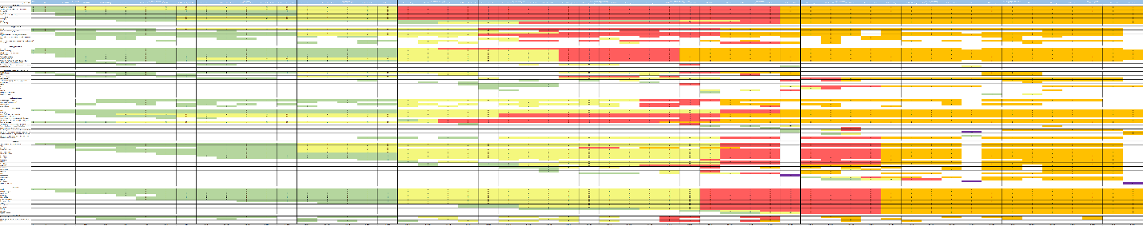
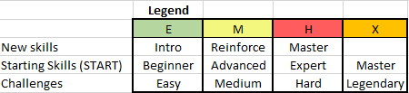

Figure 1: Skill Progression Chart [2]

Gameplay Loops

Core (Primary) Gameplay Loop

Figure 2: Primary Gameplay Loop

Secondary Gameplay Loop

Figure 3: Secondary Gameplay Loop

Tertiary Gameplay Loop

Figure 4: Tertiary Gameplay Loop

Gameplay Styles / Systems

Gameplay Systems [1,3]
- Health
  - The player has a certain amount of health, armor, and ammo. As the player consumes the supply, they can collect as they explore the map or kill the enemies.
- Kill
  - Enemies get killed after entering the stagger state. If the player chooses to kill by melee, a special execution animation will be played.
  - The enemy returns to the normal state if the player doesn’t have a chance to kill in a certain amount of time, the enemy revives.
- Supply
  - The player can collect supplies of health, armor, and ammo as they explore the map, and collect drop-offs as they kill the monsters.
  - There are a few numbers of supply boxes at different spots that contain bullets of different types.
  - Monsters have drop-offs with different amounts respective to their type.
  - Killing the enemy by chainsaw creates large amount of armor drop-offs.
- Navigation
  - TAB opens the map for navigation. Explored areas are shown in blue instead of white.
  - The collectables (except some secrets) are shown on the map with white for not collected, and orange for collected.
  - The HUD has spots indicating the target locations with distance, sometimes coded with colors, guiding the player about the current destination.
- Weapon
  - The player has many guns and grenades as their weapons.
  - Use Q or number keys to switch. T for BFG and G for Chainsaw.
# | Name | Bullet Type | Reload | Damage | Range | Play Style
1 | Pistol | Plasma gel | short | low | narrow | remote & melee
2 | Combat Shotgun | normal | short | low | narrow | remote
3 | Frag Grenade | grenade | short | low | narrow | remote
4 | Chainsaw | energy | medium | high | narrow | melee
5 | Plasma Rifle | plasma | medium | medium | medium | remote
6 | Heavy Assault Rifle | conventional | medium | medium | medium | remote
7 | Rocket Launcher | rocket | long | high | wide | remote
8 | Super Shotgun | Normal,  multiple | short | high | wide | remote
9 | Gauss Canon | plasma | long | high | wide | remote
10 | Hologram | grenade | medium | medium | narrow | remote
11 | Chaingun | conventional | Medium, overheat | medium | medium | remote
12 | BFG-9000 | Special plasma |  | massive | widest | remote
13 | Sephon Grenade | grenade | medium | medium | medium | remote

- Weapon Modification
  - Players encounter field drones to upgrade their weapons with modifications.
# | Weapon | Modification | Description (in short)
1 | Combat Shotgun | Explosive Shot | explosive projectile
 |  | Charged Burst | fast triple-shot burst
2 | Heavy Assault Rifle | Micro Missiles | small rockets
 |  | Tactical Scope | optical scope
3 | Plasma Rifle | Heat Blast | waste heat
 |  | Stun Bomb | plasma ball
4 | Rocket | Lock-On Burst | a fire-and-forget guidance system for the rockets
 | Launcher | Remote Detonation | trigger to explode in mid-flight
5 | Gauss Canon | Precision Bolt | highly accuracy with optical scope
 |  | Siege Mode | penetrating capabilities
6 | Chaingun | Gatling Rotator | spinning barrels
 |  | Mobile Turret | barrels firing simultaneously

- Enemy
# | Name | Health | Damage | Attack | Play Style
1 | The Possessed (Worker & Scientist) | low | low | melee | melee
2 | Imp | low | low | melee | melee
3 | Gore Nest | / | / | Spawn monsters | /
4 | Possessed Soldier | low | low | melee | melee
6 | Possessed Engineer | low | low | Fire drone, melee | remote
7 | Possessed Security | low | medium | Plasma, melee | remote & melee
8 | Hell Razor | 600 | medium | laser | remote & melee
9 | Hell Knight | 1800 | medium | Melee, slam | melee
10 | Summoner | 1400 | medium | energy | remote
11 | Revenant | 1600 | medium | Barrage, melee | remote & melee
12 | Unwilling | low | low | melee | melee
13 | Mancubus | high | high | Plasma barrage, quake | remote & melee
14 | Cacodemon | 2000 | high | spewing toxic bile, biting | remote
15 | Baron of Hell | 3500 | high | melee strike, ranged green fireball, ground slam to rapidly close distance | remote & melee
16 | Lost Soul | 75 | low | suicide | melee
17 | Pinky | 1000 | high | Melee, stampede | melee
18 | Cyberdemon |  | high | Barrier, plasma, quake | remote & melee
19 | Cyber-Mancubus | 3500 | high | Plasma barrage, quake | remote & melee
20 | Spectre | 2000 | high | Melee, stampede | melee
21 | Hell Guards | high | massive | combined | remote & melee
22 | Spider Mastermind | high | massive | combined | remote & melee

- Upgrading System
# | Name | Function
1 | Argent Energy | Increases health, armor, or ammo by player’s choice
2 | Praetor Token | Upgrades environmental resistance, area-scanning technology, equipment system, power-up effectiveness, and dexterity
3 | Rune | Earned by completing a trial, and upgraded by completing further challenges
4 | Weapon Mod | Weapon modifications that enhance different guns with accuracy, damage, and reload, etc.
5 | Weapon Upgrade | Cost weapon upgrade points to upgrade different guns with accuracy, damage, and reload, etc.

- Power-Ups
  - Players may encounter powerups as they start a combat, which levels up their ability for a certain amount of time.
# | Name | Function | Play Style
1 | Berserk | gauntlet-armored fists | melee
2 | Haste | Dramatically increased speed | hide
3 | Invulnerability | Protects from all attacks | melee
4 | Quad Damage | Multiplies the attack damage by four | remote

- Rune Trial
  - Players can find rune trials along exploration. Completing the trial enables them to use the rune ability.
  - Completing continuing tasks to upgrade the rune ability.
  - Up to 3 runes can be equipped at the same time.
# | Name | Function | Play Style
1 | Vacuum | Increases the range for absorbing dropped items. | explore
2 | Dazed and confused | Increases how long demons remain in a stagger state. | melee
3 | Ammo boost | Increases the value of ammo received from demons and items. | remote
4 | Equipment power | Increases the effectiveness of Equipment items. | remote
5 | Seek and destroy | Launch into a glory kill from much further away. | melee
6 | Savagery | Perform glory kills faster. | melee
7 | In-flight mobility | Provides a significant increase in control over in-air movement after a double-jump. | explore
8 | Armored offensive | Glory killing demons drop armor. | melee
9 | Blood fueled | Move faster for a short time after performing a glory kill. | melee
10 | Intimacy is best | Demons become more glory kill friendly due to a high damage resistance when staggered. | melee
11 | Rich get richer | Firing your standard weapons will not cost ammo when you have 100 Armor or more. | remote
12 | Saving throw | Get one chance to survive a death blow and recover health. This resets on death. | melee

- Secrets
# | Name | Play Style
1 | Doom guy collectibles | explore
2 | Weapons pre-collected | remote
3 | Extra Praetor Token | remote & melee & explore
4 | Extra Field Drone | remote
5 | Extra Argent Energy | remote & melee
6 | Classic Map | explore

Gameplay Styles
- Combat:
  - Killers tend to kill any enemies left in the map. The varied types and combination of monsters create a combat environment for them to have fun. And the powerups help them to juice the combat experience.
  - Explorers must kill enemies to proceed with their exploration. With the upgrading system and powerups they can work with the combat with rather low difficulty.
- Exploration:
  - Explorers tend to explore the map thoroughly with all secrets and collectables gathered. Doom has a system of secrets that consists of different things (listed above). The explorers can engage by looking at the conveyance from maps, as the collected objects turned into orange from white, explored areas turned to blue from white, hinting to the player what is left on the map.
  - Killers can also engage in the exploration since some secret spots give upgrading collectables and weapons in advance. Gathering these objects helps them progress with the combat.
- Achievement (challenges):
  - Achievers may have fun with the rune challenges and mission challenges. Completing those and continuing upgrading tasks gives them the fun from achievements made.
  - Killers can have fun with the challenges too since the challenges are basically combat elements, and the rewards of the challenges help them with upgrading the combat equipment.
- Social:
  - The game itself has a multiplayer system for socializers to have fun with friends through combat, but we are not discussing the game in a multiplayer perspective so just ignored.

Conveyances/Affordances
- Green lights: The game generally uses green lights to guide the players with movements. Especially when double jump is introduced, looking for the green lights for directions will be the best navigation. Sometimes in the outdoor environment yellow tubes are placed along the walkway to guild directions. Wires, blood trail, torches and other lights are used as well.
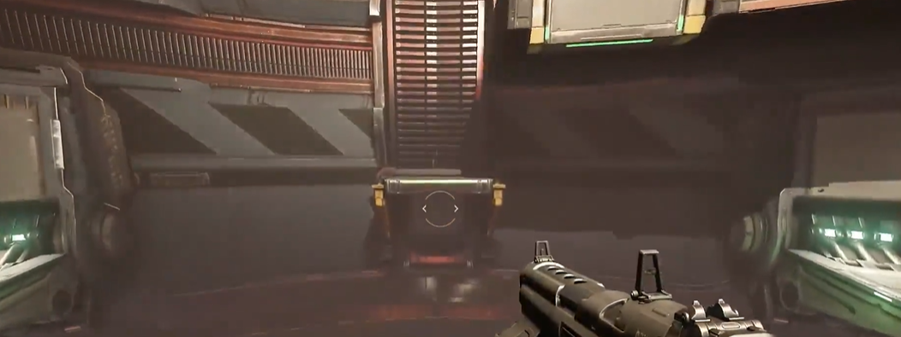
Figure 5: Green Lights for Conveyance [3]
- Other lights: yellow/white/blue lights are used to outline the obstacles or constructions. These can be used by the player to move around the space.
- Collectable supplies: have a shimmering effect.
- Stagger State: this is introduced by blue/yellow web outlines on the monsters’ body. Hinting the monsters can be glory killed at this point.
- The navigation system helps the player with where to go by a dot as prat of the HUD. So, the player knows where to go all the time.
- Doors: hinting at the next exploration area, sometimes pre-showing what’s coming next (monsters, collectables, transportation).
- Sound: Music switches between combat and exploration, hinting to the player about enemies coming/left.

Feedback
- Weapon: The weapons have different sound effects for feedback as for firing. The bullets fired have animation for shooting and hit, letting the player know about the attack result.
- Enemy: Enemies will enter stagger state to indicate their health is low and are near death. Sometimes enemies fall without stagger state to indicate death. Glory kills have special execution animation for each kind of monster.
- Interaction: General interactions have sound effects and the lights changing color for feedback for activation (for example doors opening), and some missions in the main plots have a finishing animation to indicate the end.

References
[1] C. to D. Wiki, “Doom (2016),” Doom Wiki, https://doom.fandom.com/wiki/Doom_(2016) (accessed Sep. 19, 2023).
[2] SkillProgressionChart, Anona Yang, 2023. Screenshot from Excel.
[3] “Doom”, id Software, 2016.

