Half-Life 2 Deconstruction
Designer: | Anona Yang
Document Date: | 10/11/2023

Table of Contents
Table of Contents 1
Table of Figures 2
High Concept 3
Skill Progression Chart 3
Gameplay Loops 6
Core (Primary) Gameplay Loop 6
Secondary Gameplay Loop 6
Tertiary Gameplay Loop 7
Gameplay Styles / Systems 8
Gameplay Systems 8
Gameplay Styles 14
Conveyances/Affordances 15
Feedback 19
References 21

Table of Figures

Figure 1: Skill Progression Chart [2] 5
Figure 2: Primary Gameplay Loop 6
Figure 3: Secondary Gameplay Loop 6
Figure 4: Tertiary Gameplay Loop 7
Figure 5: Health and Suit Charger [3] 8
Figure 6: Light at Night [3] 15
Figure 7: Green Light Conveyance [3] 15
Figure 8: Outdoor Color Contrast [3] 16
Figure 9: Indoor Light Contrast [3] 16
Figure 10: Logo [3] 17
Figure 11: Wire [3] 17
Figure 12: Pipe [3] 18
Figure 13: Pipe Vibration [3] 18
Figure 14: Map [3] 19
Figure 15: Ammo Pickup [3] 20

Game Deconstruction

High Concept
Half-Life 2 is a science fiction first-person shooter game developed and published by Valve Corporation. It was released on November 16, 2004. Half-Life 2 contains shooting, puzzles, and storytelling, and combines features such as carrier driving and classic physics-based gameplay. The player acts as Gordon Freeman as he joins a resistance movement to liberate Earth from the control of the Combine, which is a multidimensional alien empire. [1].

Skill Progression Chart
For additional details please check the File YangA_HL2_Deconstruction.xlsx uploaded, since the chart is too big to fit in the document as images.
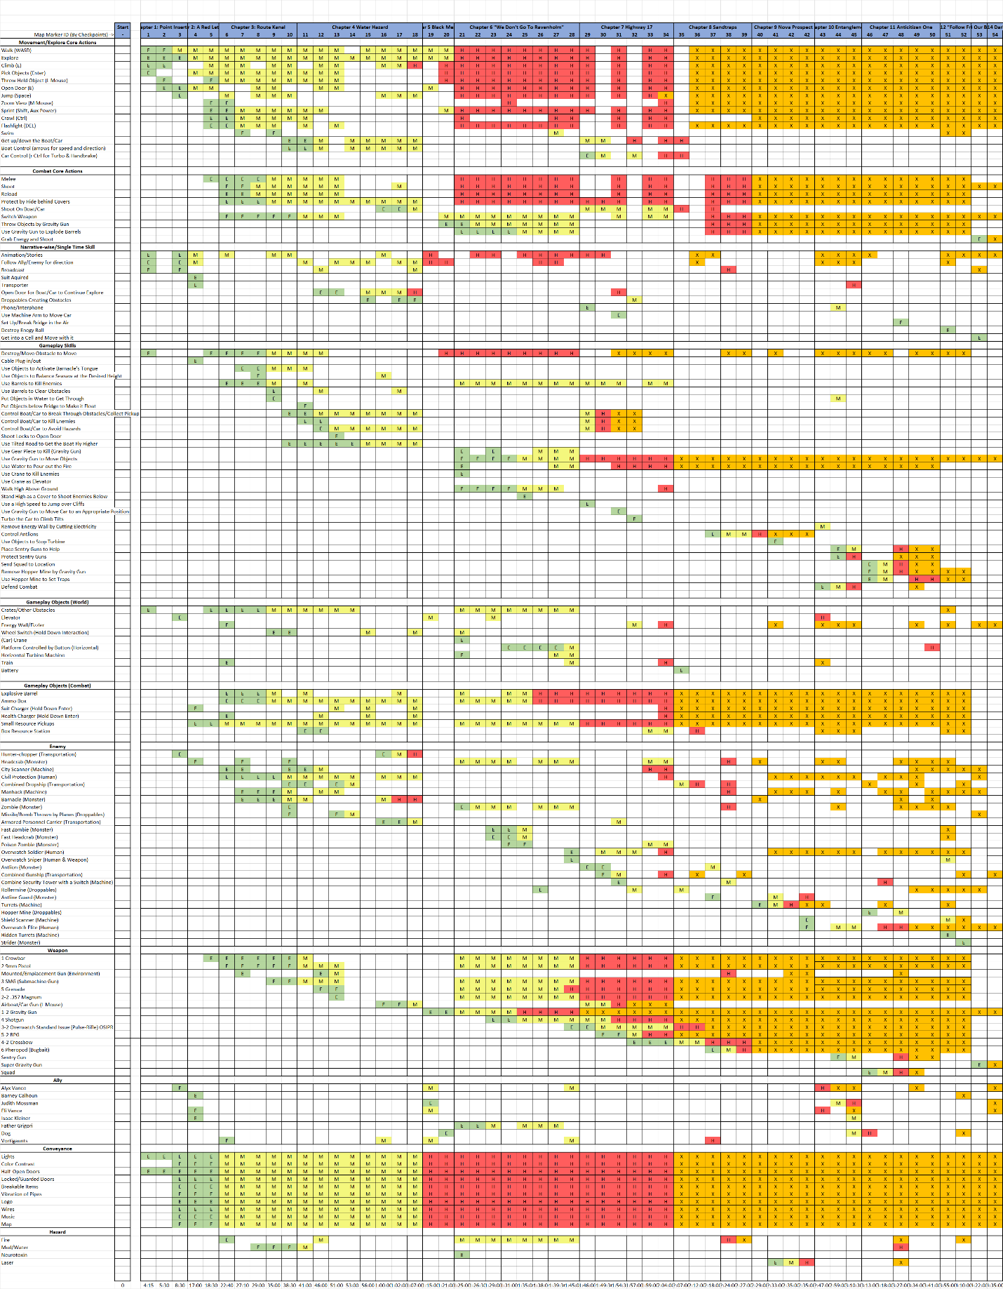
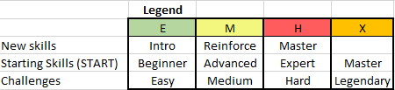

Figure 1: Skill Progression Chart [2]

Gameplay Loops

Core (Primary) Gameplay Loop

Figure 2: Primary Gameplay Loop

Secondary Gameplay Loop

Figure 3: Secondary Gameplay Loop

Tertiary Gameplay Loop

Figure 4: Tertiary Gameplay Loop

Gameplay Styles / Systems

Gameplay Systems
- Health
  - The player has a certain amount of health, armor (suit), and ammo (normal & alt). As the player consumes the supply, they can collect as they explore the map or kill the enemies.
  - Ammo drops upon combine soldiers killed.
- Pickup & Supply
  - 4 kinds of pickups: health, suit, ammo, and flashlight power.
  - 3 forms of pickups:
    - Directly pickup boxes of specific kinds in fixed amount.
    - Ammo box: need to destroy the box to obtain pickups, contains various kinds of pickup combination.
    - Box Resource Station: infinite supply of a specific kind of ammo, allowing pickup and usage in certain area. Usually exists in large combats and defending ones.
  - 2 charging supply: Suit and Health Charger
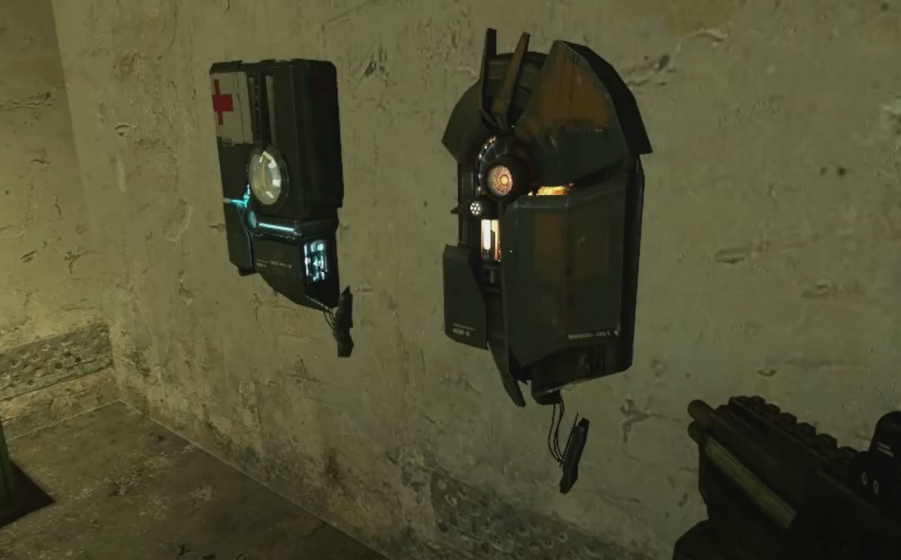
Figure 5: Health and Suit Charger [3]
    - Contains certain amounts of supply and disposable.
    - Interacted by holding down interaction.
    - Usually exists at areas with large combats happening (later chapters have a lot of them).
- Movements
  - Walk: most of the time.
  - Sprint:
    - Shares an AUX system with swimming underwater. If the AUX energy is used up, the player needs to wait for its recharging. Sprinting use AUX energy rather slowly.
  - Climb: when there’s a stair.
  - Jump: when moving in places that have a height/gap between objects.
  - Crawl: in tubes/rocks, etc. that have a thin space to get through.
  - Swim:
    - Swimming above water/under water, the latter consumes AUX energy faster than others.
  - Carrier: Air boat and car.
    - Can control the speed & direction of the carrier.
- Damage
  - Enemies get killed upon receiving certain amount of damage, which includes:
    - Melee
    - Shoot with different weapons (create different amount of damage)
    - Barrel Explosion (triggered by Gravity Gun)
    - Gear Cutting (thrown by Gravity Gun)
    - Smashing (by Crane Weight, or Carrier Speeding)
    - Attacks from third parties (Controlled Antlion, allies)
  - The player receives damages that includes:
    - Enemy attacks
      - Direct attacks from monsters: melee in general.
      - Shooting from soldiers and carriers.
      - Droppable including: bombs, mines, etc.
      - Lasers from turrets.
    - Hazard
      - Fire: environmental; created by barrel explosion.
      - Water/Mud: need to get across by jumping above objects.
      - Neurotoxin: emitted by certain objects.
    - Physics
      - Falling from height/to pit
      - Smashing too hard (in carriers)
- Narrative-wise
  - Animation/Stories
    - Waking up with a man in conscious to give the context, also ending the story with him.
    - NPCs act the stories, with movements/interactions/dialogues.
  - Follow Ally/Enemy
    - As NPCs move across space, they also lead the way and open closed doors for players.
    - Flying combine carriers fly in certain paths, which leads the way to the destination players need to go.
  - Broadcast
    - Environmental sound.
    - Tower destroyed feedback.
    - Conveyance for direction & enemy NPC acting in combine facilities.
  - Phone/Interphone
    - Allies may communicate with the player for instructions through phones when they are not right beside.
  - Time
    - The game takes 2 days in the game world.
    - Reflected by the daylight: sunset around Black Mesa east, night at Ravenholm, day at highway again.
  - Ally
    - Alyx Vance: deuteragonist, leads the way most of the time.
    - Barney Calhoun: tritagonist, guard, opens doors in the facility.
    - Judith Mossman: scientist, triple agent, more functional in the narrative.
    - Eli Vance: Alyx’s father, hostage at some point.
    - Isaac Kleiner: scientist, stays in the teleporter entrance.
    - Father Grigori: only known surviving occupant of Ravenholm, leads the way there.
    - Dog: Alyx’s pet robot that helps the player to master gravity gun.
    - Vortigaunts: auxiliary characters, set up airboat gun for the player.
- Interactable/Gameplay Objects
# | Name | Description | Possible Interactions
1 | Door | Open/locked | open
2 | Elevator | Narrative transition for space | Button interaction
3 | Sawblade (gear) | Sharp on the edge  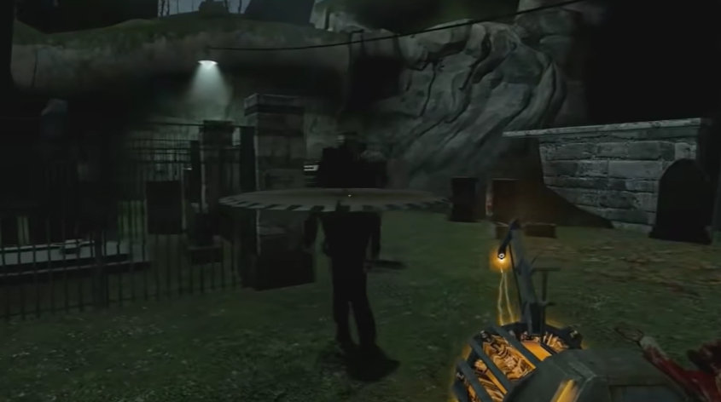[3] | Kill enemies and break obstacles
4 | Crane | 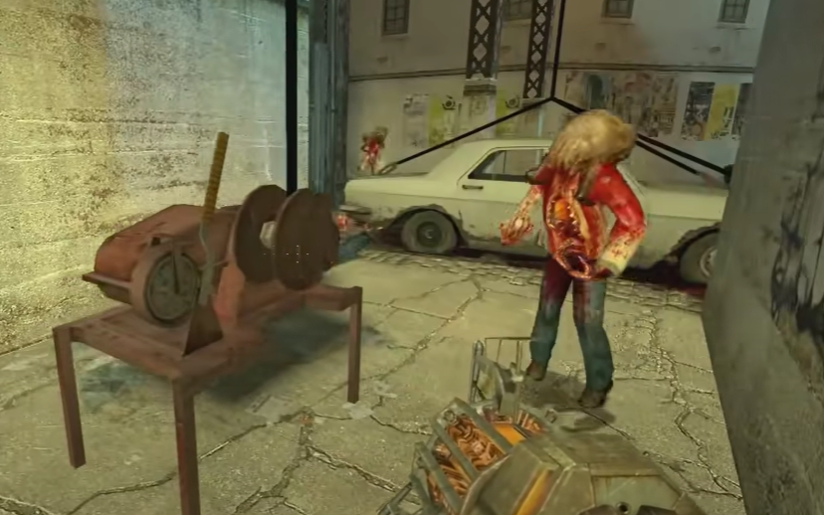[3] | Kill enemies and maneuver as bridge
5 | Platform | 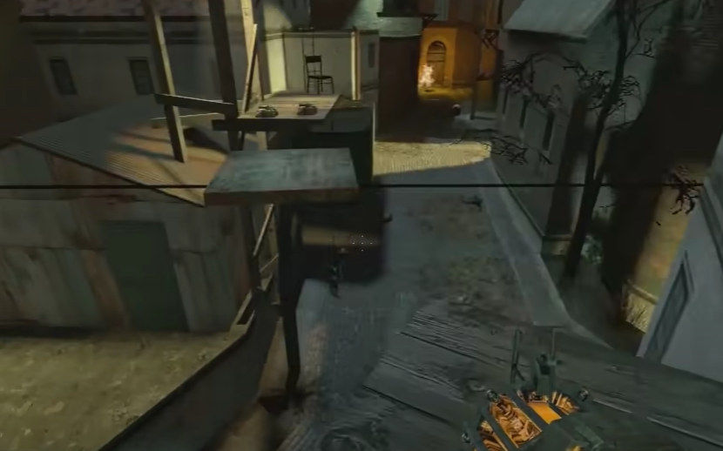[3] | Maneuver, controlled by buttons
6 | Turbine Machine | 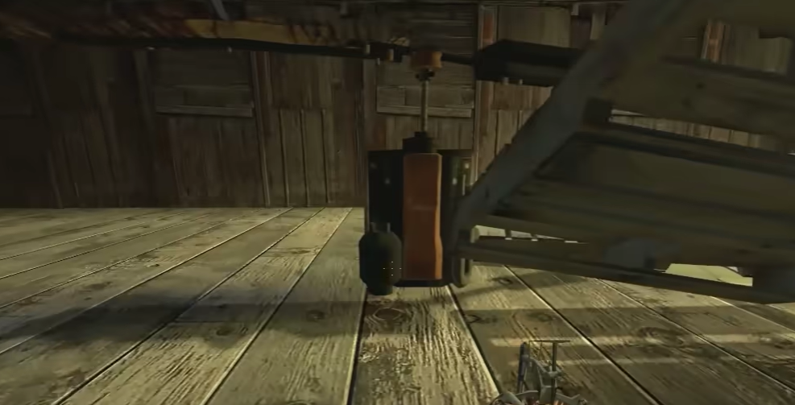[3] | Kills enemies
7 | Fizzler | 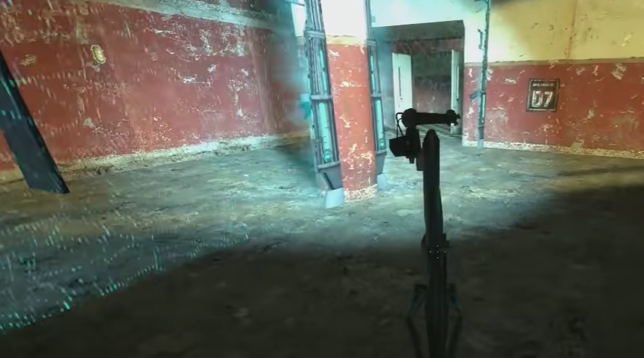[3] | Physical barrier, but not for bullets
8 | Machine Arm | 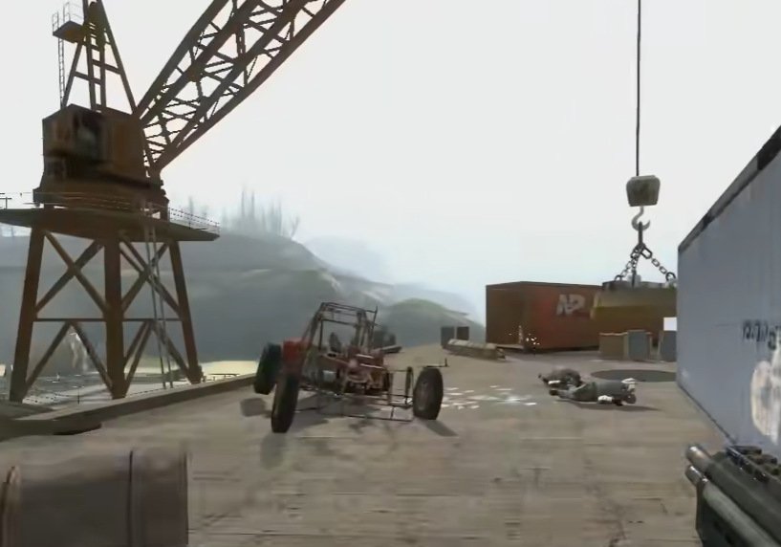[3] | Moves the car or other huge objects.
9 | Train | / | Move with it and use it as a bridge to get onto the other side of the building.  Obstacles to crawl underneath.
10 | Wheel Switch | Hold down interaction to switch | Switch for tube/gate/many things
11 | Battery | / | Connect electric circuit.
12 | Cable | / | Plug in/out to connect/disconnect circuit.
13 | Energy Ball | 1. energy power for combine  2. weapon for gravity gun | Destroy/use as weapon by gravity gun

- Puzzle-wise Mechanics
# | Name | Function
1 | Obstacle | Move away/explode/smash with velocity to get a path through.
2 | Electricity | Connect/disconnect circuit to activate/deactivate objects including fizzler, teleporter, etc.
3 | Buoyancy/Gravity | Put objects on certain places and use their weight to create a platform.
4 | Guards | Clear guards to open spaces
5 | Speed | Carrier speeding for smashing or getting over gaps.
6 | Maneuver | Bridge/platform/gate/elevator, that are activated by buttons.  Stack boxes to get to higher platforms.  Put items to have moving machines stuck and move over.
7 | Help | Call Antlions/Call Following Quad/Place Sentry Gun  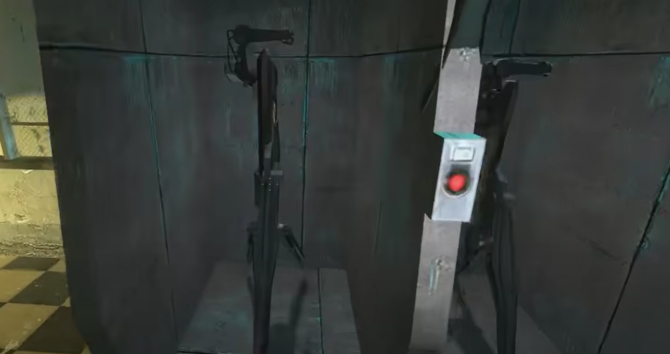[3]

- Weapon
  - The player has many guns and grenades as their weapons.
  - Use Q or number keys to switch. T for BFG and G for Chainsaw.
# | Name | Bullet Type | Reload | Damage | Range | Play Style
1-1 | Crowbar | / | short | low | narrow | melee
2-1 | 9mm Pistol | 2 | short | low | narrow | ranged
0-1 | Emplacement Gun | infinite | short | medium | narrow | ranged
3-1 | SMG (Submachine Gun) | 3 | medium | medium | narrow | ranged
5-1 | Grenade | grenade | medium | high | medium | ranged
2-2 | .357 Magnum | 2 | medium | medium | medium | ranged
0-2 | Airboat/Car Gun (L Mouse) | infinite | short | medium | medium | ranged
1-2 | Gravity Gun | Infinite/objects | medium | various | various | ranged
4-1 | Shotgun | 4 | long | high | medium | ranged
3-2 | Overwatch Standard Issue (Pulse-Rifle) OSIPR | grenade | medium | high | medium | ranged
5-2 | RPG | rockets | long | massive | wide | ranged
4-2 | Crossbow | 4 | long | high | narrow | ranged
6 | Pheropod (Bugbait) | pheropod | medium | / | wide | ranged
0-3 | Sentry Gun | Automated infinite | short | high | wide | ranged
1-3 | Super Gravity Gun | Infinite/objects | long | High | wide | ranged
0-4 | Squad | Automated infinite | short | Medium | wide | ranged

- Enemy
  - 4 kinds:
    - Xen: Monster
    - Combine: Human, Machine, Carrier
# | Name | Health | Damage | Attack | Play Style
1 | Hunter-chopper (Carrier) | low | low | ranged | ranged
2 | Headcrab (Monster) | low | low | melee | ranged
3 | City Scanner (Machine) | low | low | ranged | ranged
4 | Civil Protection (Human) | low | low | ranged | ranged
6 | Combined Dropship (Transportation) | high | high | ranged | ranged
7 | Manhack (Machine) | low | low | ranged | ranged
8 | Barnacle (Monster) | low | medium | Tongue grabbing | ranged
9 | Zombie (Monster) | medium | medium | melee | ranged
10 | Missile/Bomb Thrown by Planes (Droppable) | / | medium | explosion | movements
11 | Armored Personnel Carrier (Carrier) | high | high | ranged | ranged
12 | Fast Zombie (Monster) | medium | medium | melee | ranged
13 | Fast Headcrab (Monster) | medium | medium | melee | ranged
14 | Poison Zombie (Monster) | medium | high | melee | ranged
15 | Overwatch Soldier (Human) | medium | medium | ranged | ranged & melee
16 | Overwatch Sniper (Human & Weapon) | medium | high | ranged | ranged
17 | Antlion (Monster) | medium | medium | melee | ranged
18 | Combined Gunship (Carrier) | high | high | ranged | ranged & melee
19 | Combine Security Tower with a Switch (Machine)  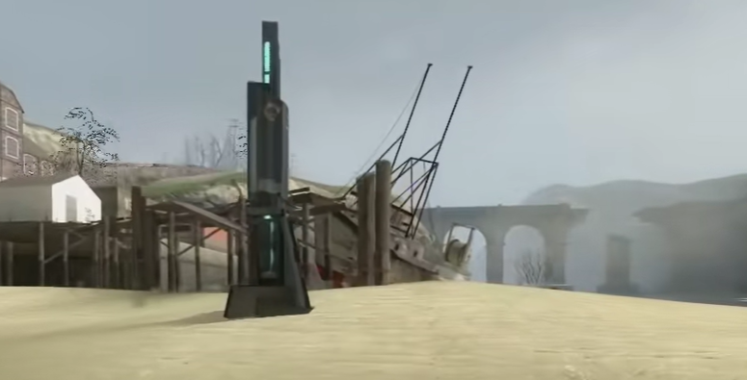[3] | / | / | Turning off will result in security broadcast | explore
20 | Rollermine (Droppable) | / | medium | explosion | Gravity gun
21 | Antline Guard (Monster) | high | high | melee | ranged
22 | Turrets (Machine) | / | high | ranged | ranged & melee
23 | Hopper Mine (Droppable) | / | medium | explosion | melee
24 | Shield Scanner (Machine) | high | / | Drop bombs | ranged
25 | Overwatch Elite (Human) | high | high | ranged | ranged
26 | Hidden Turrets (Machine) | medium | medium | ranged | ranged
27 | Strider (Monster) | high | massive | combined | ranged

Gameplay Styles
- Combat:
  - All combats are driven by narrative, killers might be forcing themselves to follow narrative until combats come to place.
  - The enemies in HL2 are a combination of monsters, soldiers, and carriers, with respective focused gameplay style of melee, ranged, and combined. And the weapons in HL2 also provide a wide range of selection to pick from.
  - Killers tend to kill any enemies left in the map. The varied types and combination of enemies create a combat environment for them to have fun with the weapon correlation. And the help from turrets, antlions, and quads provides more fun to explore combat possibilities.
  - Explorers must kill enemies to proceed with their exploration. With more and more weapons introduced and allies helping they can work with the combat with rather low difficulty.
- Exploration:
  - There is only one way to explore in a linear manner, most of the puzzles have no other possibilities to solve or get by.
  - Explorers tend to explore the map thoroughly for seldomly discovered scenery and hidden supply pickups. The hidden pickups also help explorers that are not good at combat to survive.
  - Killers can also engage in exploration since some secret pickups provide more possibility during combat.
- Achievement:
  - Achievers may have fun with the achievement systems since some of them are hard to reach and maybe even unrelated to the normal way of solving the puzzles.

Conveyances/Affordances
- Lights
  - White/Light Blue lights in nights to show direction by its color contrast.
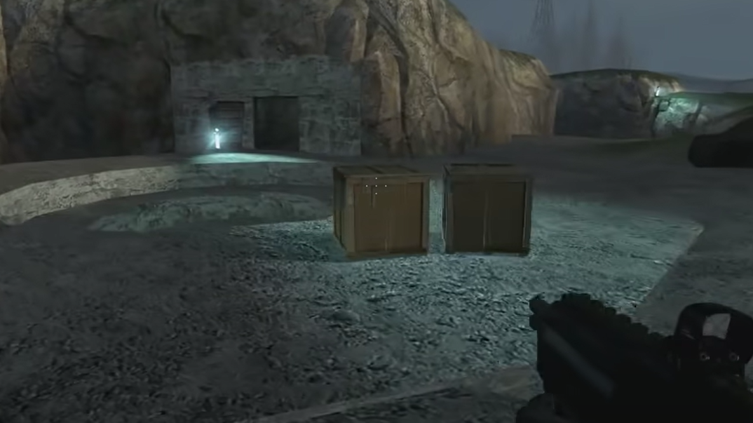
Figure 6: Light at Night [3]
  - Green/red lights to show switch status.
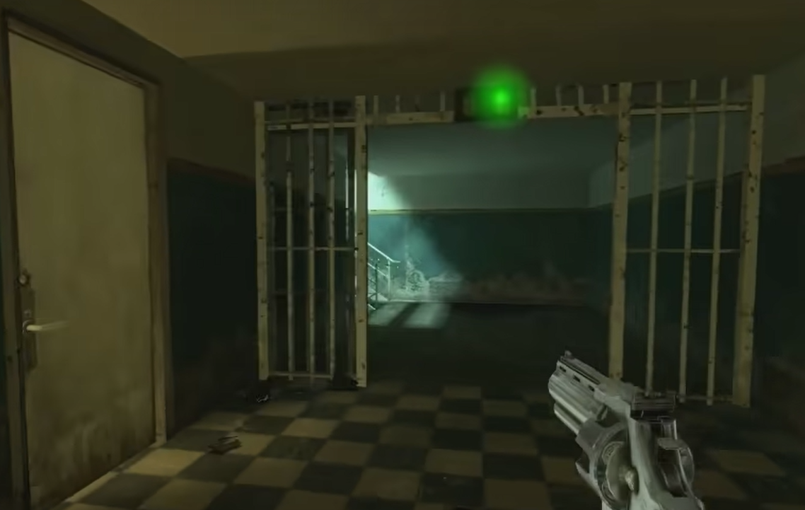
Figure 7: Green Light Conveyance [3]
- Color Contrast
  - Environmental: light and dark textures on the side and in the middle to show the way.
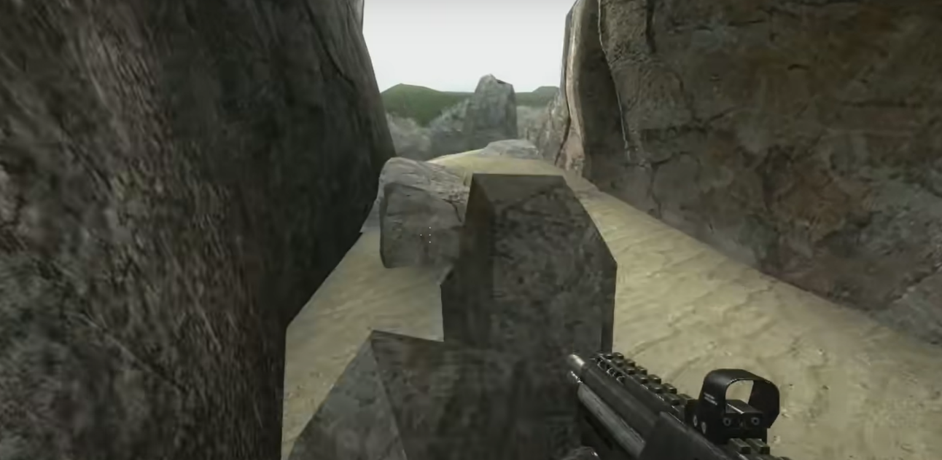
Figure 8: Outdoor Color Contrast [3]
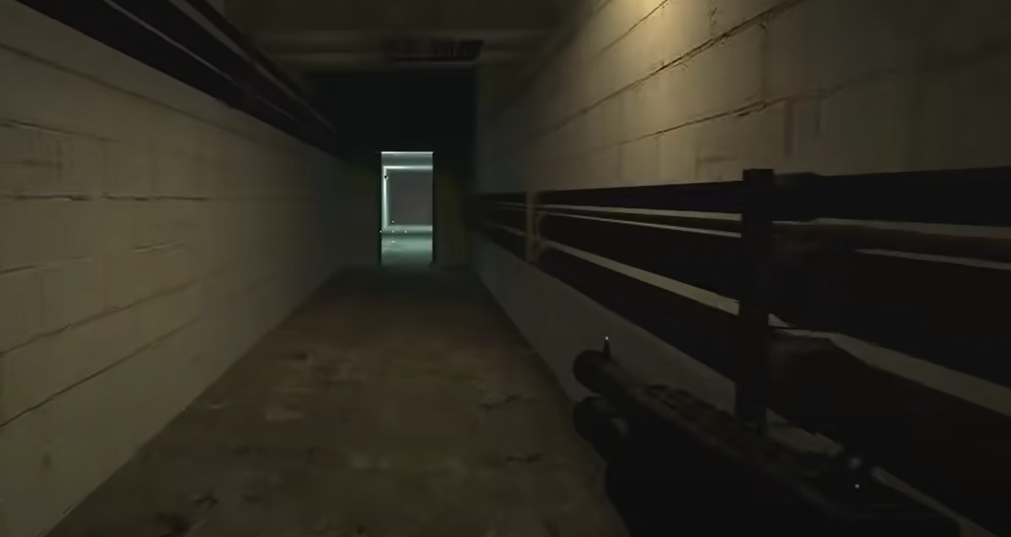
Figure 9: Indoor Light Contrast [3]
- Half-Open Doors and Locked/Guarded Doors
  - Some half-open doors are put in the early chapters to help the player learn about the doors for place transitions.
  - When getting through doors became an instinct for the player, the doors in later chapters come with guards in front of it & locks to catch attention.
- Movement
  - When the player gets closer to someplace, animals or props will move in front of the player to catch its attention.
- Breakable Items
  - Obstacles on the way towards the areas ahead, such as windows and boxes.
- Landmarks in the city
- Logo
  - The lambda logo on walls and buildings helps the player to find direction when the environment is too complex to navigate.
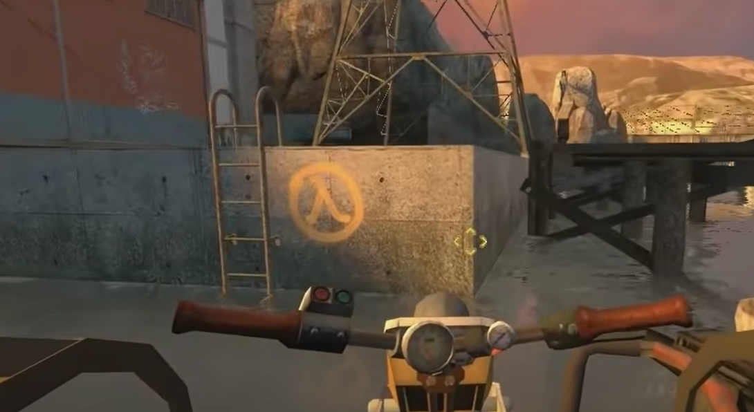
Figure 10: Logo [3]
- Wires/Pipes
  - Wires along the highway & tubes with a tilted height
  - When standing high, the pipes that have enemies climbing on it will shiver to indicate the enemies’ existence.
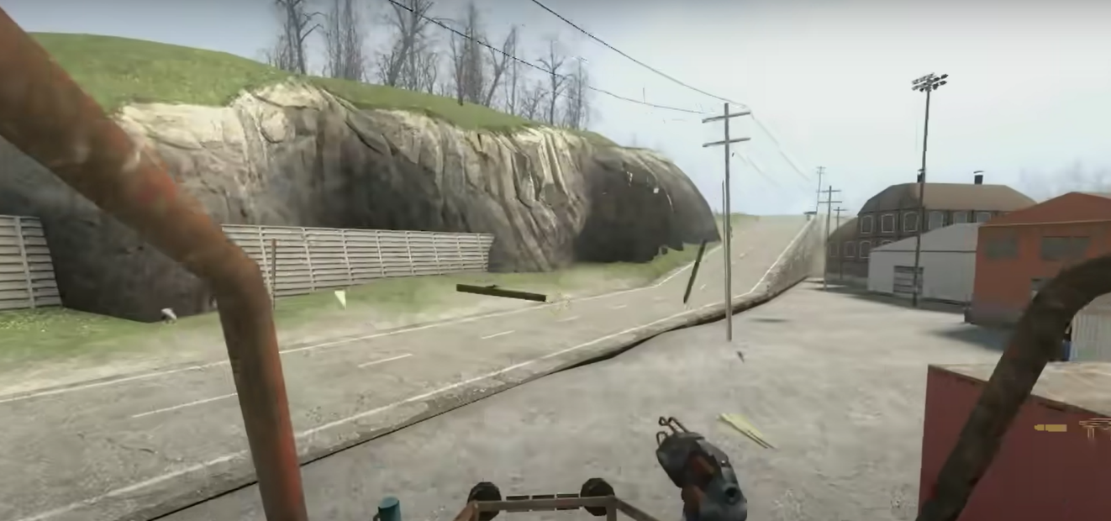
Figure 11: Wire [3]
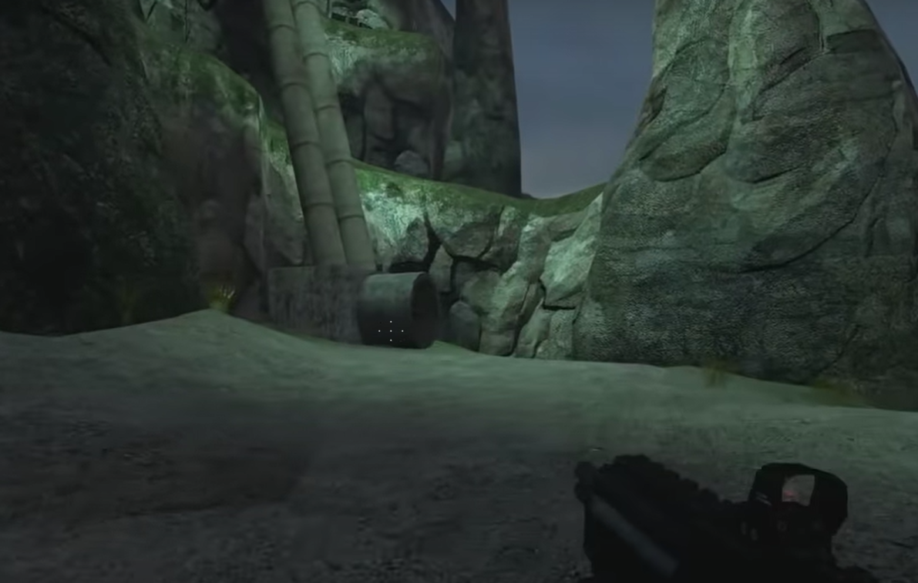
Figure 12: Pipe [3]
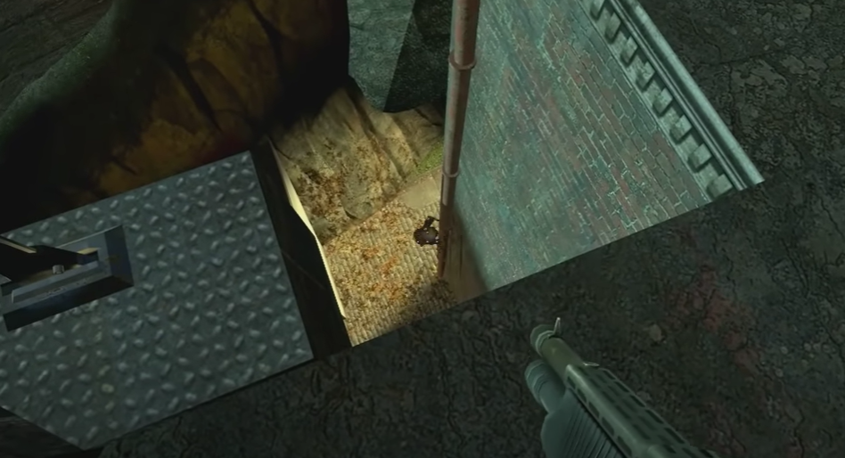
Figure 13: Pipe Vibration [3]
- Music
  - When entering an important combat or speeding on the way, music with respective style with start to help the player engage.
- Map
  - In transitions between exploration areas, there will be a map set up in the room with NPCs introducing where the player is and where he should go to.
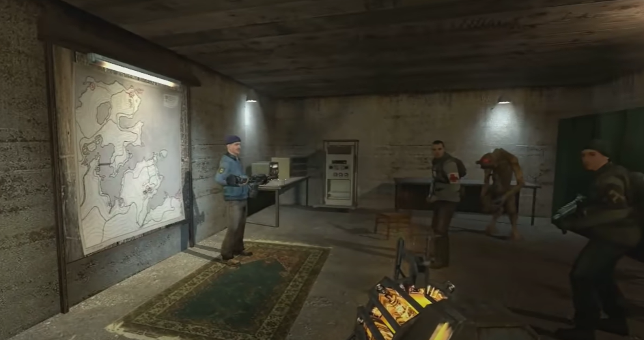
Figure 14: Map [3]
- HUD/UI
  - Health, Suit, Ammo with specific numbers.
  - Control for Boat/Car on the right side of the screen when getting up.
  - Pickup/Full indication.
  - Damage resulted with be shown with a light red shadow on the full screen.

Feedback
- Weapon: The weapons have different sound effects for feedback as for firing. The bullets fired have animation for shooting and hit, letting the player know about the attack result.
- Enemy: Enemies have a death animation, and some of them have a growl sound to indicate the death.
- Pickup: when gathering supplies, there will be sound and HUD for picked-up. When the ammo is full, there will be HUD to indicate it.
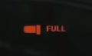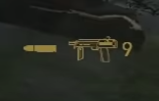
Figure 15: Ammo Pickup [3]

- Interaction: General interactions have sound effects and the lights changing color for feedback for activation (for example the doors that can’t be open give a failure sound upon interaction).
- Narrative: when reaching a new checkpoint, there will be loading HUD on the screen. And there will be chapter names in the middle of the screen to indicate the chapter-wise progression.

References
[1] “Half-life 2,” Wikipedia, https://en.wikipedia.org/wiki/Half-Life_2 (accessed Oct. 11, 2023).
[2] “SkillProgressionChart,” Anona Yang, 2023. Screenshot from Excel.
[3] “Overview and Walkthrough Maps,” Anona Yang, 2023. Screenshots from Half-Life 2.

