

Dying Light: Memories of Old
  - Version 1.0
Designer: | Anona Yang
Document Date: | 9/26/2024
Intended Level Delivery Date: | 12/1/2024

Document Revisions Table
Version | Description | Requestor | Date
1.0 | Initial Document | Professor Brandon Stephens | 9/29/2024

Table of Contents
Table of Contents 2
Table of Figures 3
Level Summary 4
Quick Summary 4
Level Feature Overview 4
Development Schedule 4
Level Overview 5
Overview Map 5
Level Details 7
Detail Maps 7
Playground 7
Forest 9
Hill 11
References 13
Appendices 14
Appendix A: Asset Lists 14

Table of Figures

Figure 1: Overview Map [1] 5
Figure 2: Playground [1] 7
Figure 3: Forest [1] 9
Figure 4: Hill [1] 11

Level Summary

Quick Summary
“Memories of Old” is a narrative-rich, independent single-player level in Dying Light. The level uses environmental storytelling to recount the life of a boy who grew up in a broken family but held onto his faith until his death. The level unfolds as a flashback dream of the boy’s life as he confronts his final moments.

Level Feature Overview
Category | Sub-Category | Feature List
Gameplay Themes |  | - Environmental narrative
 |  | - Parkour (avoid enemy in group spawners, play with verticality by floating objects)
Player | Player Weapons | - Baseball bat  - Heavy axe  - Military Machete
 | Player Skills/Abilities | - Parkour
AI | Enemies | - Biter  - Viral  - Goon
 | Friendlies | - /
Challenges | Obstacles/Hazards | - /
 | New/Unique Gameplay | - Triggered scenes/dialogues for environmental storytelling
Context | Location in Game | - Independent level as a dream
 | Challenge Fit in Game | - Somewhere around the old town
 | Narrative Fit | - Independent
 | Basic Backstory / Results Info | - The boy is facing his death, this level is a flashback of his life.
Aesthetics | Major Visual Themes | - Gloomy forest, cold houses, twisted reality and bright playground
 | Setting/Mood | - Sad, gloomy, relieved

Development Schedule
Milestone | Date
LDD | 9/29/2024
Whitebox | 10/13/2024
Initial Gameplay | 10/20/2024
Gameplay Complete | 11/3/2024
Aesthetics | 11/24/2024
Launch | 12/1/2024

Level Overview

Overview Map
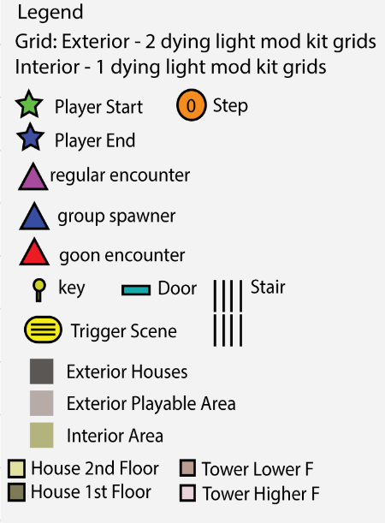
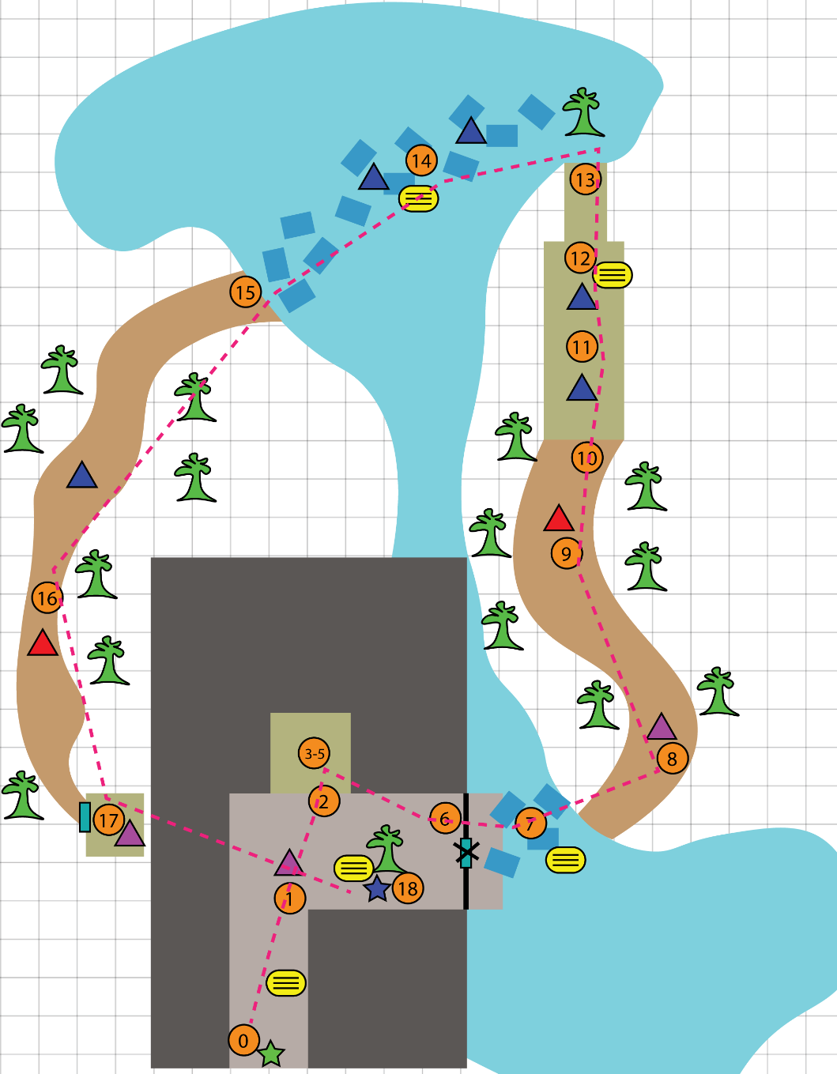
Figure 1: Overview Map [1]

Map Label | Gameplay Summary
Playground | - Player spawns at the entrance of the playground.  - Player encounters some enemies and hides into the house.  - Player picks up the key and unlock the gate to the dock.
Forest | - Player parkours through the floating objects above the river.  - Player parkours and fights the enemies through the forest.  - Player climbs up to the top of the tower, parkours through the dining hall, and jumps down onto an island.
Hill | - Player parkours through the floating objects above the river.  - Player climbs up the hill, encountering some enemies.  - Player slides down, enters a room and kills a screamer.  - Player exits the room and gets teleported back to the playground.  - End of Game

Level Details

Detail Maps

Playground
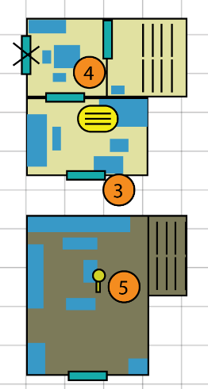
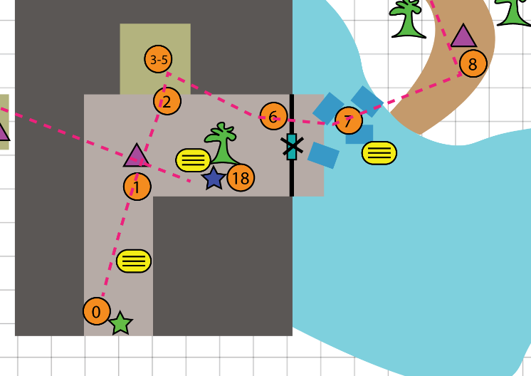
Figure 2: Playground [1]

Map Label / Stage | Event Summary  (Quest Objective) | Event Details
0 | - Player spawns | - Player (P) spawns, without control  - [daytime: 7] around dusk, just before the sun comes out.  - Trigger Scene (TD1): a boy stands at the telephone booth under warm lights, saying something, and the light flickers out, the boy disappears.
1 | - Clear the enemies | - P walks into the community playground.  - Encounter (E1): [W1] 2 biters [W2] 1 biter  - Trigger Scene (TD2): After the encounter, a girl appears on the tree, reading a book. The boy, standing beside the tree, asks the girl something.  - [daytime: 9] the children disappear.
2 | - Hide inside | - A goon spawns around the playground entrance, chasing P to enter the house.  - A warm light is turned on in the residential buildings, P parkours into the House.
3 | - Listen to what’s happening | - P gets into the boy’s bedroom, there’s a door leading to the kitchen & wareroom area, but it is locked at first.  - Trigger Scene (TD3): the boy’s parents are arguing, with sound effects of breaking glass or throwing something  - After the dialogue is over, the door is unlocked.
4 | - Look around the house | - P gets into the kitchen and finds some leftover food (loot resources).
5 | - Grab the key | - P gets to the first floor through the stair.  - P picks up the gate key on the living room table.
6 | - Get to the dock | - [daytime: 17] P gets out of the House, uses the key to unlock the gate and enters the dock.

Forest

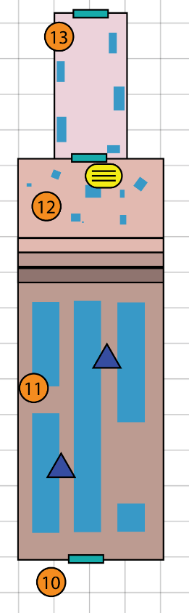
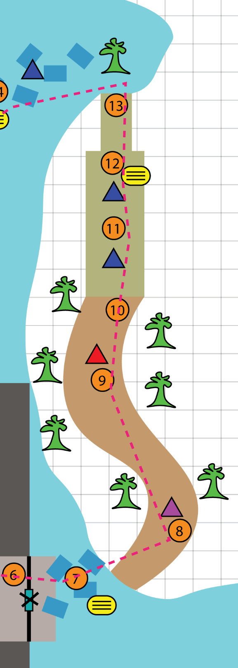
Figure 3: Forest [1]

Map Label / Stage | Event Summary  (Quest Objective) | Event Details
7 | - Enter the forest | - P parkours across the river through floating objects (mostly books/ note piles). There are streetlights showing the intended way.  - Trigger Scene (TD4): narration dialogue about the boy’s growing up in school life.
8 | - Clear the enemies | - P enters the forest and encounters enemies.  - Encounter (E2): [W1] 2 biters [W2] 1 biter, 1viral.
9 | - Run over the enemies | - [daytime: 20] P parkours to go deep into the forest.  - Encounter (E3): [W1] 1 goon, 3virales [W2] 2 biters.
10 | - Reach the tower | - [daytime: 21]  - P gets to the Tower.  - P parkours to get onto the top of the tower.
11 | - Get inside the tower | - P parkours through the dining hall, the hall lights up as P gets closer to the end.  - Encounter (E4): some group spawners of biters and virals.
12 | - Climbs to the hallway  - Side Quest | - P parkours over the floating objects of candlesticks, chairs and tables to reach the top hallway.  - Trigger Scene (TD5): a voice lures the boy to betray his faith, “whatever you do, you will fall back at the end”, “now jump”.  - Side Quest: P interacts with the chair, triggers a short dialogue, where a voice asks the player to gather a few objects scattered in the dining hall. If the player finishes the side quest, they will get additional narrative information and supplies.
13 | - Jump down the tower | - P jumps over from the top of the tower and lands on a trash pile on an island in the river, which is a replicate playground.

Hill
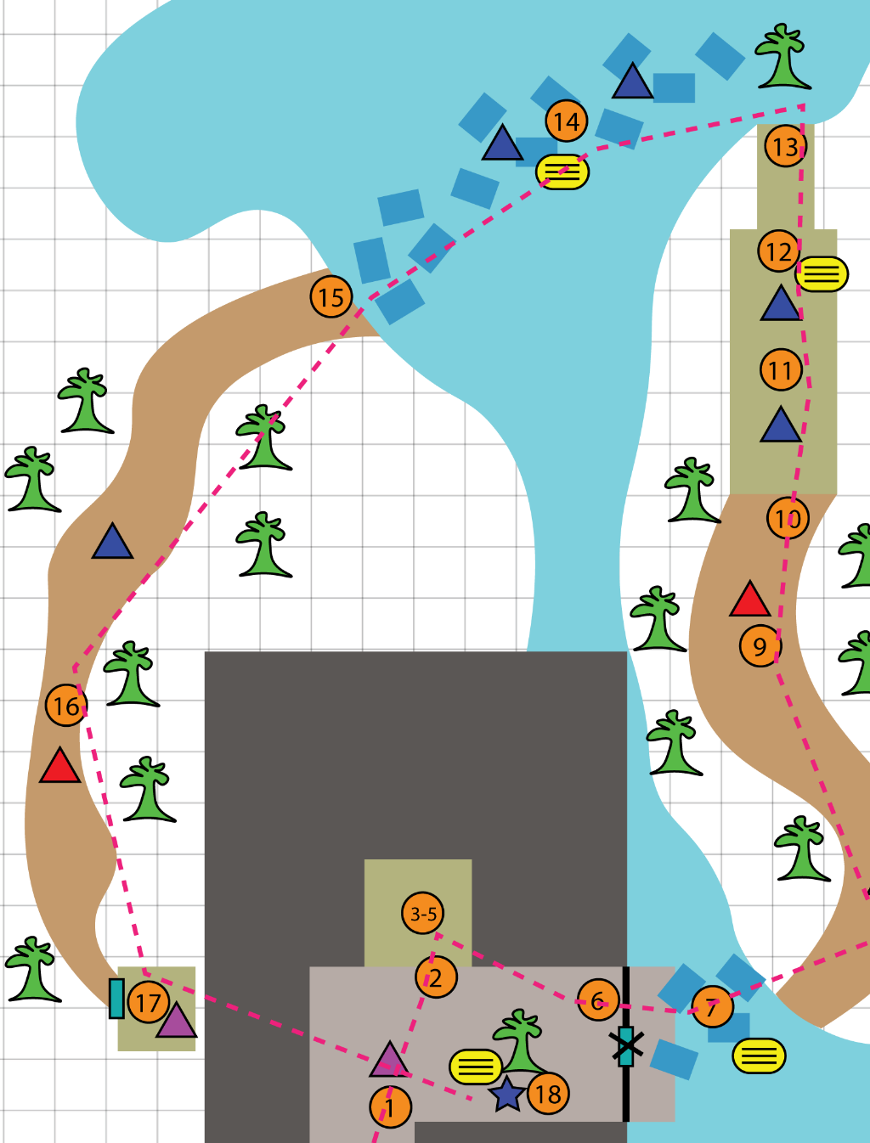
Figure 4: Hill [1]

Map Label / Stage | Event Summary  (Quest Objective) | Event Details
14 | - Cross the river | - [daytime: 23] P parkours to across the river through floating objects (mostly letters, bottles, photographs, mirrors), also have streetlamps to lead the way.  - Encounter (E5): group spawners of biters,virales.  - Trigger Scene (TD6): lots of talking surrounding the boy, but not relative to himself directly, lively but lonely.
15 | - Get on to the hill | - [daytime: 6] P climbs the hill, and parkours over some enemies.  - Encounter (E6): groups spawners of biters (but not as much E5) with 1 goon.
16 | - Slide down | - P reaches the top of the hill and slides down.  - P sees a small house and interacts with the door to get in.
17 | - Kill the screamer | - P encounters a screamer and some biters. Once the P kills the screamer, all the other enemies are dead.  - E7: 1 screamer, some group spawners of biters.
18 | - Exit the room | - [daytime: 9] P exits the door and gets teleported to the big tree at the playground. The game ends with the girl and the boy reappearing on the beside the tree.

References
[Cover Image] Anona Yang, Screenshot in Dying Light. Sep. 26, 2024.
[1] “Level Maps”, Anona Yang, Made in Illustrator. Sep. 26, 2024.
[2] “Asset References”, Anona Yang, Screenshot from Dying Light Developer Tool. Sep. 26, 2024.
[3] “Asset References”, Anona Yang, Screenshot from Miro. Sep. 26, 2024.

Appendices

Appendix A: Asset Lists
Description | Type | Priority
Trees  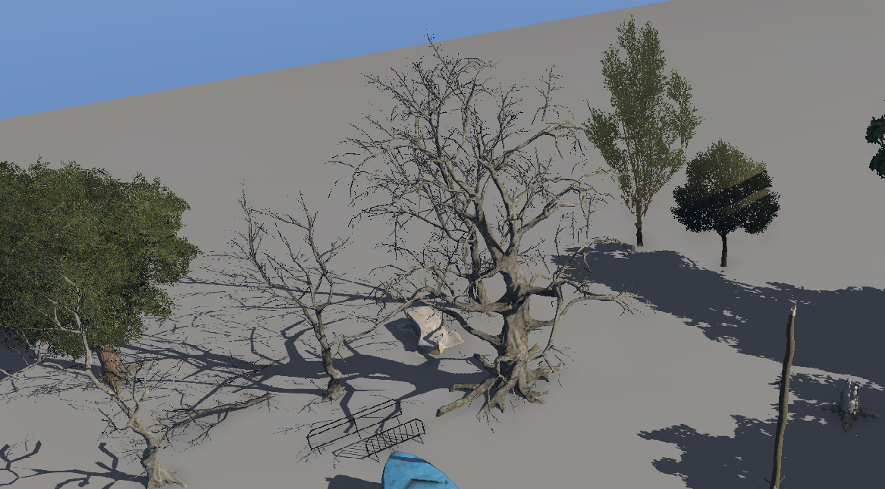[2] | Mesh | High
Boat  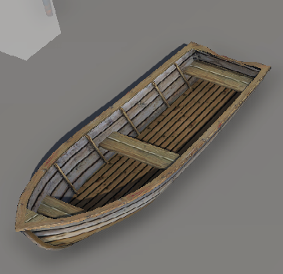[2] | Mesh | Low
Documents/Notes/Other scattered floating items  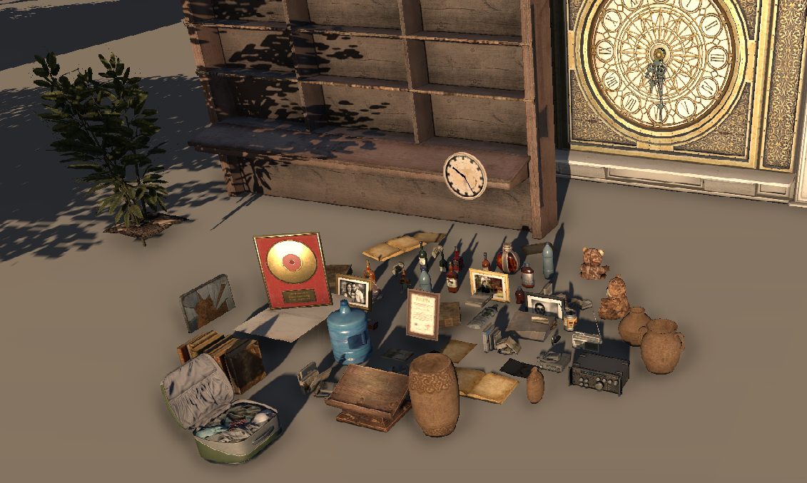[2] | Mesh | High
Houses & Tower  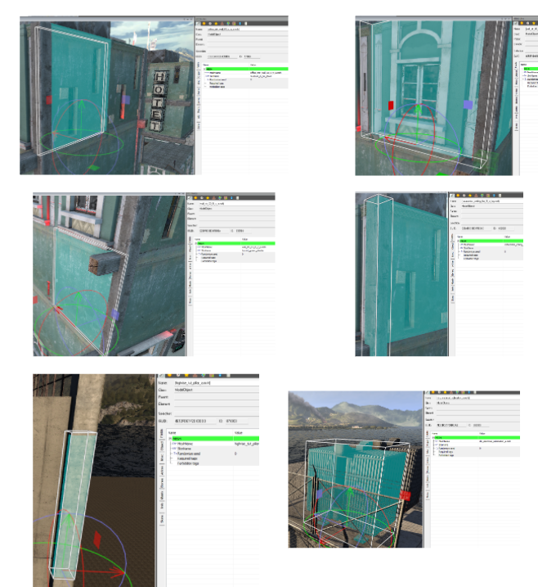[3]  And mod kits | Mesh | High

