

The Falling Star
  - Version 1.0
Designer: | Anona Yang
Document Date: | 2/2/2025
Intended Level Delivery Date: | 5/1/2025

Document Revisions Table
Version | Description | Requestor | Date
1.0 | Initial Document | Professor Mike Porter | 2/4/2025

Table of Contents
Table of Contents 2
Table of Figures 2
Level Summary 4
Quick Summary 4
Level Feature Overview 4
Development Schedule 4
Level Details 5
Level Map 5
Map 1 – Introductory Scene (Dream) 5
Map 2 – Home (Current) 7
Map 3 – Forest (Dream) 10
Map 4 – Street (Dream) 14
Map 5 –Hospital (Dream) 17
Skill Progression Chart 19
Appendix A: Aesthetic References 20
Grey-Scaled Dream World 20
Colorful Islands & Floating Text for Narration 21
Appendix B: Systems 22
Quest System 22
Interactable System 22
Journal System 22
Appendix C: Context 23
Backstory 23
Aftermath 23
Appendix D: Characters 24
Character 1: Mother Mu 24
Character 2: Auntie Jiang 24
Character 3: Grandma Duan 24
Character 4: Uncle Lin (the man) 24
References 25

Table of Figures
Figure 1: Introductory Scene Map (Dream) [7] 5
Figure 4: Introductory Scene Map (Dream) [7] 7
Figure 3: House 1st Floor Closer Look [7] 7
Figure 2: House 2nd Floor Closer Look [7] 7
Figure 5: Forest Map (Dream) [7] 10
Figure 6: Street Map (Dream) [7] 14
Figure 7: Hospital Map (Dream) [7] 17
Figure 8: Skill Progression Chart 19
Figure 9: Contact Sheet for Visual Theme 1 [1,2,3,4] 20
Figure 10: Contact Sheet for Visual Theme 2 [1,5,6] 21

Level Design Document

Level Summary

Quick Summary
In The Falling Star, a 20-minute first-person exploration and narrative-driven walking simulator, the player takes on the role of a girl whose mother has recently passed away. Following her final wish, the player embarks on a journey to uncover the story of her missing aunt’s past. Through solving puzzles and piecing together forgotten memories, the player unravels emotionally charged stories within a fragmented dream world.

Level Feature Overview
Category | Sub-Category | Feature List
Player | Player Weapons | - N/A
 | Player Skills/Abilities | - Walk/Read/Interact/Navigate
AI | Enemies | - N/A
 | Friendlies | - Static NPCs
Challenges | Gameplay Themes | - Exploration  - Piece together lost memories
 | Obstacles/Hazards | - (Easy) puzzle
 | New/Unique Gameplay | - Atmospheric interaction to enhance the mood of narrative
Context | Where Fits in Game | - N/A
 | Challenge Fit | - N/A
 | Additional Info | - This is a story that happened in the dream.
Aesthetics | Major Visual Themes | - Low poly/gray-scaled
 | Setting/Mood | - Melancholic/dreamy

Development Schedule
Milestone | Date
LDD | 2/4/2025
Whitebox | 2/18/2025
Initial Gameplay | 3/11/2025
Gameplay Complete | 4/8/2025
Aesthetics | 4/22/2025
Launch | 5/1/2025

Level Details

Level Map

Map 1 – Introductory Scene (Dream)
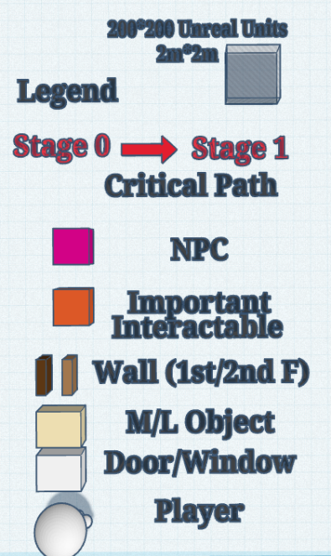
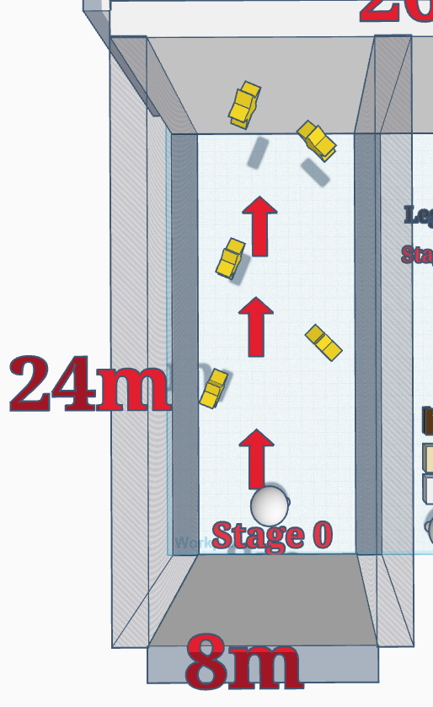
Figure 1: Introductory Scene Map (Dream) [7]

Map Label | Summary & Objective | Narrative & Details | Aesthetic Notes
0 | Introductory Scene | (No objective)  (As the player walks, stars rise into sky and are lit up one by one with the narrative lines appears beside them.)  - (S1) My mother was never in great health.  - (S2) Year after year, her coughs had accompanied me through rain and thunder but never faded with nightfall.  - (S3) It always plays a strong beat on my heart, as I know that she's always there.  - (S4) As earliest as I can recall, she would sit at her desk, gazing at the stars on late nights.  - (S5) I always wondered what she was looking at. Her gaze seemed to pierce through the heaviness of time into something - or someone - that I knew nothing about.  - (S6) But anything hidden in her sky is now meaningless.  - (S7) The curtain of stars has lifted, and her sky has become my sky.  (transition into the graveyard, after entering, enable a huge wall so the player can't see the trail coming in) | - The floor is reflective like a mirror.  - The sky starts with pure black and transitions to pure white after the scene ends.

Map 2 – Home (Current)
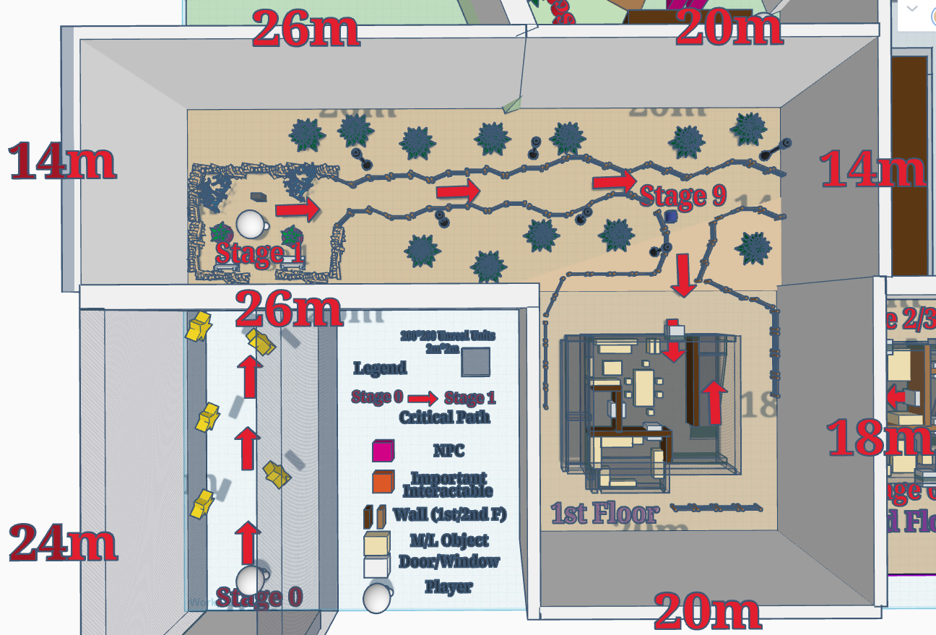
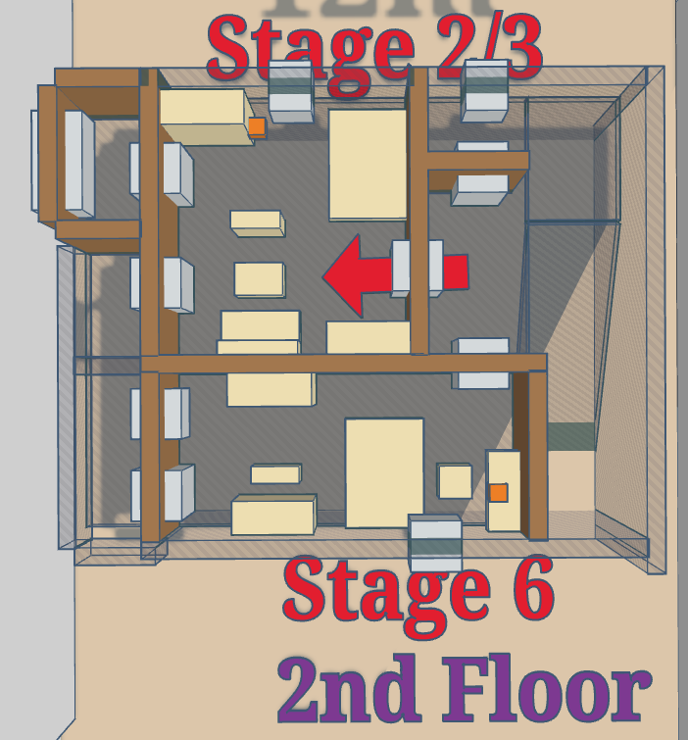
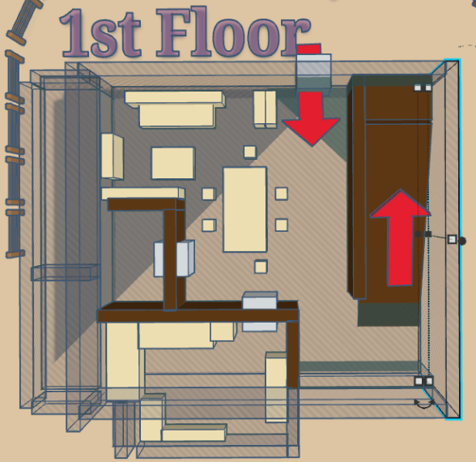
Figure 4: Introductory Scene Map (Dream) [7]
Figure 3: House 1st Floor Closer Look [7]
Figure 2: House 2nd Floor Closer Look [7]
Map Label | Summary & Objective | Narrative & Details | Aesthetic Notes
1 | Objective: Check the photo (Current) | (the player stands in front of the gravestone)  - (On the Gravestone: In Loving Memory of My Beloved Mother, Limu Shen)  (A photo lies in front of the gravestone, with interaction hinting UI pops up when the player walks near; quest objective UI pop up)  Objective: Check the photo  (Enter photo inspection mode)  - (Written on the photo: June 10th, 1978. Jiang and Mu.)  - (U1) This is the last photo of my mother and Aunt Jiang taken before Aunt Jiang went missing.  - (U2) 47 years ago, Aunt Jiang was 5, and my mother was 9.  - (U3) The little girl nestled close to her sister, clutching a rough wooden hourglass in her hand.  - (U4) She was smiling so brightly, like a shining star in the nightfall.  (Exit inspection mode)  - (H1-1) I knew my mother had a younger sister, but she seldom spoke of her.  - (H1-2) I had always thought Aunt Jiang had faded from her memories, but it seemed she remained as bright as ever.  - (H1-3) I'd like to look for my mother's lost star, if that's something I can do.  - (H1-4) I should head home and see if she had left behind anything related—maybe that hourglass is among them.  Objective: Check Mother’s Bedroom  (Gate exit for the graveyard interactable UI enabled) | - cloudy & rainy day – if possible, but the sky is like plain white
2 | Objective: Check Mother’s Bedroom (Current) | (player walks back to the house, enter 2nd floor mother’s bedroom)  - (H1-10) My mother’s room is on the 2nd floor, right next to mine—the one with green leaves overflowing onto the balcony, as lively as she could never be.  - Her room isn’t filled with much; it’s neat and tidy.  - (H1-11) I do feel a bit guilty. After my parents divorced a few years ago, I was so caught up in work that I didn’t spend much time with her.  - (H1-12) But she seemed to enjoy her time at home, comforting me by saying she was happy living alone, as it gave her more time to experiment with cooking.  - (H1-13) The lights in the kitchen and living room always burned bright, casting warm halos into the night, waiting for a traveler who had been long away from home.  (after the player gets to 2nd floor) ​  - (H1-20) I never knew what she spent her days doing in her room.  - (H1-21) Perhaps she sunbathes near the balcony, trying to catch her breath among her beloved plants, or tends to them, hoping they’ll outlive her. Well, they did outlive her.  - Hmm... that wooden hourglass, where could it be? Could there be a hidden closet in her room that I don’t know about?  (optional narrative – triggered by interaction with the notebook)  Microwave  - (OM1) My mother loves to cook. No matter how late I came home, there was always a meal waiting for me in the microwave. I knew she had fallen asleep by then, as darkness spread from her window.  an opened notebook in the kitchen:  - ​(L1) Zhou thought the Salted Duck was too salty. I used a little less salt, and she said it was fine. I can’t help but wonder why her taste is so similar with Jiang’s. Many times, when I gazed into my daughter’s eyes, the innocence in her gaze mirrored my sister’s so perfectly, as if time had woven them together. | - Street lamps along the road are turned off, when the player walks near they are turned on to guild the player.  - The narrative lines describing the location of mother’s bedroom would pop up near the house, and the camera will be triggered to focus on where the text pops up for a very short time for conveyance. (exactly same as how What Remains of Edith Finch did this)
3 | Objective: Open the hidden closet (Current) | (player finds the locked hidden closet)  Objective: Open the hidden closet  (when player gets close to it, the interaction UI will appear)  - (U10) My mother had taken great care of what Aunt Jiang left behind.  - (U11) The carvings on the hourglass were as fresh as if they had been made just yesterday.  - (U12) But there was a pretty big crack at the top, like someone had tossed it aside in haste.  - (U13) The hourglass sits there so silently, as if a period of time sealed in the past being preserved until now.​  (The player enters the 8-digit passcode, coming from the photo date, the closet opens, and the hourglass sits among many random stuff. The player interacts with the hourglass to flip it.)

Map 3 – Forest (Dream)
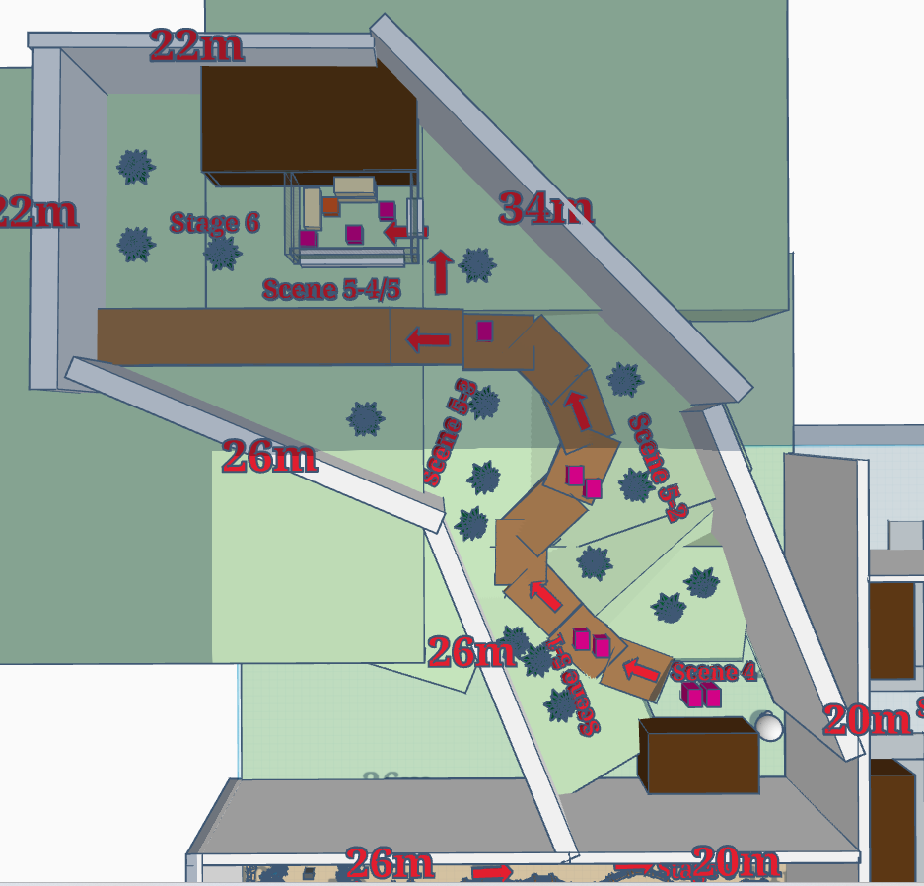
Figure 5: Forest Map (Dream) [7]

Map Label | Summary & Objective | Narrative & Details | Aesthetic Notes
4 | Objective: Listen to Aunt Jiang (Forest – Dream) | (The tick-tock sound of clock starts; the player gets teleported back to the past.)  Objective: Listen to Aunt Jiang  Young Mu (D1): “Jiang, don’t be sad. You know that little hourglass you wanted but Mama didn’t buy for you?”  Young Mu (D2): “I made one out of wood and plastic. You like it?”  Young Jiang (D3): “Really? Thanks, Sis!”  Grandma Duan (D4): “Jiang, come with me to the mountain. We’re out of food.”  Jiang (D5): “Okay, Mom! I’m going now—I'll come back and play with you later, Sis!”  Objective: Follow Grandma Duan
5 | Objective: Follow Grandma Duan (Forest – Dream) | (On the way into the woods, fallen tree trunks block the way, the player lifts them to continue following)  Scene 1  Grandma Duan (D10): “You’ve always been a good girl. If something ever makes you sad in the future, don’t overthink it.”  Grandma Duan (D11): “Just sleep, eat some food that you like, and it’ll pass. Okay, sweetie? Mommy loves you.”  Jiang (D12): “Mom, what are you talking about? Nothing’s gonna let me down! And I love you, Mom!”  Scene 2  Grandma Duan (D20): “When you were born, we were all so excited for you.”  Grandma Duan (D21): “Unlike other babies who cried right away, you smiled with your mouth wide open, so happy.”  Grandma Duan (D22): “Everyone says you’re our family’s little lucky star.”  Jiang (D23): “Mom, why are you bringing up old stories all of a sudden?”  Jiang (D24): “I’m gonna catch a rabbit today and bring it back for a nice meal! Look! There's one over there—I’m going after it!”  Scene 3  Young Jiang (D30): “Ah!! Who are you? Let me go! Mama, Mama! Help… I...”  (on the way)  - (F1) My mom once told me that my grandpa worked at a newspaper printing factory that got shut down by an accidental mountain fire.  - (F2 – sfx) The flames that night must have been as bright as day.  - (F3) Grandma and the families of the other workers managed to put out the fire, but they couldn't save their loved ones.  - (F4) After that, my grandma had to work as a maid in town and juggle a few different jobs just to make ends meet and feed the two girls.  - (F5) My mom also started working in a garment factory to help out, but it didn’t really make much of a difference.  (They reach an old factory. The door is locked, and the player watches the scene from outside.)  Scene 4  Grandma Duan (D40): “One hundred thousand, right?”  Man (D41): “It’s all here, you can count it.”  Grandma Duan (D42): “...Take good care of her. She’s a good child.”  Man (D43): “Don’t worry, she looks just like my daughter. I’ll treat her like my own.”  Grandma Duan: ...  (Grandma Duan leaves)  Scene 5  Man (D50): “Little girl, are you awake? Your mother sold you. Did you hear that?”  Man (D51): “From now on, you’re my daughter, Ziyuan Lin.”  Man (D52): “Come with me. Don’t bother with your old toys, I’ll buy you new ones.” (throws the hourglass)  Man (D53): “Here, take this watch as a gift.”  Young Jiang (D54 – sfx): “I don’t want it!” (Throws the watch)  Man (D55): “You little thing... fine. You should thank your mother; the town is much better than your home.”  Man (D56): “She couldn’t afford to take care of you, but I can.”  Man (D57): “We’ll go to the shop later and pick something you actually like.”  (optional narrative – triggered by interaction with the window)  Shattered glass: | - For each scene the NPC meshes got moved to a new place along the road, leading the player to move forward.
6 | Objective: Check the old factory (Forest – Dream)  Objective: Repair the Watch (Current) | (Jiang and Lin leave, the factory door is unlocked)  Objective: Check the old factory  - So this is how Aunt Jiang went missing.  - (U20) What Grandma explained to mom was Jiang went chasing after the rabbit and ran too fast. She couldn't catch up and lost track.  - (U21) She waited and searched the woods for hours—but Jiang never came back.  - (U22) It was a sad accident, as how my mom depicted the story she heard from grandma. But After that day, something clearly went wrong.  - (U23) Grandma grew much quieter and never spoke of Jiang, though the sorrow in her eyes overflowed into distant gazes. and even my mom could tell. that was because of Jiang.  - (U24) Mother had always thought Grandma felt guilty for her carelessness. and missed Jiang terribly after losing her in the woods.  - (U25) But now that I think about it, she might have been questioning whether she made the right choice.  (Player finds the broken watch, after interaction)  - (U30) This watch! My mother wore it all the time. when she was alive.  - (U31) 17:38...? The hands are broken.  (Player teleports to the present)  Objective: Repair the Watch  - (U32) I’ve brought it up to her several times, suggesting I buy her a new watch so she wouldn’t have to keep fixing this old one. I never thought she wore it for a reason.  - (U33) In her last days, my mother gave this watch to me. I must have kept it in my jewelry box.  Optional narrative (interact with another jewelry box)  - (OJ1) My mother never liked wearing jewelry, perhaps because she spent her early years working in the garment factory, where such adornments were more of a hindrance than a luxury.  - (OJ2) And besides, she probably never had the money to buy herself anything beautiful.  - (OJ3) I bought her a few after I started earning money. But they all ended up lying in my box because she would never wear them.  (Player goes to the daughter's bedroom)  (Player finds the watch and adjusts the hands to 17:38)  (Player teleports to the past)

Map 4 – Street (Dream)
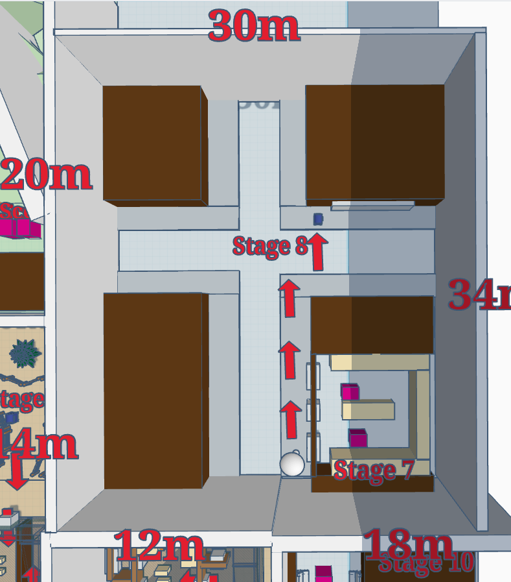
Figure 6: Street Map (Dream) [7]

Map Label | Summary & Objective | Narrative & Details | Aesthetic Notes
7 | Objective: Listen to Aunt Jiang and the man (Street – Dream) | Objective: Listen to Aunt Jiang and the man  Young Jiang (D70 -- 39): “Uncle Lin, I don’t want the watch. I want my hourglass.”  Lin (D71- 40): “What’s the point of an hourglass? You’ll need a watch when you start school.” Come on, pick one.  Young Jiang (D72 - 41): “All right... Uncle, can I go home and see my sister? I miss her a lot.”  Lin (D73 - 42): “Sister? What sister?”  Lin (D74 - 42): “Oh, it’s been over six months, and you’re still thinking about her?”  Lin (D75 - 43): “Isn’t life here good enough for you? Stop dwelling on the past.”  Lin (D76): “From now on, you’re Ziyuan Lin, the princess of the Lin family. Forget about everyone else.”  (Lin's phone rings)  Lin (D80 -- 44 – sfx): “Ziyuan, head back to school on your own. I’ve got some work to do.”  Lin (D81) “It’s just a red light away, I won’t be sending you.”  (Jiang leaves, but a pair of footprint appears outside the shop door, hiding in a corner, clearly it is Jiang listening to Lin's phone)  Lin (D90 - 45): “Hello? I’ve already given you the money, what more do you want?”  Lin (D91) “What? You want her back? That’s not happening!”  Lin (D92 - 46): “You were the one who said you couldn’t afford her, that you needed to find her a good family.”  Lin (D93 - 46): “You BEGGED me to take her. Now Ziyuan is doing just fine with me, so don’t even think about trying to get her back!”  (Lin leaves from the other side of the door, didn't notice Jiang)
8 | Objective: Follow Jiang's foodprints (Street – Dream)  Objective: Check the Mailbox (Street – Dream) | Objective: Follow Jiang's foodprints  - Jiang (J1): /Uncle Lin was really nice to me. He bought me new clothes and sent me to school./  - Jiang (J2): /I had new books and a yellow Garfield backpack, just like the other kids./  - Jiang (J3): /I like living in town, but I miss my home terribly as well./  - Jiang (J4): /I always wondered why my mom sent me away./  - Jiang (J5): /I know she was really tired from working so hard to support me and my sister./  - Jiang (J6): /But I’m growing up now, and I’ll be able to start working and help support the family too./  - Jiang (J7): /We’re happy living together—wouldn’t Mom just wait a little longer for me?/  - Jiang (J8): /If she wants to decide my future for me, I guess that would be the better choice./  - Jiang (J9): /I’ve always known she loved me, but it hurts just the same. I'm not her lucky star anymore./  Objective: Check the Mailbox  (Enter letter inspection mode)  (L2) "Sis: I’m doing well, don’t worry about me. Sep. 10th, 1978."  (Exit letter inspection mode)  - (U40) There’s no address or postage, so this letter probably never reached Mom. Aunt Jiang must have been too young to know how to send letters back then.  - (U41) As for the sender’s address... Baishi Town, Longchuan Road 18, Apt.103, 310211.  (Player teleports to the present) | - The footprints appear from the shop towards the school. When the player walks near it the text pops up on the road, this footprint disappears & next footprint appears.
9 | Objective: Check the mailbox (Current)  Objective: Fill in the address (Current) | Objective: Check the mailbox (Current)  - (U42) Since Aunt Jiang sent a letter, maybe Mom did too. I should check the mailbox downstairs.  - (U43) Maybe I’ll find one or two buried at the very bottom, just waiting to be discovered?  (After interaction with the mailbox, enter letter inspection mode)  (First letter) (57)  (L3) "Sis, how are you? I’ve been in poor health lately. I feel like my time here is running out, and I wonder if we’ll ever have the chance to meet again before that happens. It’s been so long, but my thoughts are still with you. Please take care of yourself. Dec 3rd, 2022."  (Second letter)  (L4) "Sis, how are you? I know this letter might never reach you, because I still don’t know where you are. But I couldn’t help myself—I had to write to you. I hope somehow, the wind can carry my words to you, wherever you might be. I miss you so much. May 22nd, 1980."  (Third letter)  (L5) "Sis, how are you? We still haven’t found you. Mom says it’s okay to send you letters whenever I miss you, and you’ll see them, right? I keep hoping, every day, that you’ll come back. Please come home—I miss you so much. June 20th, 1978."  (Exit letter inspection mode)  (U50) ...How could there be so many letters?  (U51) I still remember Aunt Jiang’s new address in the town. If I fill it in...  (Player enters the address and gets teleported to the past)

Map 5 –Hospital (Dream)
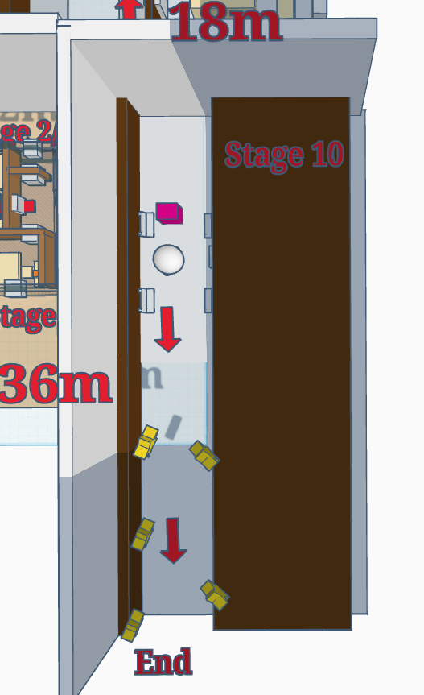
Figure 7: Hospital Map (Dream) [7]

Map Label | Summary & Objective | Narrative & Details | Aesthetic Notes
10 | (No objective)  Ending Scene | (In the hospital, outside Mom's surgery room, both ends blocked by darkness)  (A nurse appears) (61)  Nurse (D100): “Hello, are you a relative of Ms. Shen Limu?”  Nurse (D101): “A woman just asked me to give these to you.”  (Enter letter inspection mode)  (First letter)  "Sis: I’m doing well, don’t worry about me. Sep. 10th, 1978."  (Second letter)  (L6) I used to think I resented Mom for sending me away for money. But as I grew older, I realized that Uncle Lin really did give me a life beyond anything we could have hoped for back then. With all the good fortune I’ve had, I don’t have the right to criticize anyone.  (L7) So, I respect Mom’s decision, and now, we all have our own lives. I’m doing well, and I believe you are too. I’ve come to see you, so please don’t leave with any regrets. Sis, I love you. Always your little sister. Dec 12, 2022."  (Exit letter inspection mode)  (One end of the hallway opens up and text starts popping from there to lead the player’s way)  - (P1-64) Mom once told me that Aunt Jiang was born when she was 4 years old.  - (P2-65) When Mom was born, Grandma had a difficult premature birth and thought it had left her unable to have more children.  - (P3-66) But Aunt Jiang’s arrival was a surprise to the entire family.  - (P4-67) Grandma used to tell jokes with mom, always patting her pregnant belly, saying, "You’re going to have a little brother!"  - (P5-68) Mom asked, "Why can't it be a little sister?"  - (P6-69) Grandma was silent for a moment before saying, "A sister’s fine. Anyway, you’ll have a companion."  - (P7-70) After I finished reading the letter, Mom was silent for a while.  - (P8-71) "Well, then. I have no regrets anymore."  [End of Game]  - Credits  - (E1) Thank you for playing!  - (E2) Written and Designed by Anona Yang | - The ending scene of the hallway looks similar to the starting scene, except the stars are triggered to fall instead of rise.

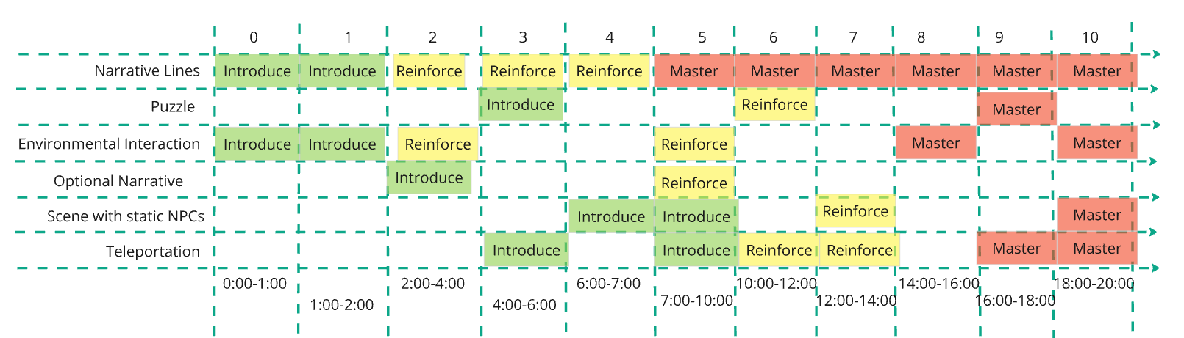
Skill Progression Chart
Figure 8: Skill Progression Chart [8]

Appendices

Appendix A: Aesthetic References

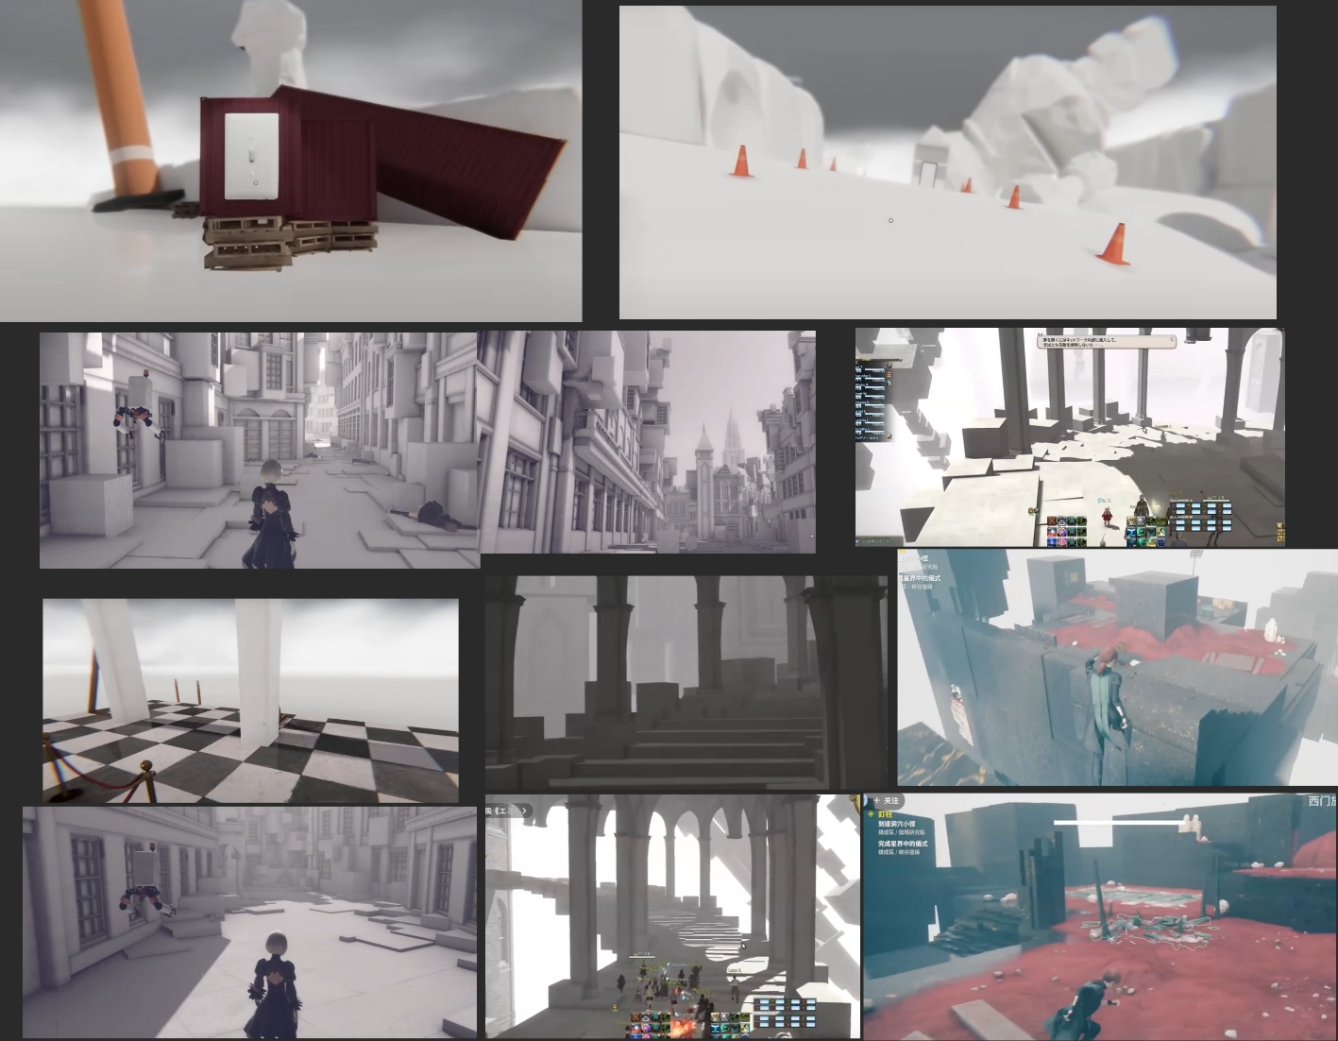
Grey-Scaled Dream World
Figure 9: Contact Sheet for Visual Theme 1 [1,2,3,4]

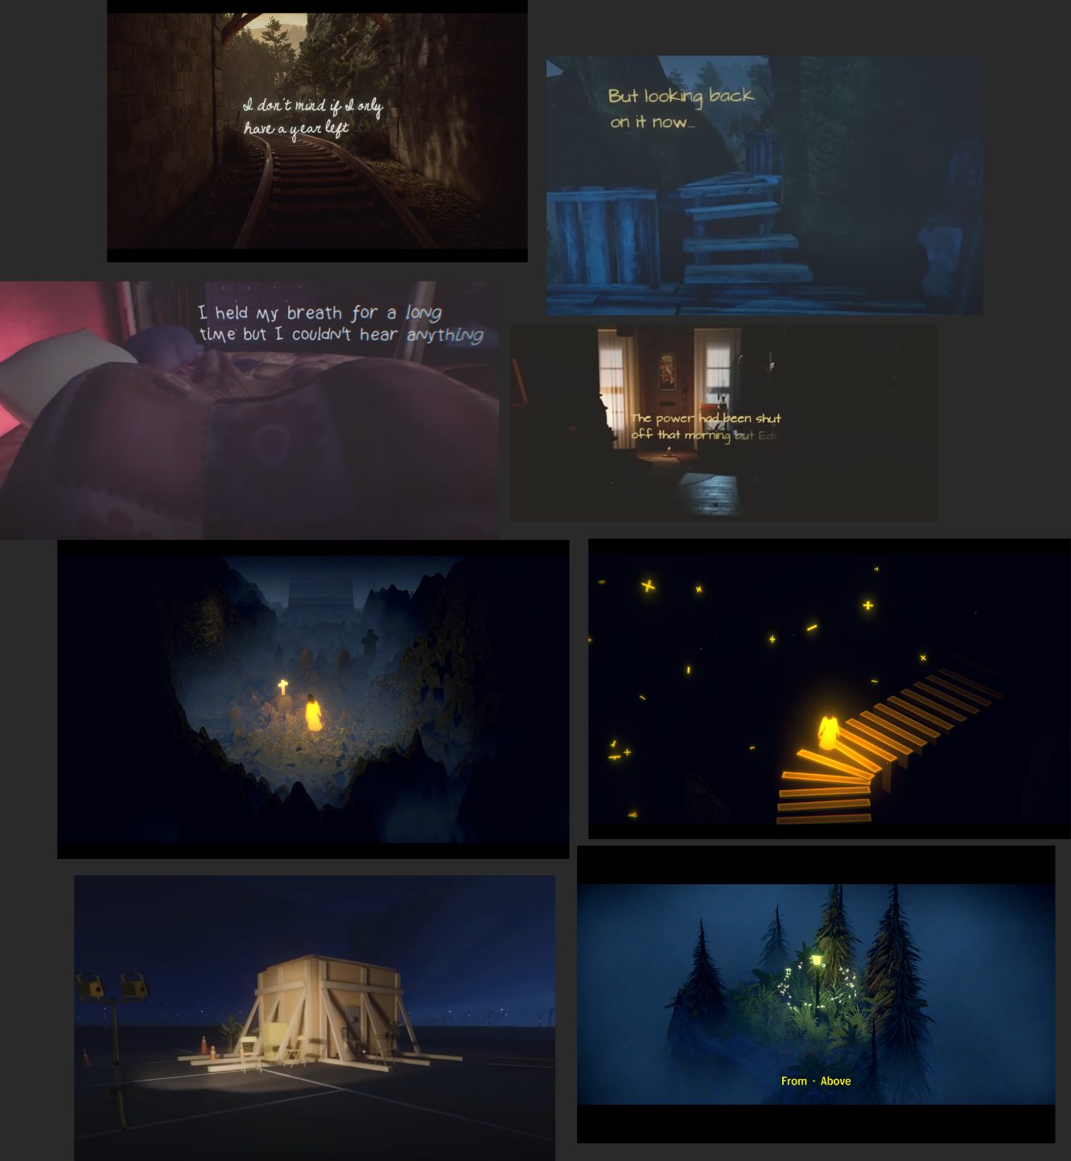
Colorful Islands & Floating Text for Narration
Figure 10: Contact Sheet for Visual Theme 2 [1,5,6]

Appendix B: Systems

Quest System
A simple quest UI displayed at the upper right corner of the screen, which helps the player to keep track of the next objective. I don’t think an objective marker is necessary in this case since this is a game that encourages exploration.

Interactable System

Common Ones
A 3D small yellow dot UI (could change) floating above the object to indicate the possible interaction. All one-offs.
- Door handles
- Optional narrative trigger objects

Special ones
- Hourglass: Jiang’s toy, a gift from Mu. The player needs to interact with it to flip (scripted animation) to trigger the teleportation.
- Watch: Lin’s gift to Jiang. Jiang broke it. Mu picked it up and kept it till now. The player needs to repair the watch and adjust the time according to the time when it is picked up in the past. (My plan is also making a scripted animation, but if time allows I can try to add mouse rotation to make the interaction more interesting.)
- Letter: Jiang and Mu kept mailing each other letters without addresses. The player will need to fill in the address (scripted) on Mu’s letters that they saw on Jiang’s letters in the past. The letter will reach Jiang in the past and “change” the story ending.

Journal System
A notebook that tracks important events and details throughout the game, such as the photo date, letter addresses, and key puzzle information. It serves as a reference for players to revisit when they forget important clues, ensuring they understand the story and stay on track.

Appendix C: Context

Backstory
Grandma Duan had always wanted a son. When Aunt Jiang was born, Grandma Duan felt reluctant to raise her, as she didn’t have enough money to support two daughters. After much thought, Grandma Duan decided to sell Aunt Jiang to Uncle Lin, a wealthy man in town who had lost his own daughter. She believed Jiang would have a better future in the town than what she could provide. Grandma Duan lied to her other daughter, Mu, telling her that Jiang had gone missing in the woods during a hunting trip.
Mu missed Jiang deeply and continued to send letters without an address, expressing her longing for her sister until her death. Her final wish was to reunite with Jiang, and it is with this quest that the player, as Mu’s daughter, begins investigating.

Aftermath
The player wakes up from the dream. They learn about the old story and try to fulfill their mother’s last wish, but those are all in the dream. The ending will not be explicitly explained and up to the player’s choice to interpret.

Appendix D: Characters

Character 1: Mother Mu
The protagonist’s mother, who recently passed away. She left behind a cherished photo of her and Aunt Jiang from their childhood, revealing the deep bond she shared with her sister before they were separated.

Character 2: Auntie Jiang
The missing sister of Mother Mu, sold to Uncle Lin by Grandma Duan when she was young. Despite the separation, she lived a happy life, though full of mystery that the protagonist seeks to uncover.

Character 3: Grandma Duan
A woman who, desperate for a son and unable to support two daughters, sold Aunt Jiang to Uncle Lin. She later lied to her daughter Mu about Jiang’s disappearance, keeping the painful truth hidden for years. Despite her actions, she deeply loved both daughters and believed that Jiang would have a better life with Uncle Lin, though the decision haunted her for years.

Character 4: Uncle Lin (the man)
A wealthy man in town who lost his own daughter in a car accident. He bought Aunt Jiang from Grandma Duan because Jiang bore a striking resemblance to his late daughter, and he hoped she would fill the void left in his life.

References
Title Image D. Matheny, “The Falling Star - Sara Teasdale,” Dmitri Matheny Blog, [Online]. Available: https://dmitrimatheny.com/blogs/dima-s-blog/posts/191523/the-falling-star-sara-teasdale. [Accessed: Feb. 2024].
[1] Pillow Castle Games, "Superliminal," Pillow Castle, PlayStation 4, Xbox One, Microsoft Windows, macOS, Nov. 2019. [Online].
[2] Square Enix, Final Fantasy XIV, Square Enix, 2010. [Online].
[3] Remedy Entertainment, Control: Ultimate Edition, Remedy Entertainment, 2020. [Online].
[4] Square Enix, NieR: Automata, Square Enix, 2017. [Online].
[5] Giant Sparrow, "What Remains of Edith Finch," Annapurna Interactive, PlayStation 4, Xbox One, Microsoft Windows, Nintendo Switch, Apr. 2017. [Online].
[6] Kira, The Forest Quartet, Kira, 2023. [Online].
[7] Maps. Anona Yang, Created in TinkerCad, Feb. 2025.
[8] Skill Progression Chart. Anona Yang, Screenshot in Miro, Feb. 2025.

