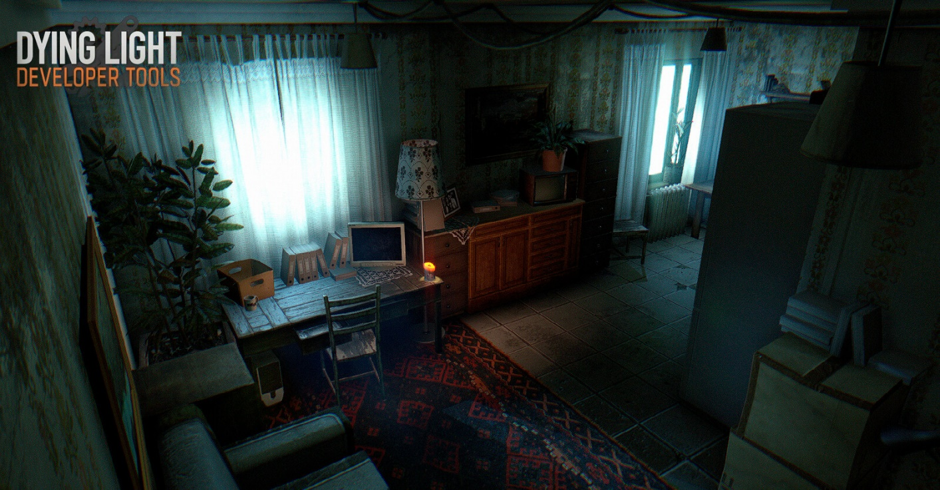

Dying Light: The Critical Cure
  - Version 2.1
Designer: | Anona Yang
Document Date: | 9/15/2024
Intended Level Delivery Date: | 3/7/2025

Document Revisions Table
Version | Description | Requestor | Date
1.0 | Initial Document | Professor Katherine Wood Clark and Professor Mike Porter | 7/15/2024
2.0 | Iterated LDD  - Changed Editor  - Reworked map and walkthrough  - Dialog draft | Professor Katherine Wood Clark | 9/26/2024
2.1 | - Changed the theme from a house to a hospital  - Added goo puzzles in walkthrough and description in appendix A  - Added notes for environmental changes | Professor Katherine Wood Clark | 10/10/2024

Table of Contents
Table of Contents 2
Table of Figures 3
Level Summary 4
Quick Summary 4
Level Feature Overview 4
Development Schedule 4
Level Overview 5
Overview Map 5
Level Details 7
Detail Maps 7
R1 7
R2 10
R3 13
R4 15
Skill Progression Chart 17
Aesthetic References 18
Spooky Hospital 18
References 19
Appendices 20
Appendix A: New Skills / Gameplay Mechanics 20
Examinable Objects 20
Trigger Scenes 20
Appendix B: Context Detail 21
Overall Story 21
Appendix C: Character Descriptions 22
NPC 1: Jonathan (Father) 22
NPC 2: Eleanor (Mother) 22
NPC 3: Thomas (Jon’s son, Young Brother) 22
NPC 4: Emily (Jon’s daughter, Older Sister) 22
NPC 5: Clara (Maiden) 22
NPC 6: Eldric (Guest, Jon’s friend) 22
Appendix D: Dialog Draft 23
D1 - C asks for food 23
TD1 - C yelling for help 23
TD2 – Music Box 23
D2 – J explains about the document 24
D3 – Suspicious Clara 24
D4 – Eleanor asks P to look for her children 25
D5 – Emily explains about the locked door 25
D6 – Clara’s cakes 26
D7 – Eldric trapped in lab 26
D8 – Eldric asks P to find the document 27
TD3 – Eldric’s coffee from Emily 27
D9 – Jonathan requests player to get the document 28
D10 – Clara’s accident 28
D11 – Document position 28
TD4 – Clara’s confrontation 29
D12 – Clara’s cakes 30
Appendix E: Development Risks 31

Table of Figures

Figure 1: Overview Map [1] 5
Figure 2: Walkthrough Map, R1 [1] 7
Figure 3: Walkthrough Map, R2 [1] 10
Figure 3: Walkthrough Map, R3 [1] 13
Figure 3: Walkthrough Map, R4 [1] 15
Figure 4: Skill Progression Chart [2] 17
Figure 5: Contact Sheet for Visual Theme 1 [3-12] 18

Level Summary

Quick Summary
"The Critical Cure" is a quest in Dying Light where the player receives a distress call from Jonathan Blackwood, a wealthy bioscience company owner trapped by the infected in his hospital. As the player investigates, they gradually uncover the mystery surrounding an important document and how it affected the family. This level incorporates techniques for reusing space to introduce story elements and enhance narrative immersion.

Level Feature Overview
Category | Sub-Category | Feature List
Player | Player Weapons | - Pistol  - Axe  - Knife
 | Player Skills/Abilities | - Survivor Sense  - Parkour  - Search for Route
AI | Enemies | - Biter, Viral, Goon, Screamer
 | Friendlies | - NPCs: Jonathan (J), Eleanor (E), Thomas (T), Emily (M), Clara (C), Eldric (L)
Challenges | Gameplay Themes | - Explore hidden clues (by survivor sense)  - Engage in the story (by triggered events & dialogues)
 | Obstacles/Hazards | - Physical obstacles blocking a hidden path (that can be cleared by trigger / as story progresses)  - Enemies patrolling by a subgoal interactable  - Goo (for alternative parkour route)
 | New/Unique Gameplay | - Looking for story hints by examining objects
Context | Where Fits in Game | - A standalone quest
 | Challenge Fit | - A side quest around half-way through old town main quests
 | Additional Info | - Check Appendix B
Aesthetics | Major Visual Themes | - A hospital, with high-tech machines, bio hazard, labs
 | Setting/Mood | - Dark, delicate, spooky

Development Schedule
Milestone | Date
LDD | 9/19/2024
Whitebox | 10/4/2024
Initial Gameplay | 11/4/2024
Gameplay Complete | 12/9/2024
Aesthetics | 2/17/2025
Launch | 3/10/2025

Level Overview

Overview Map
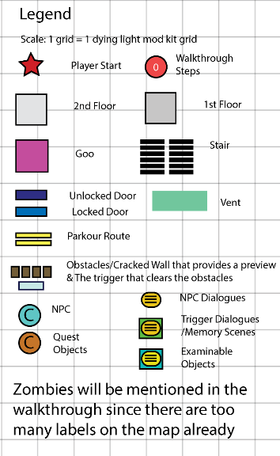
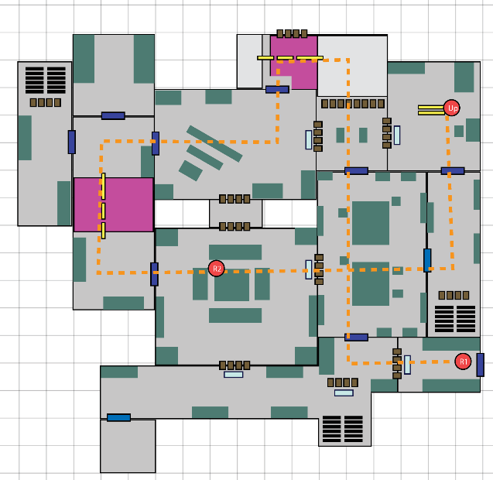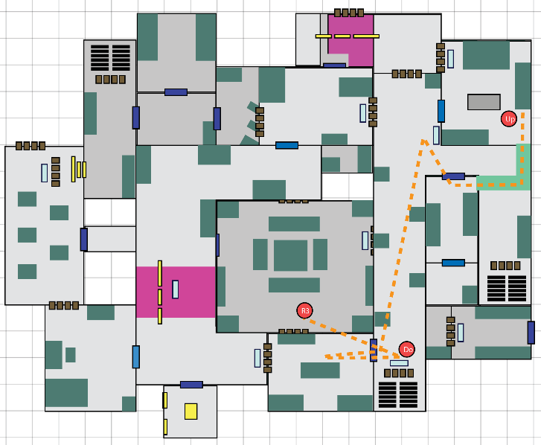
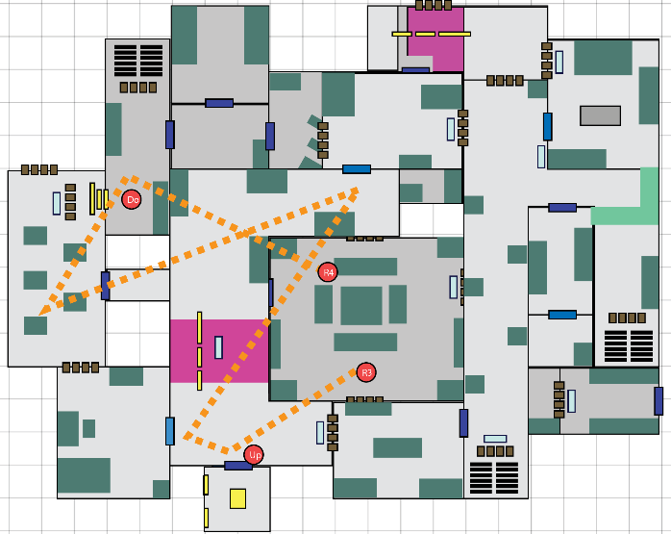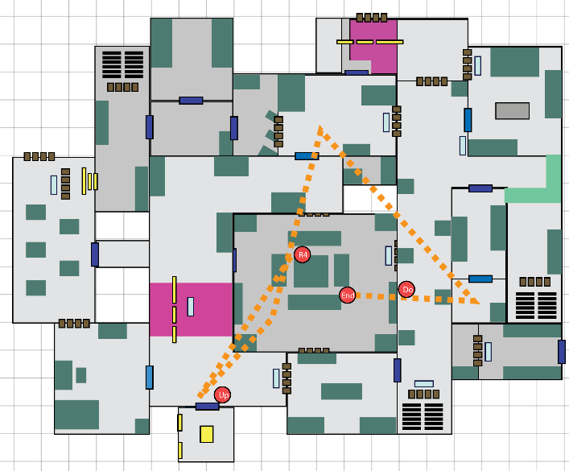
Figure 1: Overview Map [1]

Map Label | Gameplay Summary
R1 | - Player (P) enters the hospital, finds Clara (C) lying on the ground.  - C asks P to get her some food, P finds some in the waiting room. When P tries to get back to C, the infected crowds over and blocks the door.  - P has to go forward, traversing the cracked reception room and enters the lecture hall, finally finds Jonathan (J) at the entrance of the wareroom, where J is looking for medicine for Eleanor (E).  - P heads to the reception area (hub).
R2 | - E wakes up, asking P to find her children, who are probably locked up upstairs in their bedroom.  - P gets the key (K1) to enter the hallway (behind the waiting room), traversing through the sickroom, and gets to sickroom 2nd floor on the second floor by a hole on the floor.  - P climbs through the vent to get to the botanical room to restart the electric switch to turn on the power and unlock the door to let the children out.  - The children are hungry, asking P to get them some food from the cafeteria.  - P heads back to hub by the shortcut stair.
R3 | - J and C ask P to look for Eldric (L), who had probably been unconscious due to some accident and is currently in the lab on the 2nd floor.  - P parkours through the broken elevator to get to the 2nd floor, and finds L stuck in the room by crowded enemies.  - P activates a fake target to attract the enemies’ attention and frees L.  - L asks P to help him look for an important document. Together they go to the office and the display room but find nothing.  - P heads back to hub to report about L.
R4 | - J explains about the document and asks P to grab it.  - C guesses where J hid the document and wants to get it, since holding it might probably guarantee her a seat on the flight. But on the way, she falls into the elevator pit by accident.  - P goes to help C out.  - P gets the access card (K2) of the office from Jon and heads to the second floor.  - In the office, P finds the key (K3) to the storage room inside the botanical room and finds the document there.  - P heads back to the hub.  - L explains the story behind the fake document to J, everyone is disappointed.  - The flight arrives, everyone leaves and says goodbye to P.

Level Details

Detail Maps
Note: There are some tiny pieces of details I forget to label on the map, if there’s any difference between the map and the walkthrough details, listen to the walkthrough.

R1
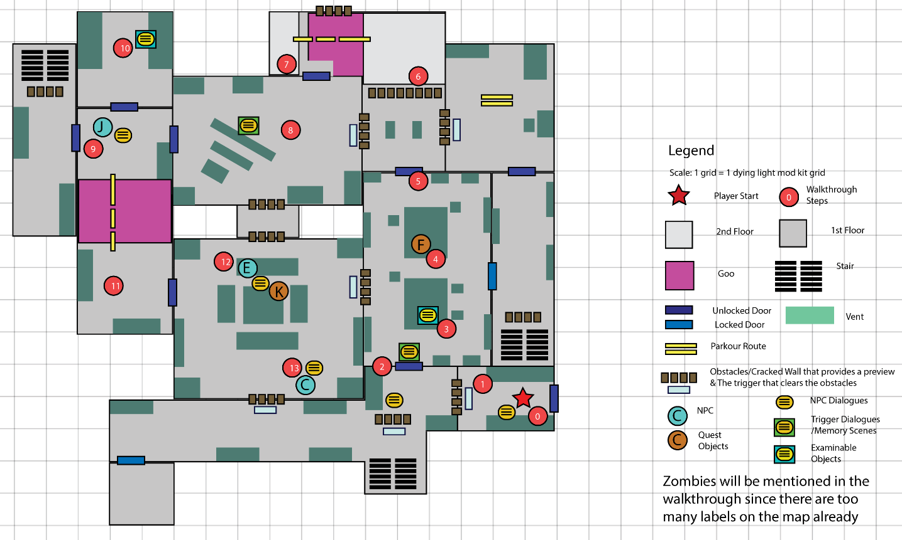
Figure 2: Walkthrough Map, R1 [1]

Map Label / Stage | Event Summary  (Quest Objective) | Event Details
0 | - Start Level | - [Day 1] [Exterior Garden] The player (P) spawns outside the hospital’s side entrance and receives a call from Troy that explains about Jonathan’s situation.  - Dialogue (D0): Troy’s call.
1 | - Enter the hospital | - [Spawn Room] P interacts with the Obstacles to remove them. enters the opened door.  - Interactive: Obstacle (teaching moment).
2 | - Talk to Clara | - [South Hallway] P meets Clara (C). C is lying on the ground, looking very weak. She asks P to get her some food, which should be available in the waiting room.  - [Environment – 1st] On the left the hallway is blocked by closets & objects, can hear noises created by the zombies. P cannot walk through.  - [Transition] P opens the door to enter the waiting room.  - Dialogue (D1): C asks for food.
3 | - Clear the enemies | - [Waiting room] P encounters a few biters in the waiting room.  - [Waiting room] P checks the food on the table and finds poisonous cakes for Jonathan (J) and Eleanor (E).  - Encounter (E1): 2 biters  - Interactable: poisonous cake (by C)
4 | - Grab food in the waiting room  - Get back to Clara | - [Waiting room] (loot opportunities) P grabs food on the table. When P tries to go back and give food to C, the door is stuck.  - Quest Object (F1): Food  - Trigger Dialogue (TD1): C yelling for help, urge P to look for another route to get to her spot  - Environment: The waiting room is very dark, only 1 or 2 lights are on (blue, cold).
5-7 | - Find an alternate route to get to Clara | - [Bio Lab] P enters the collapsed bio lab, parkours to the 2nd floor and gets across the deadly goo.  - [Goo puzzle – teaching moment] P follows the water pipe to find the water valve to clear the goo and enter the lecture hall (the door is open but in the goo area).  - Skill: parkour, goo puzzle
8 | - Check the music box | - [Lecture hall] P encounters 1 screamer, 2 biters, 1 viral.  - P triggers the music box and hears the talking between J & C.  - Encounter: [W1] 1 screamer, 1 biter; [W2] 1 biter, 1 viral  - TD2: music box (C asks J for a seat but got rejected, she tried to threaten J that she’s going to tell E about their affair, but J still didn’t answer)  - Interactable: {optional ones TBD}
9 | - Talk to Jonathan | - [Outside the Wareroom] P meets J, who is looking for medicine for E. J explains briefly about how they missed the flight because of waiting for the document delivery.  - Dialogue (D2): J explains about the document.
10 | - Check the wareroom | - [Wareroom] (loot opportunities) P finds an empty bottle of sleeping pills that was opened recently (M -> L).  - Interactable: sleeping pills
11 | - Meet Jonathan in the reception area | - [West Hallway] P traverses through the hallway to get to the reception area, encountering several enemies.  - [Puzzle] A goo is blocking the hallway, P needs to parkour from near the ceiling to get to the other side while avoid attacks from enemies. P can clean up the goo by water valve after getting passed it. P can use the goo as a trap to kill the enemies.  - [Environment – 1st] There are a lot of random objects piled up in the hallway, probably because there wasn’t time to clean it up. [Revisit after this] cleaned up by J and E, claiming to have found some food & supplies.  - Encounter: [W1] 1 goon, 1 biter; [W2] 1 biter.  - Skill: parkour, goo puzzle
12 | - Talk to Clara | - [Reception area] (loot opportunities) P finds C in the reception area, surprisingly, and asks how she got out.  - D3: Clara explains she got out by luck, very ambiguous. (turns out she went to hide some clues up in the cafeteria).
13 | - Talk to Eleanor | - [Day 2] [Reception area] E wakes up, P talks to E. E hopes P can get her children here. They probably got stuck in their bedroom on the 2nd floor. P obtains the key to the East Hallway.  - D4: E requests P to get her children. Argues with C, C left.  - Quest Object: K1.  - Interactable: {optional ones TBD}

R2

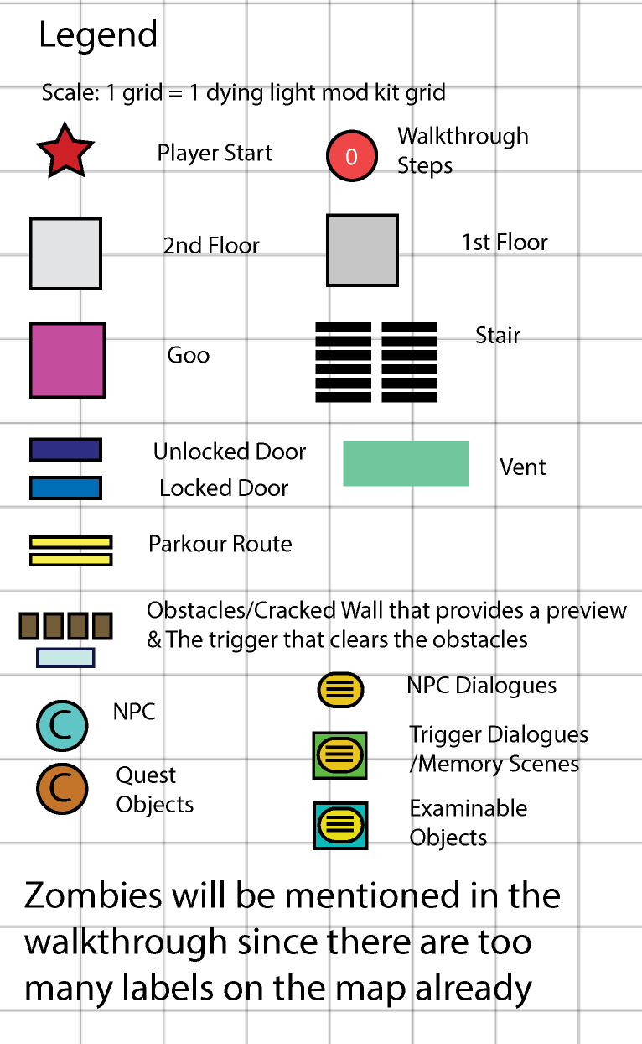
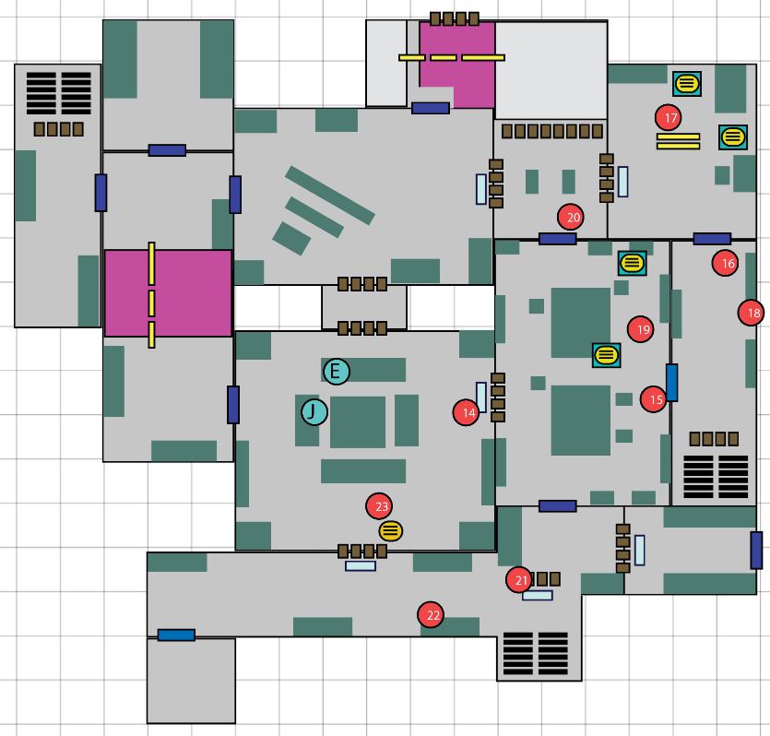
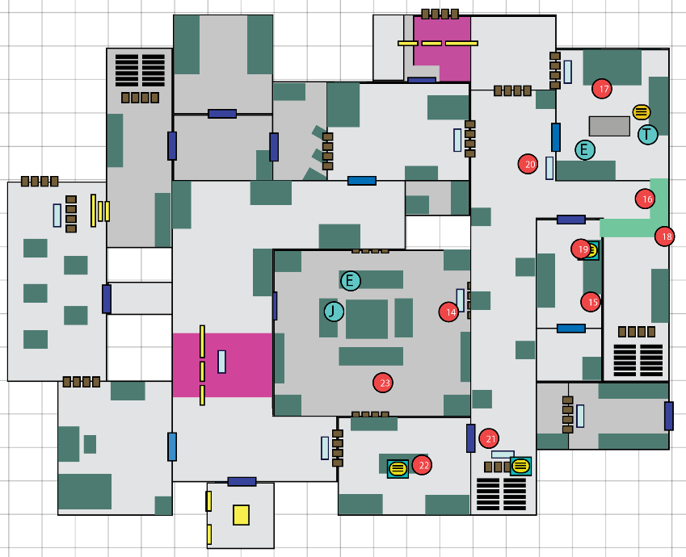
Figure 3: Walkthrough Map, R2 [1]

Map Label / Stage | Event Summary  (Quest Objective) | Event Details
14 | - Look for the children | - [Reception area] P interacts with the trigger to remove the obstacle and enters the waiting room (shortcut created by C, which is blocked by closets before).  - Interactable: obstacle
15 | - (exploration in waiting room - revisit) | - [Waiting room] P finds clues about C’s suspicious behaviors.  - [Environment - revisit] more lights (bright), traces of someone looking for something  - Interactable: disappeared cakes, brighter lights (C came to remove the cakes and left in a hurry)
16 | - Look for the children | - [East Hallway] P encounters 2 virals and enters the sickroom.  - [Environment – 1st] dark, flicker lights, spooky (power off, will be turned on at step 19) [revisit] bright and clean  - [Goo puzzle] a goo is blocking in the middle of the hallway, P needs to find the valve to clean it up before getting to the sickroom door.  - Encounter: [W1] 2 virals.
17 | - (exploration in sickroom) | - [Sickroom] P finds some random clues in the sickroom and gets to the 2nd floor through the hole.  - Interactable: Thomas’s (T) scribbles, Emily’s (M) diary (C agitates T’s anger towards J, M notices L wondering outside the office)  - Skill: parkour, navigate  - Optional Shortcut: collapsed wall to get back to the bio lab.
18 | - Talk to the children | - [Sickroom 2nd floor] The door is locked from outside, and the infected crowd over in the sickroom. P climbs through the vent to get to the botanical room.  - D5: Emily explains the situation about the door.  - Skill: navigation, crouch  - Interactable: Emily’s table has some sleeping pills.
19 | - Turn on the power | - [Botanical Room] The power is down and there are no lights in the botanical room. P turns on the power, while avoiding attacks from enemies (entered from hallway, the door is open). When the power is on, a trap is also activated to attract enemies over. [[after this action the hospital will have more lights than before]].  - [Environment – 1st] after the light is on, P can see bloody decals left by enemies on the floor, destroyed plants indicated fights happened  - Interactable: broken vase (somebody was looking for something (L/C))
20 | - Open the sickroom 2nd floor door from outside | - [2nd F East Hallway] P opens the sickroom door from outside.  - Skill: Trigger Switch
21 | - Grab food from cafeteria | - [2nd F East Hallway] Thomas says he is hungry and wants P to grab some food from the cafeteria. As the enemies are crowding over the hallway, P needs to clear a route for the children.  - Encounter: [W1] 2 biters [W2] 1 viral.
22 | - (exploration in cafeteria) | - [Cafeteria] (loot opportunities) P grabs food and sees the disappeared poisonous cakes in the trash can.  - [Environment – 1st] blood decals, traces for fights, chaotic  - Quest Object (F2): Food  - Interactable: cakes.
23 | - Get back to Eleanor  - Talk to Clara | - [Hallway -> Reception area] P heads back to the reception area through the stairs near the cafeteria. The furniture had moved a little bit and left an open aisle for P to go through (C opened it). P interacts with the obstacle trigger to get a shortcut back to the reception area.  - [Reception area] P asks C about the cakes.  - [Environment – 2nd for hub] more supplies sorted out; cleaner and brighter, but some blood decals at the entrance on the north and west entrance, the north entrance is opened (by explosion, a shortcut to get to 2nd floor East hallway is opened)  - Interactable: furniture moving traces (C just went to the cafeteria to throw away the cakes), obstacle trigger  - D6: C argues she just wanted a seat, if she couldn’t get it, she’ll start her revenge. P asks about the sleeping pills (P not sure who took it), C denies, E gets mad, J stops the argument. J obviously knows something but didn’t say. J asks P to look for his friend Eldric in the lab, they need to prepare for leaving but haven’t seen him since the infected burst into the hospital.

R3
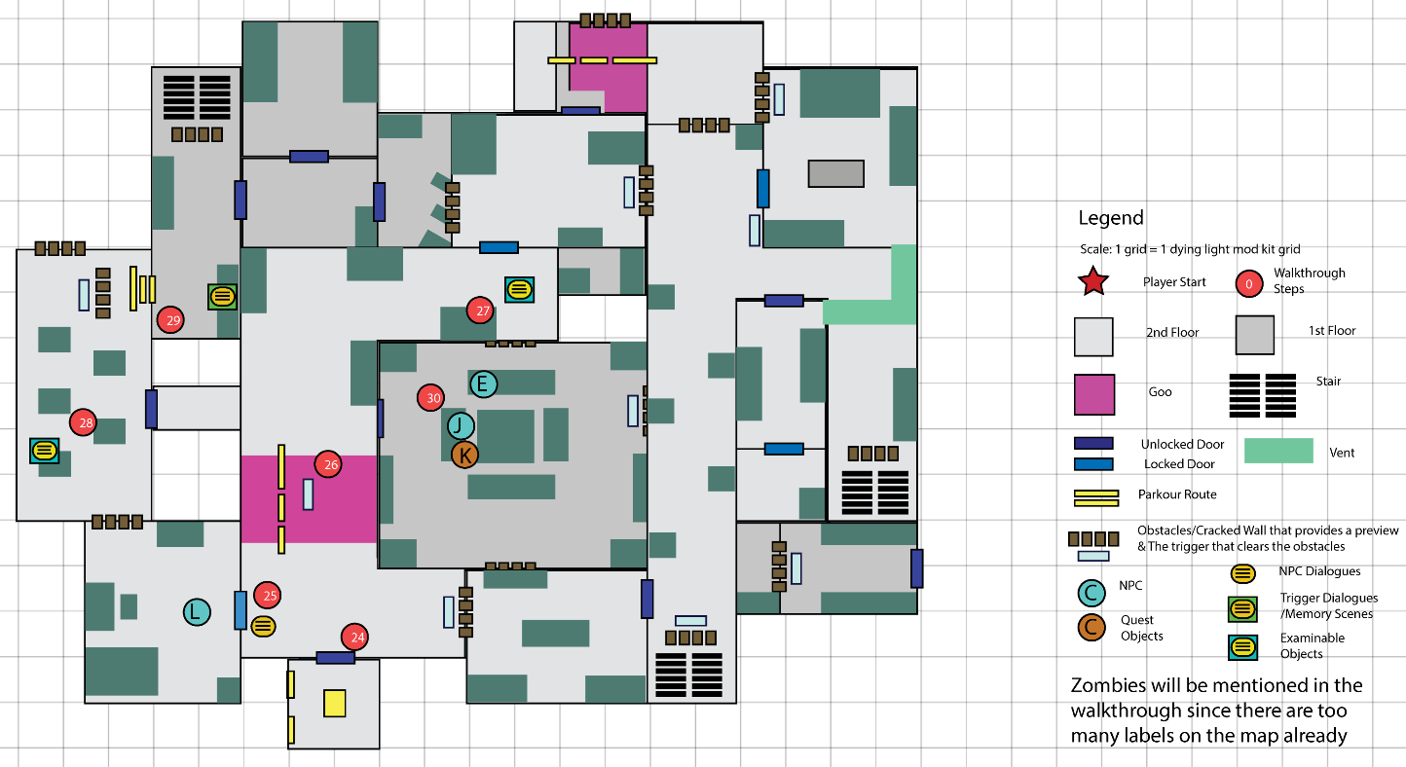
Figure 3: Walkthrough Map, R3 [1]
Map Label / Stage | Event Summary  (Quest Objective) | Event Details
24 | - Look for Eldric | - [Day 3] [South Hallway] P gets to the elevator and finds the elevator is broken. P parkours to the 2nd floor.  - Skill: parkour
25 | - Talk to Eldric | - [2nd F Central Hallway] P hears L calling from inside that he is trapped: there are so many infected he is afraid to open the door.  - Encounter: 1 goon, 1 screamer, 2 biters  - D7: L hiding behind the door
26 | - Activate the fake target  - Talk to Eldric | - [2nd F Central Hallway] P parkours to traverse the goo area and activates the fake target (trap) to kill the enemies, let L get out. [Goo puzzle]  - [Lab] P talks with L about what happened to him and finds some clues.  - [Environment (hallway) – 1st] blood traces, collapsed structures [revisit] explosions cleared up many blocking objects  - Skill: Parkour, fake target, goo puzzle  - Interactable: L’s notes (L’s tasks about destroying the document) {optional ones TBD}  - D8: L woke up on Day 2, clearly somebody let him eat sleeping pills somehow. L lost an important document (P wonders in mind about J’s document) and asks P to help him find it.
27 | - Look for document around the office | - [2nd F Central Hallway] P and L go to the office, but the door is locked. P finds some scattered papers on the floor.  - Encounter: 2 virals  - Interactable: scattered documents (J’s messages with his workers, he finds out the document is fake after missing the flight), C’s notes in the trash can (etc. flirting message), E’s sticky notes on the door
28 | - Look for document around the display room | - [Display room] {loot opportunities} P and L go to the display room.  - Trigger Dialogue (TD3): L remembered Emily handed him a cup of coffee, guess that’s where the sleeping pills come from.  - Interactable: {optional clues TBD}
29 | - Get back to Jonathan | - [2nd F West Hallway] P interacts with the broken wall and parkours down to the 1st floor.  - Interactable: Trigger Obstacle, {optional clues TBD}  - Skill: parkour
30 | - Talk to Jonathan about the document | - [West Hallway] P heads back to the reception area. On the way P encounters some enemies.  - Encounter: 1 screamer, 1 biter.  - [Reception area] P reports to J about L looking for the document. J says he is aware of that, and wants P to get him the document, which is locked somewhere on the 2nd floor.  - [Environment] some collapsed structure falling from ceiling (explosions happened on the 2nd floor)  - D9: J requests P to grab the document but hasn’t say the location yet.

R4
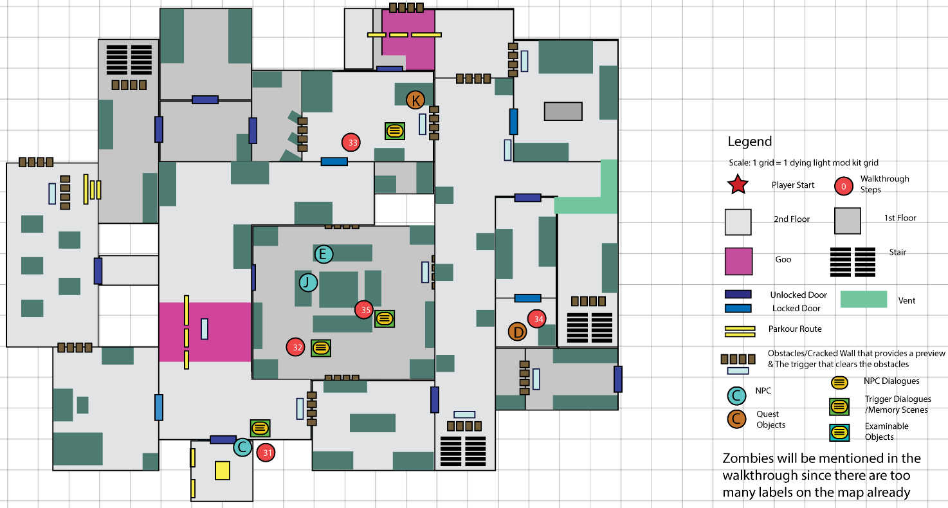
Figure 3: Walkthrough Map, R4 [1]
Map Label / Stage | Event Summary  (Quest Objective) | Event Details
31 | - Help Clara out | - [Elevator] C, heard about J talking about the document, guesses where the document is and runs to get it before P. But she accidentally falls into the elevator pit and needs P to do something to get her up (or simply trapped by some enemies).  - Encounter: 1 goon, 2 biters, 1 viral.  - D10: C asking for help, while E argues with J about C’s affair.
32 | - Ask Jonathan about the document | - [Reception area] E&J continues their argument. P asks about the document, J answers that it is in the locked room in the botanical room, behind E’s favorite flower. P needs to grab the key (K3) in the Office first. And J gives P the key card (K2) for the Office. E stops arguing when J mentions her flower.  - D11: J explains where the document is.  - Quest Object: K2
33 | - Get the key from the office | - [2nd F] P traverses through the 2nd floor to get to the Office.  - Encounter: [W1] 2 biters [W2] 1 goon [W3] 1 viral  - Interactable: {optional clues TBD}  - Quest Object: K3  - Trigger Dialogue (TD4): coffee cup (C asks J about their relationships, J responds that it is just an accident, he had already apologized and wanted C to stop being like this)
34 | - Get the document in the botanical room | - [2nd F] P traverses through the 2nd floor to get to the botanical room. P finds the document.  - Encounter: [W1] 2 biters [W2] 1 goon [W3] 1 viral  - Interactable: {optional clues TBD}  - Quest Object: Document.
35 | - Give Jonathan the document | - [Reception area] L mentions the document is fake, J says he already knew it, and the “fake document” is his strategy so he can keep the real document out of people’s sight. L is shocked, T apologizes to J. The flight is arriving, and J decides to take C with them. Everyone will leave here safely.  - D12: conclusion.

Skill Progression Chart
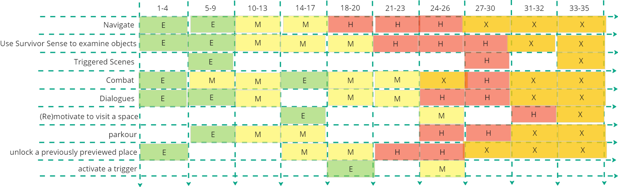
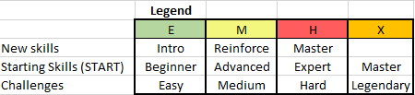
Figure 4: Skill Progression Chart [2]

Aesthetic References
The family hospital has many modern/fancy furniture, but as the infected invaded, the hospital’s power is dead, and many of the spaces are filled with blood and dusty trash. The lighting tone will be mostly cool tone to keep a spooky and dark vibe, while blending some warm lights as conveyance.

Spooky Hospital
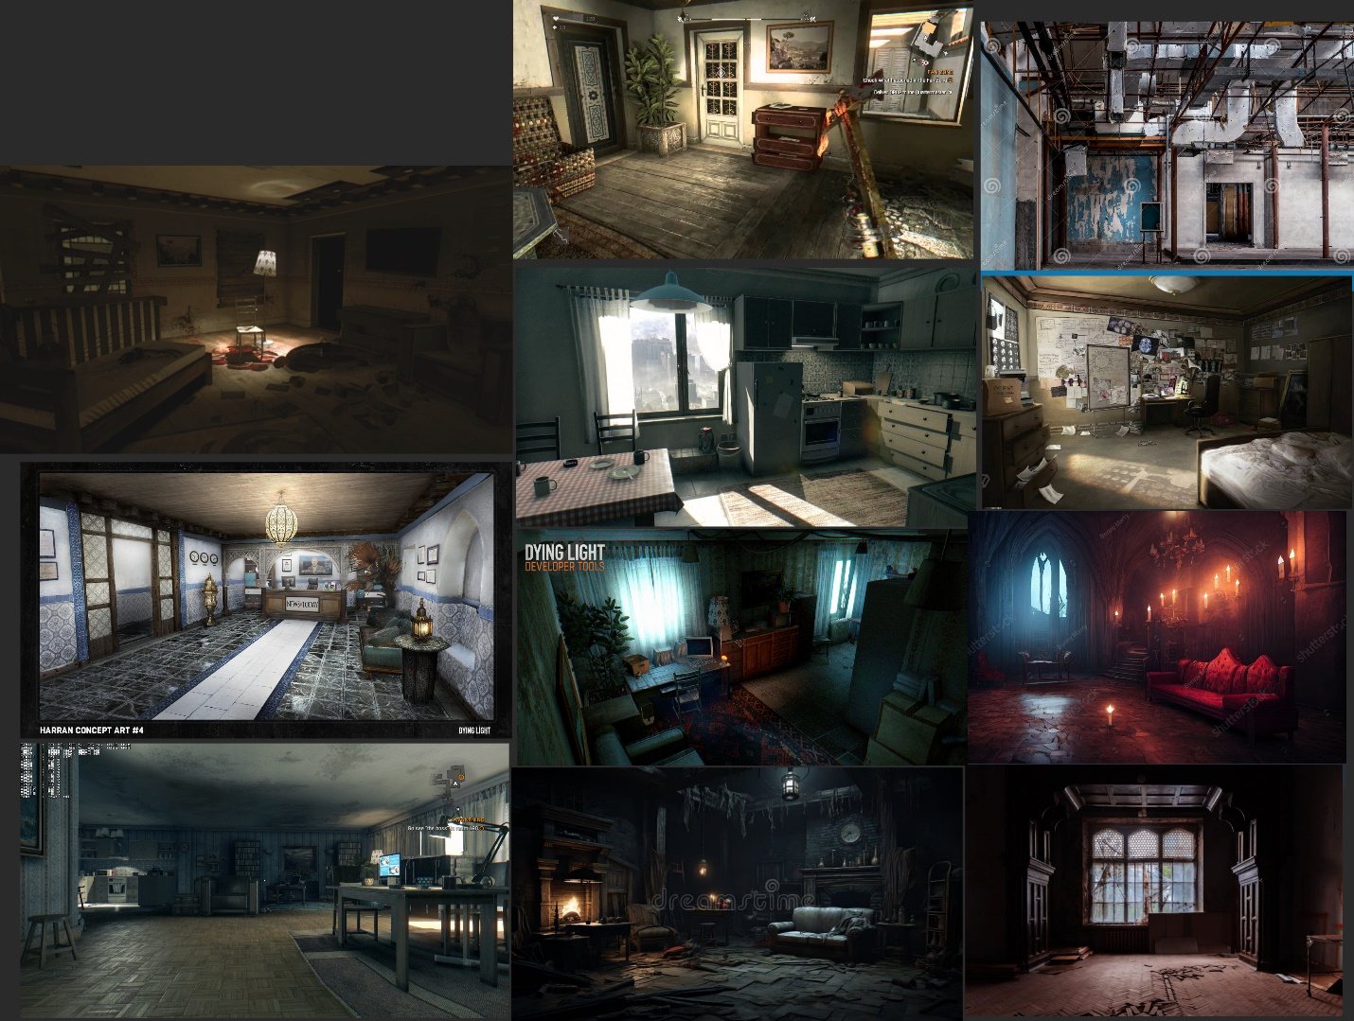
Figure 5: Contact Sheet for Visual Theme 1 [3-12]

References
[Cover Image] Hide, “ArtStation - Hide and seek custom map for Dying light. 2020,” www.google.com, 2024. https://images.app.goo.gl/tmJ2Q5mWgNnp3Pyi9 (accessed Sep. 26, 2024).
[1] “Level Maps”, Anona Yang, Made in Illustrator. Sep. 23, 2024.
[2] “Skill Progression Chart”, Anona Yang, Picture from Miro. Sep. 22, 2024.
[3] Hide, “ArtStation - Hide and seek custom map for Dying light. 2020,” www.google.com, 2024. https://images.app.goo.gl/tmJ2Q5mWgNnp3Pyi9 (accessed Sep. 26, 2024).
‌[4] D. Light, “Dying Light inspired room environment - Showcase - Epic Developer ...,” www.google.com, 2024. https://images.app.goo.gl/hWtZWaCBqi1XsTum9 (accessed Sep. 26, 2024).
[5] in Dying, “a really cool picture i took in Dying Light : r/dyinglight,” www.google.com, 2024. https://images.app.goo.gl/2pDQvYLRH3vMXbEn9 (accessed Sep. 26, 2024).
[6] in, “What is it with interiors in recent games getting downgrades? : r ...,” www.google.com, 2024. https://images.app.goo.gl/NFFvKBanAV3xD6Ku5 (accessed Sep. 26, 2024).
‌[7] App.goo.gl, 2024. https://images.app.goo.gl/TevxGhP2Uu2j6JTCA (accessed Sep. 26, 2024).
‌[8] App.goo.gl, 2024. https://images.app.goo.gl/QDustnhp1DjRYfP16 (accessed Sep. 26, 2024).
‌[9] Just, “Just a reminder that dying light could have been a horror game : r ...,” www.google.com, 2024. https://images.app.goo.gl/tr4hFyPR4WdLboKL8 (accessed Sep. 26, 2024).
‌[10] C. Hospital, “21,976 Creepy Hospital Interior Royalty-Free Photos and Stock Images ...,” www.google.com, 2024. https://images.app.goo.gl/xHXCYXUeQTi9btBB9 (accessed Sep. 26, 2024).
‌[11] H. Hospital, “Haunted Hospital Interior: Over 732 Royalty-Free Licensable Stock ...,” www.google.com, 2024. https://images.app.goo.gl/XWsyWJrWyEYrzJV78 (accessed Sep. 26, 2024).
‌[12] S. Hospital, “Spooky Hospital Interior Stock Illustrations – 3,732 Spooky Hospital ...,” www.google.com, 2024. https://images.app.goo.gl/ztAGYWsHFnni6ibu9 (accessed Sep. 26, 2024).
‌

Appendices

Appendix A: New Skills / Gameplay Mechanics

Examinable Objects
- Made by Message Trigger Entity in Dying Light Developer Tool.
- When the player uses the survivor sense, they will be able to identify the object is interactable.
- When the player interacts with the object, they will read a pre-written text that describes the object.
- It will be a great tool to convey many environmental narrative pieces that aren’t obvious enough in the space.

Trigger Scenes
- A scripted dialogue scene activated by player entering a trigger box.
- Involves lights changing, objects disappearing/appearing.
- Describes a memory/scene that happened in the past.
- A great visual form to present some of the supplementary narrative info.

Goo Puzzle
- Steam-like bio hazard spilled from labs
- Can be cleaned up by water, when the player interacts with the valve
- Respawns after cleaning, with some kind of delay (with question mark, respawn->reuseable, not respawn (my preference) ->environment change)
- Basically kill volumes, kill both the player and enemies

Appendix B: Context Detail

Overall Story
- Jonathan, the head of a bioscience company, was ready to take a flight with his family to escape the city.
- However, just before their departure, a scientist in his company reported progress on a critical research document related to the viral, delaying their flight while Jon waited for its arrival.
- Meanwhile, Clara, the family maid, is angry because she was not given a seat on the flight, and tensions escalate when she has a heated argument with Eleanor, Jon’s wife. Their argument grew out of control and attracted many infected nearby, letting the family get trapped in the hospital.
- Troy receives a call for help from Jonathan and sends the player. As the player investigates, they help Clara gather food, assist Eleanor in checking on the children, help Jon search for his friend Eldric, and retrieve the research document left on another floor.
- During the investigation, the player gradually finds Eldric is a spy sent by Jonathan’s business component, who planned the fake document. But Eldric doesn’t think the plan benefits anybody, so he is trying to destroy the document and hide the truth that it's fake. The player will also notice Clara, who is trying to steal the document and ensure she gets a seat on the flight.
- At the end of the investigation, Eldric reveals that the document is fake, disappointing everyone. But Jonathan predicted everything and utilized the fake document to hide the real document. The flight finally arrives, everyone gets on and wishes the document will speed up the cure research.

Appendix C: Character Descriptions

NPC 1: Jonathan (Father)
Description | /
Background | Owns a bioscience company.
Goals/Motivation | Wait for the flight and take the real document together.
Personality/Archetype | Upright, kind-hearted
Relationships | /

NPC 2: Eleanor (Mother)
Description | /
Background | Hospitalwife
Goals/Motivation | Leave this place, keep Jonathan’s heart
Personality/Archetype | Indecisive, insecure
Relationships | /

NPC 3: Thomas (Jon’s son, Young Brother)
Description | /
Background | Instigated by Clara to blame Jonathan for keeping the family until the document arrives
Goals/Motivation | Leave this place
Personality/Archetype | innocent
Relationships | /

NPC 4: Emily (Jon’s daughter, Older Sister)
Description | /
Background | Discovered Eldric’s suspicious behaviors, put sleeping pills in his coffee and let him miss the flight
Goals/Motivation | Help Jonathan
Personality/Archetype | smart
Relationships | /

NPC 5: Clara (Maiden)
Description | /
Background | Had an accidental affair with Jonathan. Though Jon rejected, Clara still don’t want to end her affection.
Goals/Motivation | Steal the document and get a seat on the flight
Personality/Archetype | Foolish, do things at wills
Relationships | /

NPC 6: Eldric (Guest, Jon’s friend)
Description | /
Background | A spy sent by Jon’s business opponent, but acts against the orders he got
Goals/Motivation | Destroy the document and hide the truth that it’s fake
Personality/Archetype | Upright
Relationships | /

Appendix D: Dialog Draft

D1 - C asks for food
Clara
"Who... who the hell are you?"
"You with Jon? Or are you just here to loot like the rest of ‘em?"
Crane
"I’m here to help. Troy sent me."
Clara
"Help? That’s a first. They all left me... no seat for me on the damn plane."
"I’m starving. There’s food in the waiting room. Get me something, will you?"
Crane
"I’ll grab it. Hang in there."

TD1 - C yelling for help
Clara
"What’s taking so long?"
"Damn it! The door’s stuck, isn’t it?"
Crane
"Yeah, is there another way to get in?"
Clara
"Go to the reception area! There’s a door that leads to the hallway I’m in! Just hurry!"
Crane
"Got it."

TD2 – Music Box
Clara
"You know... you could still give me a seat on that flight."
Jonathan
"I told you, Clara, that’s not happening."
Clara
"So, you’re just going to leave me behind? After everything? That’s so cruel of you."
Jonathan
"You knew the situation. It’s not personal."
Clara
" Not personal? I wonder how Eleanor would feel if she knew what we’ve been doing behind her back."
Jonathan
" You won’t tell her. This… it’s done. You’re not getting a seat, Clara."

D2 – J explains about the document
Jonathan
"You... You’re here. Good. I need your help."
Crane
"What’s going on? What were you looking for?"
Jonathan
"Medicine. Eleanor... my wife… she’s not doing well. We’re out of everything we had left. I’m trying to find anything that could help her."
"We should’ve been gone by now... We had a flight ready. But I waited... "
Crane
"Waited for what?"
Jonathan
"The document. I got word from my company that a document—critical research on the viral—was being delivered. I thought it might be the key to stopping this nightmare. So, I decided to delay the flight, but now we ran into this mess."
Crane
"We’ll figure this out. Let’s get back to Eleanor."

D3 – Suspicious Clara
Crane
"Clara? How’d you get out?"
Clara
"Just... got lucky, I guess. Things worked out."
Crane
"Lucky? That’s it?"
Clara
"Yeah, lucky. It happens sometimes, you know?"
"But thanks for your help. It means a lot to me."
Crane
"Right... You’re welcome."

D4 – Eleanor asks P to look for her children
Eleanor
"Mmm…"
"You... you must be Crane?"
Crane
"You finally wake up. Are you feeling alright?"
Eleanor
"I’ll be fine, but... my children…Emily and Thomas—they’re stuck upstairs. Their bedroom... on the second floor."
"Please, help me get them down. I’m so worried about them."
Crane
"I’ll find them. Do you have a way to the second floor?"
Eleanor
"This... it opens the East Hallway. Please... hurry."
Clara
"Oh, right. Go be the hero, save the day. Meanwhile, we’re all stuck here because of Jon’s fantastic decision-making."
Eleanor
"Not now, Clara. You know why you’re really upset."
Clara
"Whatever. I’ll leave you to it. Let’s see how this plays out."
Crane
"Well. Stay here, I’ll get them. "

D5 – Emily explains about the locked door
Crane
"Emily? Thomas? Are you alright?"
Emily
"We’re okay, but... the door’s locked from the outside. We can’t get out!"
Crane
"The infected are crowding over from downstairs. We definitely can’t exit from there. Do you know any ways to get out?"
Emily
"The power’s out... the lock’s electronic. You must restore power first."
"There’s a vent in the hallway... it leads to the botanical room. The power switch should be in there."
Crane
"Got it. Stay away from those things below, I’ll get the door open as soon as I can."

D6 – Clara’s cakes
Crane
"Clara... what did you do in the cafeteria?"
Clara
"I threw some cakes away. Not that it matters now."
Crane
"Come on, you know what I mean. Why are you doing this?"
Clara
"What do you think? I wanted a seat on that damn flight to leave this place. If I can’t, why should I just watch them leave?"
Crane
"And what about the sleeping pills?"
Clara
"What? No. That wasn’t me."
Eleanor
"Liar! You’ve been sabotaging us from the start, haven’t you?"
Jonathan
"Enough, Eleanor."
"We don’t have time for this. Crane, thanks for bringing our children here. There’s one more thing I hope you can help me with. "
"We need to find Eldric. I haven’t seen him since the infected broke in."
Crane
"Where was he last?"
Jonathan
"He was staying in the lab. Check there first."

D7 – Eldric trapped in lab
Eldric
"Hey! Over here! Please, help me!"
Crane
"Eldric? I’m Crane, Jonathan sent me. What’s going on in there?"
Eldric
"I’m trapped! There are so many infected out there... I’m afraid to open the door. They’ll hear me and break in!"
"Please find a way to draw them away. I can’t get out like this! It’s terrifying"
Crane
"Alright. Let’s see if I can find anything to lure them somewhere else."

D8 – Eldric asks P to find the document
Eldric
"Thank god, I would starve to death without you."
Crane
"You were stuck here all the time? What happened?"
Eldric
"I don’t know... Yesterday, I woke up feeling off, like I’d been drugged. Someone must’ve slipped me sleeping pills. I didn’t take them myself, I swear."
"It’s... Jon’s. Something critical to his work. I was supposed to hold onto it, but now... I can’t find it anywhere."
"Please, help me find it. If Jon finds out I lost it... it’ll be bad for both of us."
Crane
"Alright. Where should we start?"
Eldric
"Probably at the office. Let’s go."

TD3 – Eldric’s coffee from Emily
Eldric
"Wait... I think I remember something."
"Two days ago, before I felt drowsy... Emily handed me a cup of coffee. I didn’t think much of it at the time, but..."
Crane
"You think that’s how you got drugged? But Emily, you really think it’s she?"
Eldric
"That was my doubt…but it must be the coffee. But why?"
Crane
"There’s more going on here than you realize."

D9 – Jonathan requests player to get the document
Jonathan
"I am so glad you’re safe, my friend Eldric."
Eldric
"Thank you for remembering me. I really need to take a nap after all these mess."
Crane
"I spoke with Eldric. He’s looking for your document. Good news is he’s having trouble finding it."
Jonathan
"Yes, I’m aware of that. Eldric’s been... suspicious recently."
"Listen, I need that document, and I need you to find it. It’s locked up somewhere on the second floor."
Crane
"Where exactly is it?"
Clara
"HEEEELP!"
Jonathan
"…Can you please check on her first?"

D10 – Clara’s accident
Clara
"Help! Someone get me out of here!"
Crane
"Clara! What happened?"
Clara
"I want to get some food from the cafeteria, but the infected crowded over and pushed me in here."
Crane
"Hang on. I’ll get them killed, run out of here when you can."

D11 – Document position
Eleanor
"You think this is over, Jon? You think I’m just going to forget what you did with Clara?"
"This mess is all because of her! You think I didn’t know? The late nights, the excuses—Clara’s been after you for months!"
Clara
"I didn’t do anything wrong! All I wanted was a seat on the flight! You couldn’t even give me that!"
Jonathan
"Enough! This isn’t the time. "
Eleanor
"But… "
Jonathan
"Crane, the document is in the botanical room. Behind Eleanor’s favorite flower, locked up. But you’ll need the key to get in that storage area."
Eleanor
"What…? "
"My flower? You hid it there?"
Jonathan
"You’ll need to grab the key from the Office first. It’s locked, but here—"
Crane
"Got it. I’ll find the document."

TD4 – Clara’s confrontation
Clara
"So, are we just going to pretend like it never happened? Like I was nothing?"
Jonathan
"Clara, it was an accident. I apologized. I’m trying to fix things—can’t you let it go?"
Clara
"Let it go? You used me, then threw me aside."
Jonathan
"I didn’t use you. I made a mistake, but this can’t keep going."
Clara
"You wouldn’t even give me a seat on the flight after everything."
Jonathan
"We will figure that out, but not now. "
Clara
"How cruel you are..."

D12 – Clara’s cakes
Eldric
"Jon, I need to tell you this. The document is fake, your business opponent planned all this. "
"He thought the document would keep you waiting, and you would be trapped here and die from the infection."
Jonathan
"I already know that. But Crane is holding the real document, the one can probably save this city."
Eldric
"What? You guessed all that? And me?"
Jonathan
"You have been suspicious all the time. But I figured you made the right choice, so I didn’t say."
"I’m glad you are still on my side, Eldric."
Eldric
"You used the fake document to hide the real one…? Thank god I didn’t find and destroy it."
Jonathan
"The flight is coming in a few hours. Crane, thank you for being here. I’ll take the document to our research team as soon as possible and hopefully it helps with the crisis."
Crane
"You’re welcome, that’s what I should do."
Clara
"Wait, what about me? You still want to leave me here alone and see me die?"
Jonathan
"…Fine. Come with us. But let’s clarify, the thing between us is over, copy that?"

Appendix E: Development Risks
Map Label | Description/Mitigation | Type | Priority
Overall | Lots of interactable objects for P to read notes/examine clues, if the ones intended in the LDD don’t have appropriate assets in the editor, I will be looking for similar ones to replace and convey the message with the same intention. | Mesh | Medium
Overall | Many dialogues. And the triggered ones might not work as intended. Probably go for the simplest way to do all the dialogues first and move to the triggers afterwards. | Dialog | High
Overall | Scope of the space might be big. Possible to cut a few ones. | Mesh | Medium

